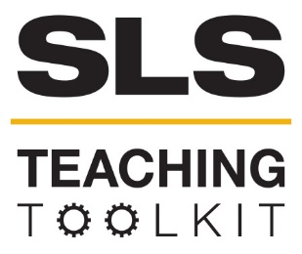 | Beyond the Haircut:  University Barbershop Aims to Build Community and Create Economic Opportunities in an Historic Atlanta Neighborhood
 | Time Commitment: 30-60 mins | Type: Reading; Discussion; Take-home assignment | Big Ideas: Asset-based Community Development; Community Asset Mapping
OVERVIEW:
The University Barbershop stands at the corner of Dr. Martin Luther King Jr. Drive and James P Brawley Drive in Atlanta, GA. Established in 1956, it is one of the oldest barbershops in America. Today, it remains an important center where local boys find mentorship, and patrons find community. In this case study, barber LaTeef Majaliwa contemplates the unique position of University Barbershop, and wonders how he can strength community impact while also meeting the economic needs of the barbershop and its employees.
Lateef Majaliwa (University Barbershop) and Bob Myers (Georgia Tech Scheller College of Business) created this case to stimulate discussion around sustainable communities and business. It was supported by the Center for Serve-Learn-Sustain and the Ray C. Anderson Center for Sustainable Business at the Georgia Institute of Technology. (July 2017)
INSTRUCTIONS:
- Use this case study in the way that works best for your class: assign it as a take-home reading, or as an in-class reading.
- Either as a take-home assignment, or in-class discussion, answer the Discussion Questions, or craft your own.
SLS STUDENT LEARNING OUTCOMES & ASSESSMENT
The Serve-Learn-Sustain toolkit teaching tools are designed to help students achieve not only SLS student learning outcomes (SLOs), but the unique learning outcomes for your own courses. Reflection, concept maps, rubrics, and other assessment methods are shown to improve student learning. For resources on how to assess your students’ work, please review our Assessment Tools at http://serve-learn-sustain.gatech.edu/tool-category/assessment.
This tool achieves SLOs 1, 3, 5, 6. See the end of this tool for further details.
Want Help?
Bob Myers is the contact for this tool. You can reach her at robert.myers@gatech.edu

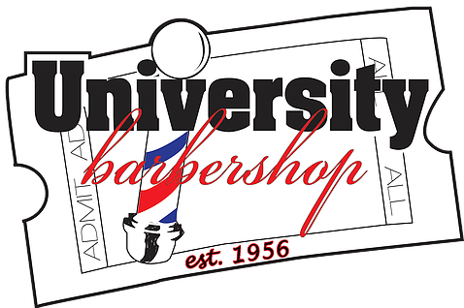
Beyond the Haircut:
University Barbershop Aims to Build Community and Create Economic Opportunities in an Historic Atlanta Neighborhood

Introduction
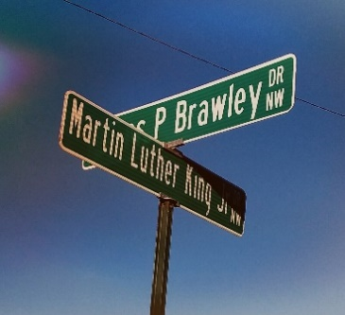
At the corner of Dr. Martin Luther King Jr Drive and James P Brawley Drive in Atlanta sits one of the oldest barbershops in America—University Barbershop est. 1956. The barbershop is often busy, and today is no exception. One of the barbers, Lateef, is sitting in the waiting area prior to his next appointment. Two young boys named Kymo and Kyree come in with smiles on their faces. They live in the neighborhood and (like other local boys) frequently come by to visit. Lateef likes to use these casual encounters to mentor young people. Lateef immediately asks Kymo and Kyree about a lemonade stand t hey have been running. Kyree responds that they have competition. Today, another kid set up a lemonade stand in Kyree’s usual spot. However, even if the boys had claimed their spot before the other kid, they would not have been able to run their business. They were not prepared to open today because they are out of cups and ice. Lateef asks the boys why they don’t have their necessary supplies. They tell him that they spent all the money they had earned. Lateef advises the boys not to spend all their profit; they need to keep some of it for future supplies. Lateef promises the boys that he will buy a cup of lemonade once their stand is up and running again. They finish talking, and then Kymo and Kyree run out of the shop. Lateef begins to think about what more he could do to help these boys. He wonders if there might be another product that Kymo and Kyree could sell that has overhead similar to lemonade. He also considers how he could best serve others in the community. He has already created a welcoming environment where many young boys come by just to talk. How could his mentorship make an even bigger impact? He also thinks about his own business dream: to open a barber school. What would it take to start such a school in this neighborhood?

History
Established in 1956, University Barbershop is located in the Atlanta University Center, just over half a mile west of downtown Atlanta’s Mercedes Benz Stadium. Across the street from the shop is the original home of West Hunter Street Baptist Church, where civil rights icon Ralph David Abernathy Jr. served as lead pastor. The church building also served as a location for many meetings involving the formation of the Southern Christian Leadership Conference. Sadly, the historic church building has been boarded up and desolate since the early 1970s. According to rumors, it might be turned into a wax museum or pub. The National Park Service began a study in 2014 to determine if the site should be designated as a unit of its system. The estate of Ralph David Abernathy III’s (Ralph David Abernathy Jr.’s son) is trying to raise $3.5 million to build a plaza outside the church that would include statues of his mother and father.
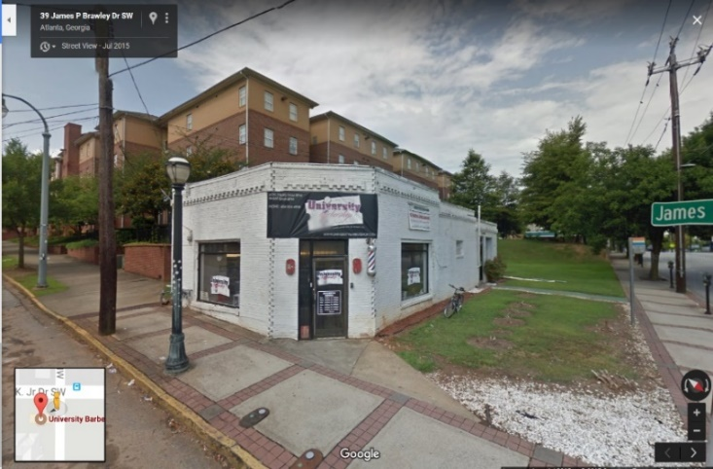
Also across the street from the barbershop (and next to the church) sits a relatively new strip mall anchored by a Walmart Supercenter. The plaza has a beauty supply store, an Atlanta Police Department mini precinct, a MetroPCS store, and a BTJ Wings restaurant—but no barbershop.
Figure 1: University Barbershop
Behind University Barbershop sits the Clark Atlanta University campus. During the school year, students make up the majority of the barbershop’s clientele since it is the closest barbershop to campus. The shop benefits from walk-by traffic headed to Walmart and the restaurants on MLK Jr Drive. Also, the neighborhood’s many parades afford the barbershop a great deal of visibility.
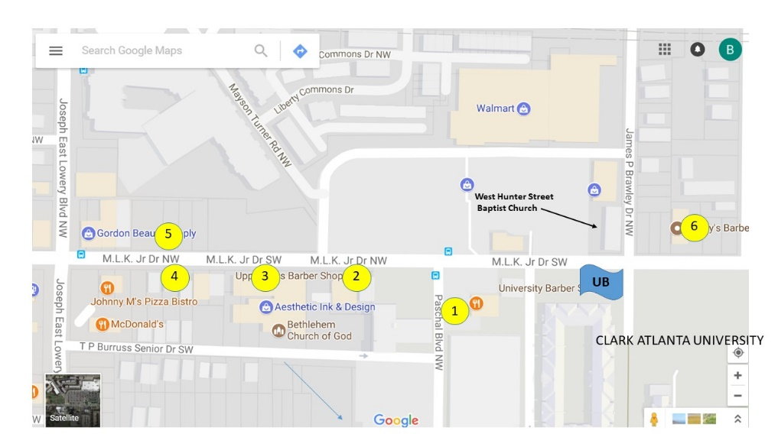
In addition to University Barbershop, six other barbershops line a one-third of a mile stretch along MLK Jr Drive. They are: (1) Bobby’s Barbershop, (2) Upper Cuts Barbershop, (3) Phillies Finest Barbershop, (4) K.O. Barber, (5) Pro Cuts, and (6) D Schaup & Salon. See Figure 1.
Figure 2. Barbershops on MLK Jr Dr. near University Barbershop (UB)

Over the years, many famous people have patronized University Barbershop: Mayor Andrew Young; Dr. Martin Luther King Jr.; Ralph David Abernathy Jr.; presidents of Clark Atlanta University; and a variety of professional athletes including local favorites Tashard Choice, Derrick Morgan, Michael Johnson, and Calvin Johnson (Go Jackets!).
University Barbershop’s hours of operation are: Monday through Thursday from 9 a.m. to 8 p.m., and Friday and Saturday from 8 a.m. through 8 p.m. The shop is closed on Sunday.
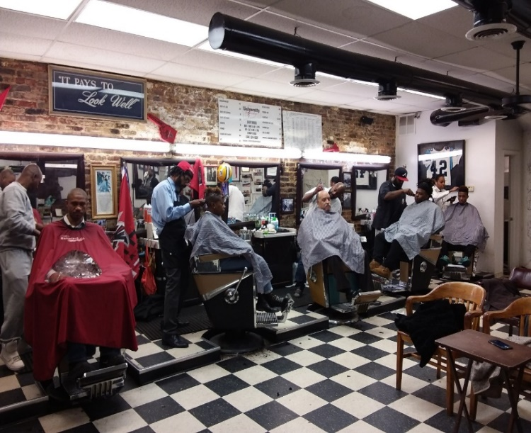
To cater to female clientele, a section of the establishment was walled off for use as a beauty salon. The wall gives women a sense of privacy by separating them from the larger men’s section. The area has three stylist chairs, a sink for shampoos, and built-in hair dryers. Currently, one hairstylist operates the salon area.
Figure 3. The University Barbershop. Hours of operation: Mon-Thu 9:00 am – 8:00 pm; Fri-Sat 8:00 am – 8:00 pm. Closed on Sunday
In the main room, five barber chairs line one wall, and one additional station stands on the opposite wall. Next to the single station, two rows of wooden chairs face a wall-mounted TV. Here, customers can wait, watch TV, or talk. By the window is a bookshelf full of children’s books and a few coloring books. The Children’s Museum of Atlanta provided this area as part of their program to encourage reading. Above the library is another TV with an Xbox.
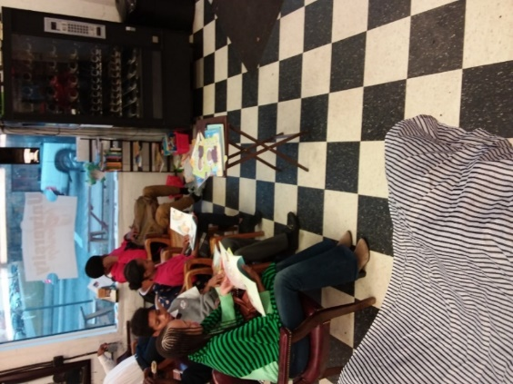
The shop’s mode of operations is booth rental. The barbers along the wall with five chairs and the hairstylist each pay a weekly chair/booth rental fee of $200. The single station along the opposite wall has a part-time barber who pays $100 per week. The weekly rental fee gives them exclusive use of a specific chair. Working as independent contractors, barbers choose the hours they cut, and they are responsible for managing their own appointments and clients. Walk-in customers are handled informally and are usually given to the newer barbers to help them build their client base. Walk-ins (who receive appointments on a first-come, first-served basis) generally patronize the first barber who becomes available.
Lateef has been a tonsorial artist for over 20 years. He started in Chicago but moved to Georgia in 1998 to continue his trade. He first worked in Gwinnett County; however, switching to a new location in Downtown Atlanta (on Mitchell Street across from the Courthouse) in 2000 sparked a nearly two-decade commitment to serve the Atlanta community.
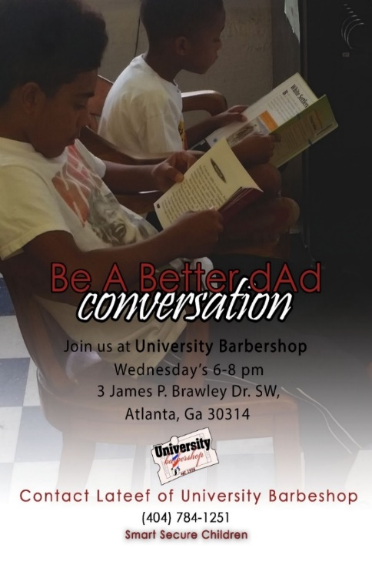
In 2005, Lateef took his trade to the Buckhead community for a different experience with new clientele. The new location operated on 50/50 commission Although many of Lateef’s regulars followed him to Buckhead, they did not like the higher prices. This barbershop cultivated a high-end, “exclusive” type of atmosphere. Unlike a traditional barbershop, the Buckhead location had a nicely decorated space and played relaxing music in the background. While Lateef’s former location focused on building relationships with the clientele, the new location focused more on pampering, such as offering clientele wine and magazines. In 2006, Lateef opened the Dokter’s Office barbershop in the Vine City community. This venture exposed Lateef to the benefits of a business being active within the community it serves. For instance, he served on the Vine City youth committee and hosted a basketball camp that included food, water, and a school supply giveaway for participants. Now at University Barbershop, Lateef continues to use his trade to be active in different community initiatives, such as mentoring youth, fatherhood classes, and Neighborhood Planning Unit (NPU) meetings. NPU is a City Hall initiative to give different neighborhoods in Atlanta a voice to the city council (mostly in regard to land use).
Figure 4. An advertisement for a community event held at University Barbershop.
Barbers in Georgia
In 2012, 1,144 barbers were licensed in the state of Georgia. Annual salaries vary from a low of $38k in less desirable areas like Athens (cough) to a high of $51k in Atlanta (Go Jackets!).
Barbers must be licensed in the state under the Georgia Board of Barbers. To obtain a license to practice legally the tonsorial arts, one must graduate from a Georgia Barber College with 1,500 hours of specialized training or log 3,000 hours of training as an apprentice. Regardless of which training option one selects, a national theory (written) and practical exam must also be passed. Georgia provides reciprocity for licenses obtained in other states with similar requirements. A license is valid for two years and must be renewed on December 31st of even-numbered years. In order to teach the trade, a barber must complete an additional 1,500 hours in a course for aspiring instructors at an accredited barber school.
The Future of University Barbershop
Serve-Learn Sustain interprets sustainable communities as integrated systems, wherein environmental, economic, and social factors all inform each other. As you read this case study, consider these terms as discreet factors, but also as connected. Ask yourself, how does the economy impact the environment? How does the environment affect society?
Just as the two boys exit University Barbershop, an older man named Sam walks past the empty vending machines and sits down. He provides “street news”—talking about everything from newscaster Monica Pearson to the Falcons and their connection to local politics. He is very entertaining and opinionated and draws a lot of laughter from the barbers and patrons. Again, Lateef’s mind wanders. He thinks, “There has to be a way to strengthen our impact in the community while generating other income outside of haircuts. We should be able to leverage our historical value to maximize on the earning potential of the building.” As a businessman, Lateef often asks himself the following questions:
- Is there a different business model that would be more conducive to the barbers and the shop? Lateef has worked for two different barbershop models: booth rental and commission-based. Each has its pros and cons. Could there be a better model?
- What could he do to improve efficiency? Could he do more cuts per day without sacrificing the experience for the customer? Should he alter his business hours?
- Are there any other revenue opportunities he could or should pursue, such as starting a nonprofit company?
- What would it take to open a barber school in the area and to make it the place to learn the trade? How would that fit in with University Barbershop?
- Is there a service that University Barbershop could offer to the other barbers on the Westside?

SLS Student Learning Outcomes

Goal: Develop Skills & Knowledge
- Identify relationships among ecological, social, and economic systems
- Describe how actions affect community sustainability
- Work effectively in different communities
- Analyze the impact of decisions on community sustainability
Goal: Connect to Professional Practice
- Relate discipline to community sustainability
Goal: Work in Diverse Contexts
- Create and evaluate approaches to addressing community sustainability
- Communicate with the public about sustainable communities
Goal: Build Long-Lasting Values and Beliefs
- Manifest personal values and beliefs demonstrating responsible community membership

