SLS Case Study: The 1995
Chicago Heat Wave
Discipline: | Type: Reading Assignment; Take-Home Assignment; In-Class Activity; Discussion | Time Commitment:  1-2 hrs. | Category: Case Studies on Sustainable Communities; Equity, Justice & Sustainability, Community Health
Big Ideas: Social and Environmental Determinants of Health; Infrastructure: Physical, Technological, Social; Social, Cultural & Environmental Context
OVERVIEW:
Are heat waves simply natural disasters over which we have no control? With heat waves set to increase over the coming decades, how can we fight these invisible killers? In this case study, head back to 1995 Chicago, when one of the deadliest heat waves in US history struck the city, killing hundreds. Learn about the demographics that were particularly vulnerable to the heat wave, and how those vulnerabilities made this heat wave (and others like it) not just a natural disaster, but a social one. After reading this case study and an interview transcript with one of the experts on the 1995 Chicago heat wave, turn to the Discussion Questions to think about how social networks and the built environment can protect us during heat waves now and in the future.
This tool was contributed by Kevin Lanza.
INSTRUCTIONS:
- Before class, ask students to read this case study, followed by the interview transcript “Dying Alone.” Make sure they read the first before the second.
- Ask students to answer the Discussion Questions in writing, and bring a copy of their answers, as well as the interview transcript, to class. Encourage them to annotate their transcript.
- Depending upon the length of your class, prioritize which specific questions you would like students to respond to during the time allowed for discussion.
SLS STUDENT LEARNING OUTCOMES & ASSESSMENT:
The Serve-Learn-Sustain toolkit teaching tools are designed to help students achieve not only SLS student learning outcomes (SLOs), but the unique learning outcomes for your own courses. Reflection, concept maps, rubrics, and other assessment methods are shown to improve student learning. For resources on how to assess your students’ work, please review our Assessment Tools.
This tool achieves SLOs 1 and 3. See the end of this tool for further details.
Want Help?
Kevin Lanza is the contact for this tool. You can reach him at lanza.kevin@gatech.edu

The 1995 Chicago Heat Wave
Record-Breaking Heat
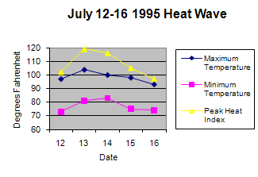In July 1995, the city of Chicago, IL, experienced one of the deadliest natural disasters in US history. A heat wave, defined as two or more consecutive days of excessively high temperatures, engulfed the city. From July 12-16th, the Chicago Midway Airport recorded maximum temperatures of 97, 106, 102, 98, and 93˚F, respectively (Figure 1). Yet while temperatures exceeded all-time records, city government reassured Chicagoans that the high temperatures, although abnormal, were not a cause for concern.
Figure 1. Temperature during the five hottest days of the Chicago heat wave. Heat index is a combined term for air temperature and relative humidity that captures “how it really feels” [1].
Paired with lack of concern, the city was unprepared to deal with the extreme temperatures. The heat caused the electrical power grid to fail numerous times across the metropolitan area, creating sporadic power outages that impacted most aspects of modern life. Many older homes, apartment buildings, shops, and offices were not designed to protect against heat, and air conditioning was not as common as it is today. Stores closed, food spoiled, alarm systems failed, cooling centers – temporary, air-conditioned public spaces set up by local authorities to provide relief from the heat – became overwhelmed, and people baked in hot buildings that had poor air circulation.
“It’s hot. It’s very hot. Yesterday we broke records. We all have our little problems, but let’s not blow it out of proportion. It is a crisis. It’s hot out there. We all walk out there. It’s very, very, very hot. It’s like getting heavy snow. It’s like getting real cold weather. Yes, we go to extremes in Chicago. And that’s why people love Chicago. We go to extremes.”
- Richard M. Daley, Mayor of Chicago, July 14, 1995 [2]
The Ensuing Health Crisis
Besides disrupting everyday life and creating uncomfortable conditions, the prolonged extreme temperatures from the Chicago heat wave were also a serious health threat. In humans, high temperatures can raise one’s core body temperature to the point of heat-related health issues. Heat illness ranges from heat exhaustion to the medical emergency of heat stroke, the latter of which is characterized by a worsening of heat exhaustion symptoms (i.e., profuse sweating, weakness, rapid breathing, muscle cramps, dizziness, nausea, and vomiting), along with central nervous system dysfunction (i.e., delirium and coma). If left untreated, heat stroke can result in death [3].
During the peak of the Chicago heat wave, many hospitals ran out of hospital beds and went on by-pass status, closing their doors to new patients (Figure 2). The lack of medical response and capacity contributed to a public health crisis. From July 14-20th, the medical examiner’s office in Chicago recorded 485 heat-related deaths on death certificates [4]. However, when comparing the total number of deaths from all causes with the long-term average of daily deaths for this same time period (Figure 3), researchers attributed 739 excess deaths to the Chicago heat wave.
Extreme Heat into the Future
Alarmingly, scientists project that the danger of extreme heat to public health will increase over the next century. In addition to human-induced global warming set to raise global temperatures by 2.5-11°F by 2100 [7], climate change will likely increase several measures of heat waves over time (Figure 4). Moreover, cities experience warmer temperatures than nearby rural areas, a phenomenon known as the urban heat island effect, making them particularly vulnerable to an increase in heat waves.
However, we aren’t helpless in the face of this threat. There are strategies we can implement to mitigate the disastrous consequences of heat waves. Chicago is a good example. In response to the 1995 heat wave, the city of Chicago strengthened and updated its heat emergency response system by developing an Extreme Weather Operations Plan – a comprehensive set of actions to reduce heat-related illness during heat wave events. In 1999, this more robust plan was put to the test when Chicago was hit by another heat wave, and its implementation did significantly reduce, though it did not completely protect against, heat-related mortalities [9]. Time will tell how Chicago, and other cities across the globe, respond to rising urban temperatures because of human-induced global warming and urban heat islands. Check out Urban Heat Islands and the Georgia Tech Climate Network for a tool about how this affects our community.
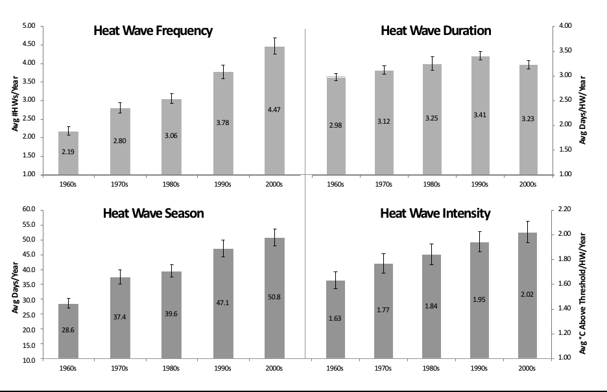
Figure 4. Heat Wave frequency, duration, season, and intensity over time [8].

Next, read the transcript “Dying Alone,” an interview with Dr. Klinenberg. This interview explores why the 1995 Chicago Heat Wave was a social disaster, rather than an exclusively environmental one. After completing both readings, answer the questions below.

Discussion Questions
- During the 1995 heat wave, the city of Chicago made several deadly mistakes. Describe two specific failures of Chicago’s city government in reaction to the prolonged extreme heat.
- What are the reasons that Dr. Klinenberg gives for Chicago’s Latino community faring better in the heat wave, and for African American neighborhoods faring worse?
- Based on what you’ve learned about the most vulnerable demographics, is there someone you know that is at high risk for heat-related illness? What are some strategies to reduce their risk for heat-related health issues? Be specific.
- Have high temperatures ever affected your health? If so, where did this take place, what were the circumstances, and what were your symptoms?
- 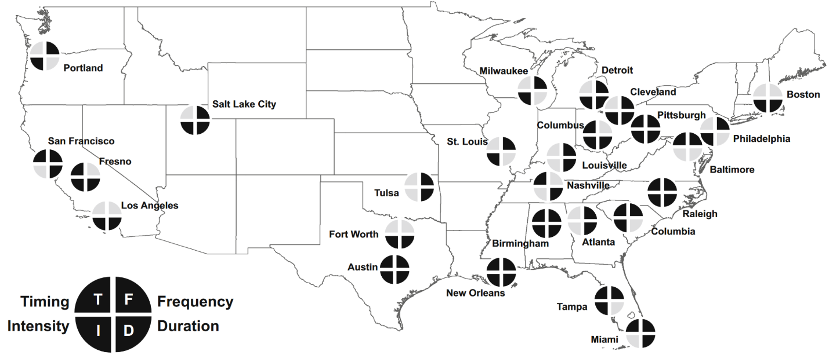In the U.S. map below, pie diagrams split into four sections demonstrate significant changes in how major cities experienced heat waves between 1961 and 2010. Each section of the pie measures one of four heat wave characteristics (i.e., timing, intensity, frequency, and duration). If the section of the pie appears in bold, then that city’s experience of that heat wave characteristic has significantly shifted above the natural average. Review the map. Are you surprised by these findings? What parts of the country do you think heat waves will have a larger impact on, and why?
Timing = length of heat wave season (May – September); Intensity = strength of heat wave temperature; Frequency = number of heat waves; Duration = number of heat wave days [10].

- A primary focus of the interview with Dr. Klinenberg is the role of social networks in mitigating the effects of natural disasters like heat waves. Think about your various social circles (e.g., family, friends, professionals) and who fits in each circle (or multiple circles). Are there connections between individuals in different social circles? Which individuals would you most likely contact in the case of an emergency? Are these same individuals those who would be the most helpful during an emergency?
- Using real-life experiences and/or your imagination, what would you do during a five-day heat wave without electrical power? What, if anything, would concern you? Explain your plan, and discuss how your decisions might change if you experienced this event while at Georgia Tech versus at the house you grew up in (if different).
- Consider showing this clip of local Chicago coverage of the heat wave. How did local officials respond to the crisis? Did they take an individualistic or systemic approach?

Resources for Further Reading
City of Chicago. (2014). 2014 extreme weather operations plan. Retrieved July 10, 2018 from here.
City of Chicago. (2007). Chicago climate action plan: climate change and Chicago. Retrieved July 10, 2018 from http://www.chicagoclimateaction.org/filebin/pdf/report/Chicago_Climate_Impacts_Report.pdf
Klinenberg, Eric. (2001). “Dying Alone: The social production of urban isolation.” Ethnography 2(4): 501-31.
Klinenberg, Eric. Heat wave: A social autopsy of disaster in Chicago. University of Chicago Press, 2015.
Thomas, M. (2015). Heat wave: an oral history. Retrieved June 25, 2018 from http://www.chicagomag.com/Chicago-Magazine/July-2015/1995-Chicago-heat-wave/

US Environmental Protection Agency. (2006). Excessive heat events guidebook in brief. Retrieved July 10, 2018 from https://www.epa.gov/sites/production/files/2014-07/documents/eheguide-brief_final.pdf

References
- National Weather Service. (n.d.). Brief review of the extreme heat episode in Chicago July 29-31, 1999. Retrieved July 1, 2018 from https://www.weather.gov/lot/1999Jul29

- Thomas, M. (2015). Heat wave: an oral history. Retrieved June 25, 2018 from http://www.chicagomag.com/Chicago-Magazine/July-2015/1995-Chicago-heat-wave/

- Minnesota Department of Health. (2012). Minnesota extreme heat toolkit. Retrieved June 5, 2018 from http://www.health.state.mn.us/divs/climatechange/docs/mnextremeheattoolkit.pdf

- Whitman, S., Good, G., Donoghue, E. R., Benbow, N., Shou, W., & Mou, S. (1997). Mortality in Chicago attributed to the July 1995 heat wave. American Journal of Public Health, 87(9), 1515-1518.
- National Oceanic and Atmospheric Administration. (1995). Natural disaster survey report: July 1995 heat wave. Retrieved February 06, 2016 from http://www.nws.noaa.gov/os/assessments/pdfs/heat95.pdf

- US Environmental Protection Agency. (2015). Climate change indicators in the United States. Retrieved February 06, 2016 from http:// www3.epa.gov/climatechange/science/indicators/health-society/heat-deaths.html

- Pachauri, R. K., Allen, M. R., Barros, V. R., Broome, J., Cramer, W., Christ, R., . . . Dasgupta, P. (2014). Climate change 2014: synthesis report. Contribution of Working Groups I, II and III to the fifth assessment report of the Intergovernmental Panel on Climate Change: IPCC.

- Habeeb, D., Vargo, J., & Stone, B. (2015). Rising heat wave trends in large US cities. Natural Hazards, 76(3), 1651-1655.

- US Centers for Disease Control and Prevention. Heat-related deaths --- Chicago, Illinois, 1996—2001, and United States, 1979—1999. Retrieved June 25, 2018 from https://www.cdc.gov/mmwr/preview/mmwrhtml/mm5226a2.htm

- Habeeb, D., Vargo, J., & Stone, B. (2015). Rising heat wave trends in large US cities. Natural Hazards, 76(3), 1651-1655.

SLS Student Learning Outcomes
- Identify relationships among ecological, social, and economic systems.
- Demonstrate skills needed to work effectively in different types of communities.
- Evaluate how decisions impact the sustainability of communities.
- Describe how to use their discipline to make communities more sustainable.*
* Note: SLO 4 is intended to be used by upper division, project-based courses such as Capstone.

