 | SLS Case Study: The Flint Water Crisis
Discipline: All | Type: Reading; Discussion; Take-home assignment, project; In-class exercise | Time Commitment: 30-60 mins with potential for expansion | Category: Case Studies on Sustainable Communities; Community Health
Big Ideas: Systems Thinking; Inequality, Poverty, and Sustainable Development; Infrastructure: Physical, Technological, Social
OVERVIEW:
The Flint Water Crisis is one of the most significant instances of environmental injustice in the 21st century. In this case study, read about the impact of the crisis on the natural world, as well as the residents of Flint, Michigan, and learn about how we can use technology to create a safe, sustainable water system. Serve-Learn-Sustain interprets sustainable communities as integrated systems, wherein nature, technology and society all inform each other. As you read this case study, consider these terms as discrete factors, but also as connected.
This tool was contributed by Bethany Jacobs.
INSTRUCTIONS:
- Use this case study in the way that works best for your class: assign it as a take-home reading, or as an in-class reading. Supplement the case study with sources from the Additional Readings section to read/watch/listen to in class.
- Either as a take-home assignment, or in-class discussion, answer the Discussion Questions, or craft your own.
SLS STUDENT LEARNING OUTCOMES & ASSESSMENT:
The Serve-Learn-Sustain toolkit teaching tools are designed to help students achieve not only SLS student learning outcomes (SLOs), but the unique learning outcomes for your own courses. Reflection, concept maps, rubrics, and other assessment methods are shown to improve student learning. For resources on how to assess your students’ work, please review our Assessment Tools.
This tool achieves SLOs 1 & 4. See the end of this tool for further details.
Want Help?
Jennifer Hirsch is the contact for this tool. You can reach her at jennifer.hirsch@gatech.edu

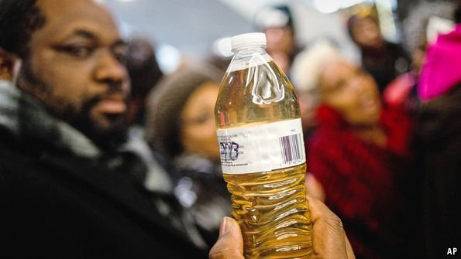Flint Water Crisis Case Study
Flint Community Meeting. Source: Fusion

Introduction
On April 25th, 2014, the city of Flint, Michigan switched water providers from the Detroit Water and Sewage Department to the local Flint River. Flint, a declining industrial town where 41.2% of residents lived below the poverty line and 56.6% were African-American, was experiencing a dramatic economic deficit (CNN). The switch to the Flint River (billed as temporary while Flint built its own pipeline to the Karegnondi Water Authority) had the potential to save the city $200 million over the next twenty-five years (Kennedy). City officials, including Mayor Dayne Walling, asserted that, “It’s regular, good, pure drinking water, and it’s right in our backyard” (Cherry).
Yet within days, residents complained of the water’s look and smell. By August, e-coli and fecal coliform levels in the water prompted water boiling advisories. Meanwhile, the most insidious effect of the water switch wasn’t obvious until several months later, when the EPA asserted that corrosive elements in the water were breaking down lead pipes. Both the EPA, and later, Virginia Tech professor Marc Edwards, notified the city that lead ppb (parts per billion) dramatically exceeded safe water levels. Water in the home of Flint resident Lee Ann Walters, for example, tested at 397 ppb. The EPA sets a safety limit of 15 ppb.
As the crisis unfolded over the following years, one of its most disturbing elements was the continuing insistence of state and city officials, including Michigan Governor Rick Snyder, that the water was safe, that reports to the contrary were unfounded, and that opportunities to switch the water source were untenable because of associated costs. But by January 5th 2015, Gov. Snyder had declared a state of emergency in Flint. Over the coming months multiple city officials resigned, and as of 2018, fifteen people have been criminally charged in relationship to the Flint water crisis, while the long-term effects of the lead-poisoning remain unknown (Egan).
Governor Snyder. Source: NYMag
Serve-Learn-Sustain interprets sustainable communities as integrated systems, wherein Society, Nature, and Technology all inform each other. As you read this case study, consider these terms as discrete factors, but also as connected. Ask yourself, how does nature impact society? How can technology support or damage nature and society?

Nature
While many trace the beginning of the Flint Water crisis to 2014, it’s rooted in much older issues of municipal and industrial pollution, and a longstanding failure to protect Flint’s natural environment. Though the Flint River served as the city’s major water source several decades ago, by 1969 reports found its quality severely degraded from years of environmentally irresponsible practices. This “poor water quality [was] due to unregulated discharges” by the city itself, and by plants like General Motors, which fueled Flint’s economy into the 1980s (Leonardi & Gruhn). As CNN reports, “In 2001, [Michigan] ordered the monitoring and cleanup of 134 polluted sites within the Flint River watershed, including industrial complexes, landfills and farms laden with pesticides and fertilizer.” Yet despite this early sign that the city knew the Flint River was compromised, less than fifteen years later, administrators proposed it as a viable water source. City residents were skeptical from the beginning, as the river was “famously filthy” (Finnegan). Their concerns proved all too legitimate in the coming months.
Key Takeaway: Flint’s water problems were decades in the making. Histories of irresponsible environmental practices set the stage for the crisis.
Ironically, the crisis itself has compelled new waste production which may yet compound Flint’s existing problems. Today, most Flint residents still rely on bottled water, for everything from drinking to cooking to brushing teeth. One community member relayed in a Reddit AMA that “We go through about 4 cases a week” (Cherry). In 2016, one family of three used 151 bottles a day, a high number that nevertheless accounts for less than half of the water an average American family uses daily (Zdanowicz). While Flint has prioritized recycling, the Natural Resource Defense Council warns that bottled water has a longstanding environmental cost. For example, when Fiji shipped 18 million gallons of bottled water to California in 2006, it produced “about 2,500 tons of global warming pollution” (Adams). Thus, Flint’s reliance on bottled water increases waste in an already overburdened city.

Technology
Much of the crisis can be attributed to state and city regulators’ mismanagement of Flint’s water supply. Providing citizens with safe drinking water is an essential government responsibility, one that relies on a variety of technologies and infrastructures. According to Terese Olson, Associate Professor of Civil and Environmental Engineering at the University of Michigan, building water systems “requires input from multiple stakeholders at various points in the design process” (Gettys). The switch from one water source to another (as in Flint’s case) necessitates a two-to-three-year planning period, as well as careful water treatment to avoid both toxins in the water, and corrosion in the pipes.
Key Takeaway: Engineers and safety experts have developed crucial safeguards for our water. Ignoring these technologies resulted in the Flint water crisis.
In 2014, Flint claimed to avail itself of these technologies. A statement from the city asserted, “There have been numerous studies and tests conducted on [Flint River] water by several independent organizations […] verif[ing] that 'the quality of the water being put out meets all of our drinking water standards and Flint water is safe to drink’” (Cherry).
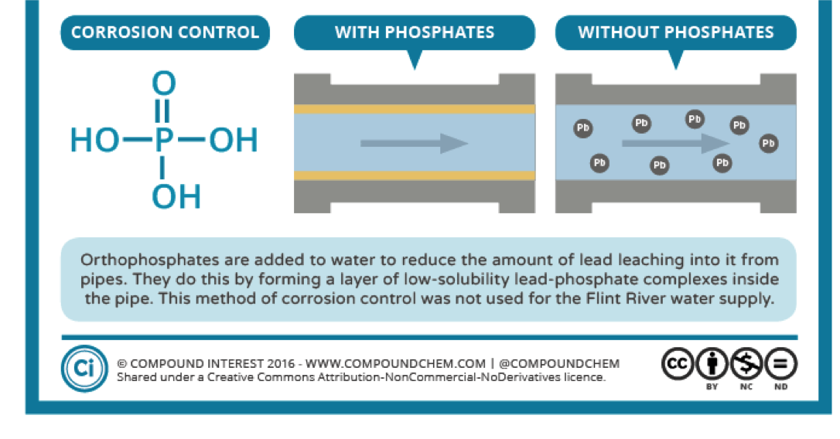But other agencies and experts quickly disproved that assertion, as in the case of Virginia Tech civil engineering professor Marc Edwards. When Edwards arrived in Flint, he had already made a name for himself by researching unsafe lead levels in Washington D.C.—despite being pressured at the time to desist by both the EPA and WASA (Home-Douglas). Edwards’ research, both in D.C. and Flint, proved that infrastructural failures had left residents vulnerable to lead poisoning, and that administrators knew about it. One of the failures Edwards identified in Flint came down to mistreatment of the water. More accurately, its lack of treatment per industry guidelines. As the image to the right illustrates, treating water with orthophosphates reduces lead-leaching and protects drinking water. The Flint water supply never benefited from this crucial technology, which is largely to blame for the city residents’ multiple instances of lead poisoning.
Source: CompoundChem

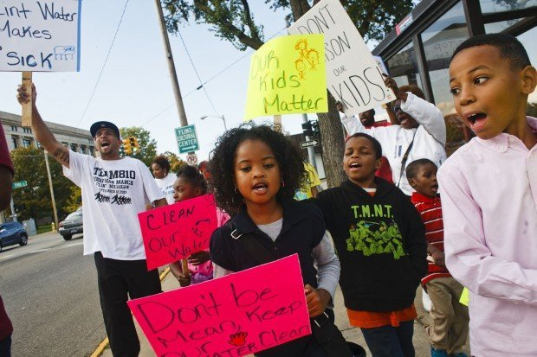Society
Flint children marching in protest, Oct. 7 2015 (Michigan Live)
Lead is a common threat in economically depressed communities of color, where residents are not only exposed to contamination, but often see their efforts to address the problem ignored. In Flint’s case, it took two years for city administrators to heed the warning of city residents. In 2016, an independent panel appointed by Gov. Snyder “concluded that disregard for the concerns of poor and minority people contributed to the government’s slow response.” The panel determined that the Flint crisis “is a story of government failure, intransigence, unpreparedness, delay, inaction and environmental injustice” (Bosman).
In fact, Flint is a textbook example of what experts call environmental racism: “Coined in the 1980s, the term refers to the disproportionate exposure of blacks to polluted air, water and soil” (Elgion). As a result of this exposure, communities of color are much more likely to suffer from health problems associated with these pollutants. In Flint, residents complained of rashes, hair loss and other sickness caused by the water, while children proved especially vulnerable to these effects. The World Health Organization has found that high levels of lead exposure in children can “cause coma, convulsions and even death.”
But the real impact on Flint’s children may be more insidious. This is because lower, non-lethal levels of lead exposure can still “affect children’s brain development resulting in reduced intelligence quotient (IQ), behavioral changes such as reduced attention span and increased antisocial behavior and reduced educational attainment” (WHO). Even more disheartening, WHO finds that impoverished children, like many in Flint, are especially vulnerable to lead exposure. In other words, the Flint community may feel bear? the costs of the crisis for decades, with many of its consequences likely to go unrecognized and unreported.
Key Takeaway: The impact of the crisis on Flint residents’ health may not be known for decades.
Thus, Flint represents the harrowing nexus of infrastructural failure, mistreatment of the natural world, and indifference to the social costs thereof.

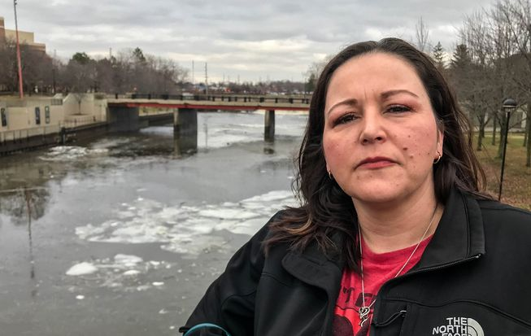Community Response
LeeAnne Walters. Source: Goldman Environmental Prize
Reading about the injustices perpetrated against Flint by its own government is a discouraging and even infuriating experience. But there is an equally important element to this story that should not only encourage, but inspire us. When Flint switched its water source to the toxic Flint River, local residents were the first and most passionate detractors, sparking an activist movement that began with town halls and has since carried across the country.
One apt example is LeeAnne Walters, the resident who initially reached out to Marc Edwards. With Edwards’ help, Walters became a citizen-scientist. She "methodically sampled each zip code in Flint and set up a system to ensure the integrity of the tests. She worked over 100 hours per week for three straight weeks and collected over 800 water samples—garnering an astounding 90 percent response rate” (Persio). In 2018, she received the Goldman Environmental Prize for her work in Flint.
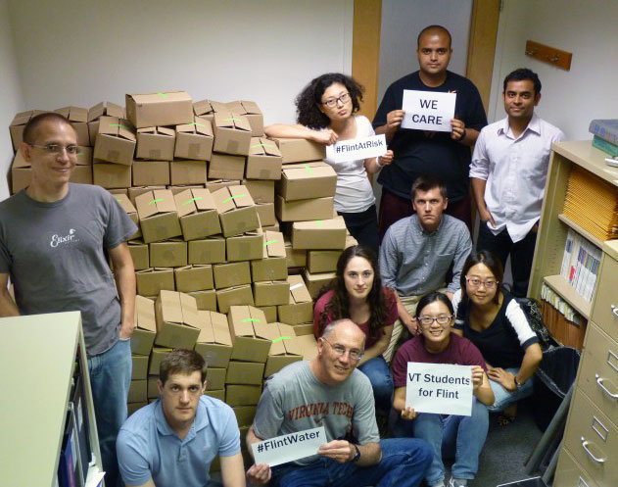Indeed, it was Walters who lead Edwards to Flint, and with him, a number of Virginia Tech student researchers. Many of these students traveled to Flint on their spring break to distribute lead-testing kits, helping residents to combat government indifference with hard science (Adams and Tuel). In 2017, a similar act of community activism occurred when over three hundred plumbers from United Association Local 370 descended on Flint, installing water filters in Flint homes for free.
Photo by the Flint Water Study team. Source: Virginia Tech Magazine.
The work of these plumbers and students draws attention to an important element of local and national response to the Flint disaster: the power of dedicated citizens marshaling their disciplinary knowledge for environmental justice. Scientists, engineers, lawyers and laborers can all partner with the Flint community to repair its infrastructure and hold its government accountable. In doing so, they offer an example to the many students at Georgia Tech whose disciplinary training will have tremendous impacts on the world.

Discussion Questions
Photo courtesy Fotolia/czardases (Mother Earth News)
- What challenges did the people of Flint face before and after public acknowledgment of the lead crisis? How did structural inequality—i.e. the barriers experienced by low-income households and citizens of color—impact how the crisis unfolded and why the Flint River was compromised in the first place?
- Nature, Technology, and Society are interlocking systems. What aspects of the Flint Water crisis demonstrate this interconnectedness? Cite your answers from the case study itself or the resources under Further Reading below.
- What does the article show about the work of scientists and engineers within the field of Environmental Justice?
- The need for Environmental Justice manifests in many different ways, in many communities. How can we apply the lessons we have learned about Flint to a local issue in Atlanta?
- How can you use the skills you're developing in your major studies to participate in the environmental justice movement?

Further Reading
Adams, Dominic, “Millions of plastic bottles flood Flint amid water crisis” (Michigan Live, 2016).
Adams, Jason and Jesse Tuel. “Fighting for Flint: A Virginia Tech Team Exposes Lead Poisoning,” (Virginia Tech Magazine, 2016).
Cherry, Anna. “How Flint’s water crisis has changes its citizens”, (URBO, 2017).
Drum, Kevin. “Flint Probably Has Bigger Problems Than Lead Pipes,” (Mother Jones 2016).
Egan, Paul, “These are the 15 people criminally charged in the Flint water crisis” (Detroit Free Press, 2017).
Elgion, John. “A Question of Environmental Racism in Flint” (The New York Times, 2016).
Finnegan, William, “Flint and the Long Struggle Against Lead Poisoning,” (The New Yorker, 2016).
"Flint Water Crisis Fast Facts," (CNN, 2017).
Flint Water Study
Gettys, Travis, “The science behind the flint water crisis,” (Raw Story, 2016)
Home-Douglas, Pierre. “The Water Guy.” ASEE PRISM, vol. 14, no. 3, 2004, pp. 28–32.
Jones, Dayna. “Flint Water Crisis: The Importance of Building a Grassroots Environmental Justice Infrastructure,” (Law at the Margins, 2018).
Kennedy, Merrit. “Lead-Laced Water in Flint: A Step-by-Step Look at the Makings of a Crisis” (NPR, 2016).
Persio, Sophia Lotto. “Who is LeeAnne Walters? Activist Who Helped Expose Flint Water Crisis Wins Top Prize,” (Newsweek, 2018).
Report of the Michigan Civil Rights Commission, “The Flint Water Crisis: Systemic Racism Through the Lens of Flint,” (Michigan.gov, 2017).
Smith, Lindsey. “After ignoring and trying to discredit people in Flint, the state was forced to face the problem,” (Michigan Radio, 2015).
World Health Organization, “Leading Poisoning and Health” (2017).
Zdanowicz, Christina, “Flint family uses 151 bottles of water per day” (CNN, 2016).

Audio and Visual Resources
ACLU of Michigan. Here’s to Flint. (2016).
For the Movement. “Environmental Racism: It’s a Thing.” (National Urban League, 2018).
Garza, Ryan, and Brian Kaufman. Flint: An American Nightmare. (Detroit Free Press, 2019).
Here & Now. “Flint Residents Confront Long-Term Health Issues After Lead Exposure.” (NPR, 2017).
Moore, Michael. Roger & Me. (1989).
NOVA. Poisoned Water. (PBS, 2017).
Our World. The Poisoning of Flint. (BBC, 2016).
Smith, Lindsey. “Not Safe to Drink.” (Michigan Radio, 2015).

SLS Student Learning Outcomes

- Identify relationships among ecological, social, and economic systems.
- Demonstrate skills needed to work effectively in different types of communities.
- Evaluate how decisions impact the sustainability of communities.
- Describe how to use their discipline to make communities more sustainable.*
* Note: SLO 4 is intended to be used by upper division, project-based courses such as Capstone.

