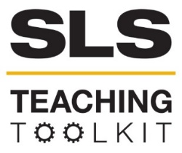 | Raising Awareness Through Poster Design
Discipline: All | Type: Take-home assignment/project | Time Commitment:  6-8 hrs. | Category: GT1000; Sustainability in Atlanta
Big Ideas: Doing Good In Your Neighborhood; Information Visualization; GT as Living Lab
OVERVIEW:
It's one thing to be able to articulate what sustainability means, and it's another thing to be able to communicate your ideas through visual design, but this poster design tool does both. Through this tool, students use poster campaigns to raise awareness about Georgia Tech's sustainability practices. While many students already have some skills with design software and photography, here they'll practice design skills using Adobe software available in the library, the Multimedia Studio, or through the Virtual Lab. Contact the SLS main office for assistance in displaying quality student work on campus.
INSTRUCTIONS:
- Ask students, either as individuals or in their small groups, to visit the SLS website and to then create their own working definition of what sustainability means to them.
- Next, have students investigate how Georgia Tech is already engaging in sustainability initiatives. Have each small group identify at least 3 on-campus sustainability initiatives.
- Now that students have identified their descriptions and initiatives, invite them to briefly write as individuals on how these projects connect and enhance the Tech community. Remind students that their working definition, the initiative they identified, and their description regarding community connection and enhancement should be part of their poster’s design.
- Students should take their own photos, if possible, of the initiative that they have identified as part of their design work. Encourage them to also include these photos in their posters.
Students may either instruct themselves on Adobe products via Lynda.com (the library has a subscription which requires e-mail ID and password to access) or should be encouraged to attend a regularly offered library workshop on using the Adobe software suite.
SLS STUDENT LEARNING OUTCOMES & ASSESSMENT:
The Serve-Learn-Sustain toolkit teaching tools are designed to help students achieve not only SLS student learning outcomes (SLOs), but the unique learning outcomes for your own courses. Reflection, concept maps, rubrics, and other assessment methods are shown to improve student learning. For resources on how to assess your students’ work, please review our Assessment Tools.
This tool achieves SLOs 1 &3. It also achieves GT1000 SLOS 2, 5 & 6. See the end of this tool for details.
Want Help?
Serve-Learn-Sustain is the contact for this tool. Email us at Serve-learn-sustain@gatech.edu

Sustainability at Georgia Tech: Awareness Posters
Contact the SLS main office for assistance in displaying quality student work on campus.

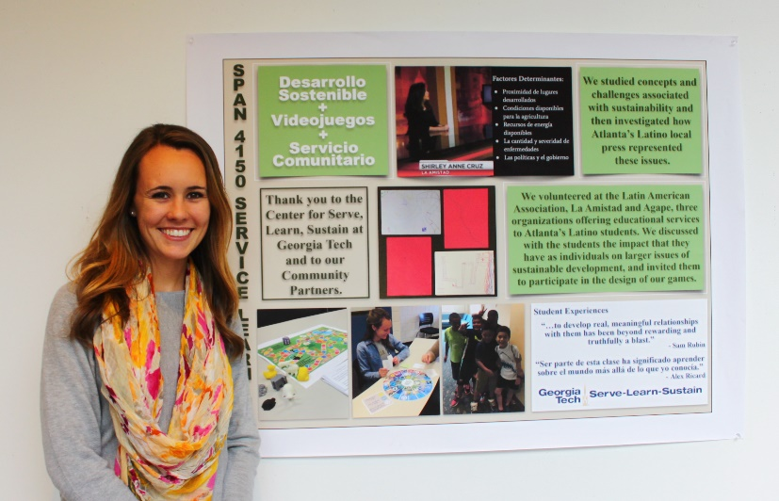
Instructions
- Visit the Center for Serve-Learn-Sustain (SLS) website. After reviewing the website create your own definition, in 150 words or less, of what sustainability means to you.
- Now, investigate how Georgia Tech is already engaging in sustainability initiatives. Identify at least 3 on-campus initiatives and visit them. While you’re there, take a selfie, which you’ll save for later in the poster design process.
- After your visits, decide which initiative you’d like to concentrate on for your poster.
- In 150 words or less, describe the initiative you’ve selected and discuss how it connects and enhances the Tech community.
- Now, construct a poster measuring 24” x 36” that includes your selfie, definition of sustainability, and your discussion. Make sure to include a title and your name somewhere on the poster. You are strongly encouraged to use graphic design software such as Adobe InDesign or Illustrator for this project. Be as creative as possible!
  - Need Adobe help? Either check out Lynda.com design courses available through the library portal (use your Tech e-mail handle and password to log in) OR visit the Multimedia Studio in CLC for assistance.
  - The library also frequently offers workshop sessions on these software packages.
- Make sure to proofread your poster.
- Print your poster. The Multimedia Studio or Paper and Clay in the Union offer printing services.
- Share your poster in class—be prepared to offer a very short report (1-2 minutes) about the initiative you selected and what you learned during this process.
SLS Student Learning Outcomes
- Identify relationships among ecological, social, and economic systems.
- Demonstrate skills needed to work effectively in different types of communities.
- Evaluate how decisions impact the sustainability of communities.
- Describe how to use their discipline to make communities more sustainable.*
* Note: SLO 4 is intended to be used by upper division, project-based courses such as Capstone.
GT1000 Curriculum and Learning Outcomes
University Culture
- Manage the university environment in ways that support academic and personal success and involvement at Georgia Tech.
- Develop a sense for what it means to learn at Georgia Tech and create a list of resources to support that learning process.
Academic Success and Time Management
- Create a time management plan and begin the process of implementing effective time management skills.
- Develop a personal study strategy based on strengths identified in a self-regulated learning survey.
Communication and Relational Skills
- Write reflectively on topics related to college major and first year college experience.
- Participate as an effective member of a team to produce and deliver a high-quality, professional presentation on a topic of value to the class.
Major/Career Research
- Describe the required skills, daily activities, current and future state (growth potential), and salary potential of the major/career selected.
Career Development Skills
- Prepare a resume applicable to internships, co-ops, study abroad programs or leadership positions (as appropriate).
Leadership/Involvement at Tech
- Identify organizations and activities for possible involvement that reflect personal, academic, and career goals and interests.

