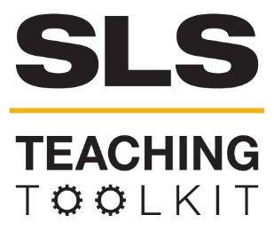 | Teaching about the UN Sustainable Development Goals (SDGs): Resources
Discipline: All | Type: Resource List | Time Commitment:  N/A | Category: UN Sustainable Development Goals (SDGs)
OVERVIEW:
Use these resources to help students learn more about the United Nations Sustainable Development Goals. You may assign readings, find organizations to work with, or simply ask your students to explore what’s available. General resources related to the UN SDGs are compiled below, followed by a short blurb about each SDG and references to related research at Georgia Tech where applicable. This tool was contributed by Bonnie Lapwood.
INSTRUCTIONS:
This teaching tool is intended to serve as a resource for instructors and students rather than a structured lesson or module. Instructors may review the resources described below and assign some of them to students as an introduction to the SDGs. Depending upon the course, some resources may be more appropriate than others. For specific recommendations on SDG course integration, please contact SLS to arrange a consultation.
SLS STUDENT LEARNING OUTCOMES & ASSESSMENT:
The Serve-Learn-Sustain toolkit teaching tools are designed to help students achieve not only SLS student learning outcomes (SLOs), but the unique learning outcomes for your own courses. Reflection, concept maps, rubrics, and other assessment methods are shown to improve student learning. For resources on how to assess your students’ work, please review our Assessment Tools.
See the end of this tool for further details.

Want Help?
SLS is the contact for this tool. You can reach us at serve-learn-sustain@gatech.edu

Teaching about the UN Sustainable Development Goals (SDGs): Resources

Get to Know the United Nations Sustainable Development Goals
- Basic facts about the UN Sustainable Development Goals:
  - Developed by the United Nations to replace the Millennium Development Goals (MDGs) which expired in 2015
  - 169 targets across 17 goals within 5 pillars
  - 1-3 indicators per target
  - Part of the 2030 Development Agenda
  - Can be implemented on a variety of scales from national to local and/or institutional
- The UN Global Goals website, found here, outlines each of the 17 Sustainable Development Goals and the metrics that are used to measure progress towards them. The website also has a list of video resources.
- Additional details on the Sustainable Development Goals can also be found on the UN’s main website.
- For more information on how the Sustainable Development Goals are being implemented and prioritized at Georgia Tech, students can refer to this page that includes SDG-related programming for Fall 2020, and they can also watch President Cabrera’s address launching SDG implementation at Georgia Tech. Students may also be interested in viewing the Liam's Legacy Symposium at Georgia Tech on Creating, Implementing, & Measuring the U.N. Sustainable Development Goals.
  - An additional video resource related to teaching about the SDGs at Georgia Tech is available here: “Advancing the UN SDGs & Education for Sustainable Development at Georgia Tech and Across the Greater Atlanta Region.”
- RCE Greater Atlanta “supports implementation of the U.N. Sustainable Development Goals at the regional level through education and training.” RCE Greater Atlanta has also sponsored the following events:
  - Atlanta Global Studies Symposium at Georgia Tech - RCE Greater Atlanta Track, Session 1: Advancing Education for Sustainable Development (ESD) through RCEs
  - Youth and the SDGs Virtual Showcase
- UNITAR (United Nations Institute for Training and Research) provides modules created in collaboration with Georgia Tech and other students within the RCE Greater Atlanta network. The course may be accessed here: Youth & SDGs E-learning Course. To register for the course, scroll down and click “Sign Up.” You must then register an account and complete checkout for the course (however, there is no cost to register). The course can then be accessed via this link (also found in the confirmation email). You will need to use “Log in with unitar.org/event.” Then, use the enrollment key that is found in the confirmation email.
  - UNITAR also offers Learning, Training & Practice on the SDGs, a series of video webinars that cover SDG implementation in different contexts as well as a wide variety of topics related to the SDGs.
- CIFAL Atlanta also offers resources and trainings on the SDGs, with some geared towards a younger audience and some geared towards K-12 teachers.

Get to Know the SDGs & Related Research at Georgia Tech
SDG 1: No Poverty
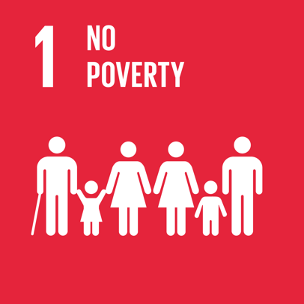
Why It Matters
The first SDG addresses the global wealth divide and underscores the importance of lifting people around the world out of poverty by 2030. Key metrics include eradicating extreme poverty, which is defined as people living on less than $1.25 a day, and reducing the proportion of people living in poverty by at least 50% by 2030.
At Georgia Tech, Dr. Shatakshee Dhongde is conducting research regarding how poverty is measured, which is an important component of evaluating progress towards this goal. This video explains Dr. Dhongde’s multi-dimensional approach to measuring poverty, specifically in the US context, which takes into account factors such as education, health indicators, housing, environmental hazards (air quality, water quality, and food security), and transportation access.

SDG 2: Zero Hunger
Why It Matters
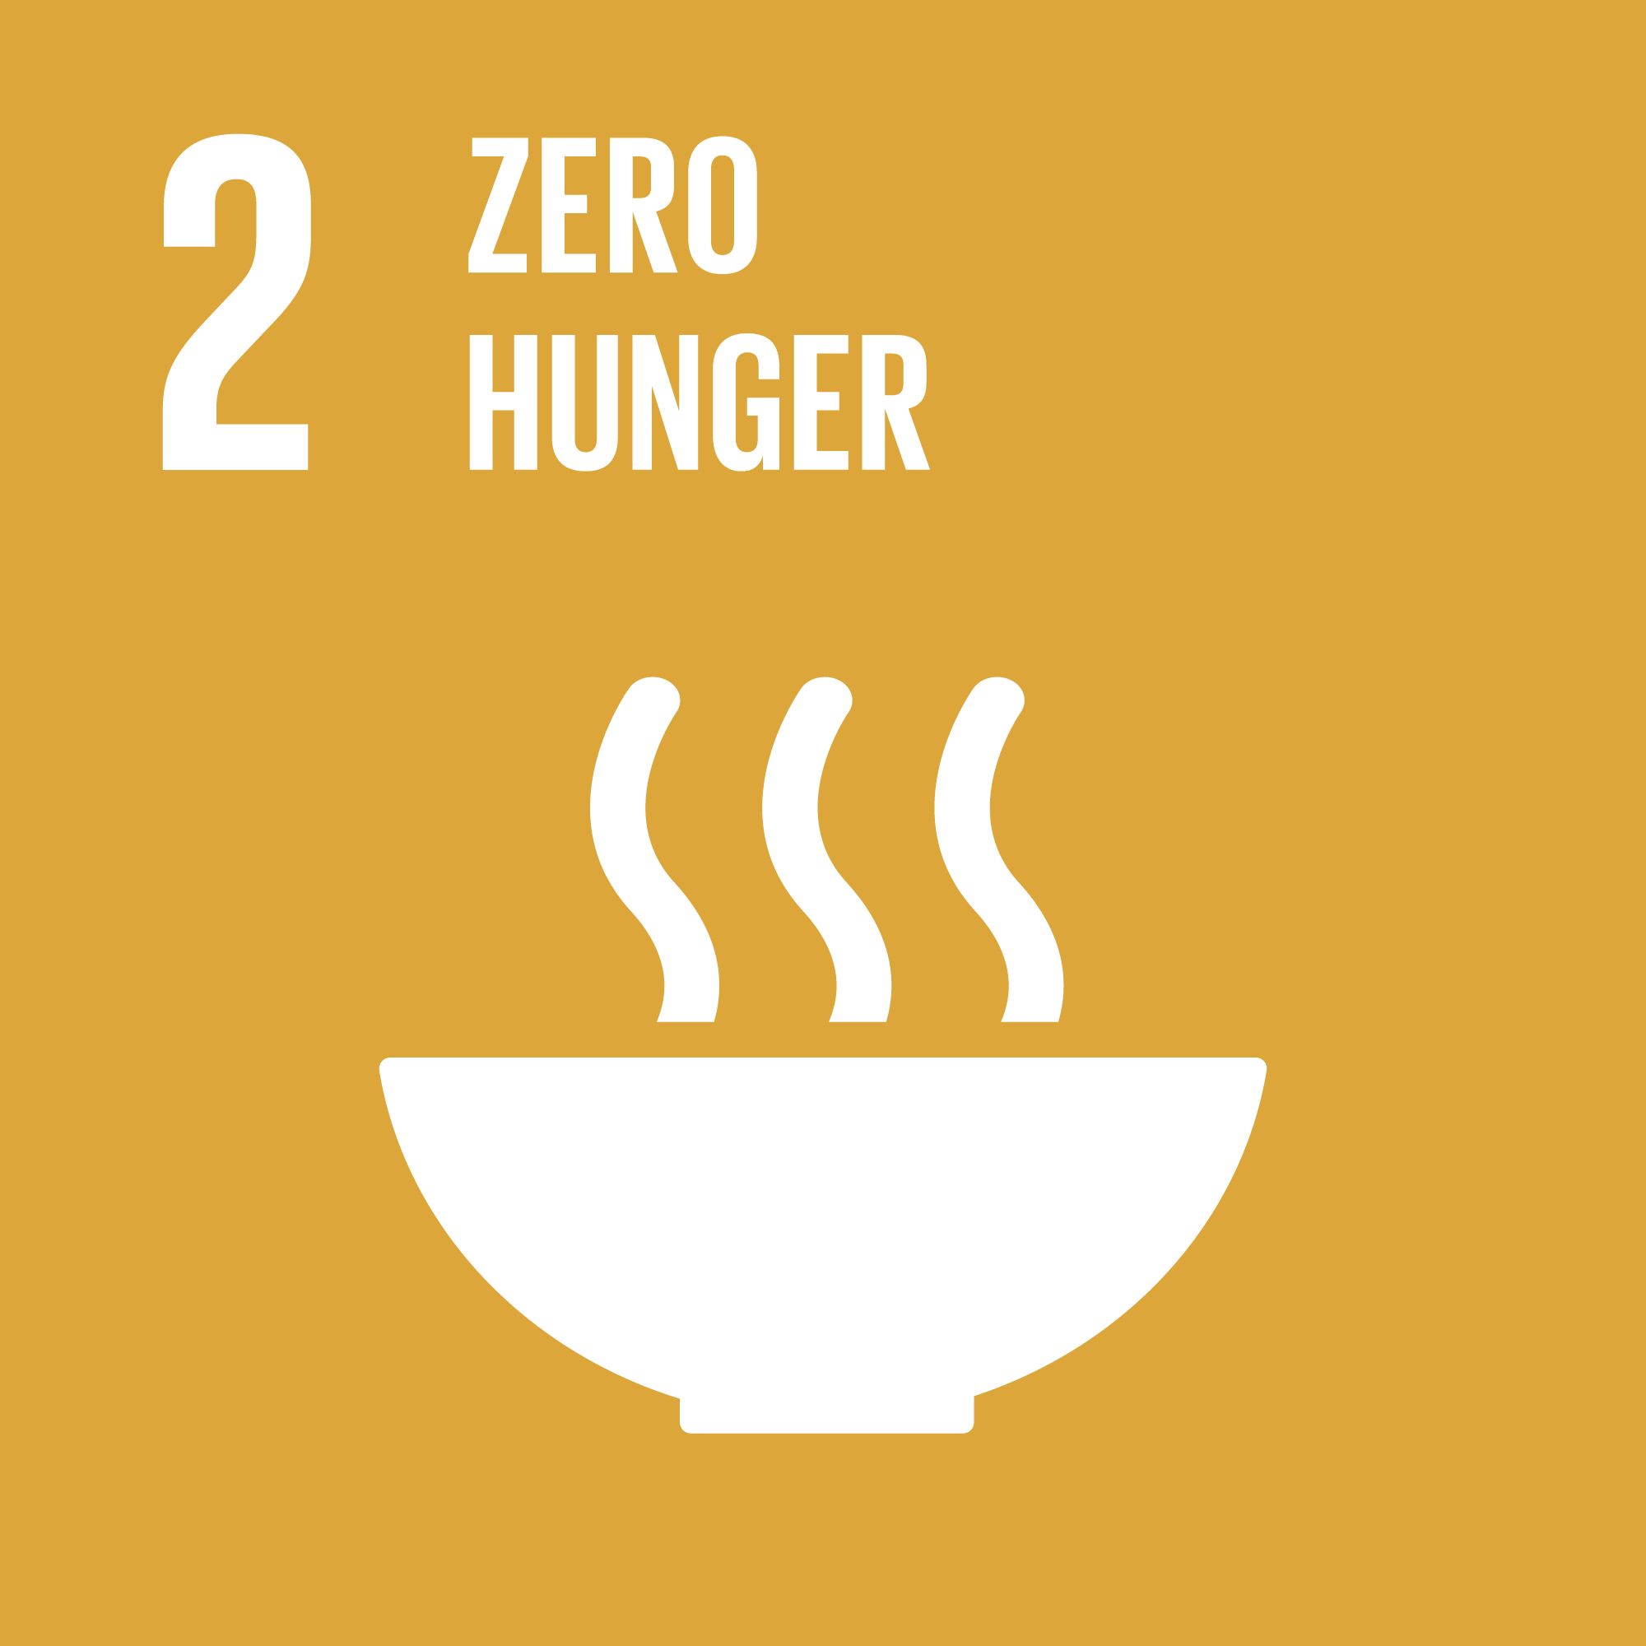
The second Sustainable Development Goal relates to food access, nutrition, and food security. This goal not only focuses on increasing access to food sources, but also on meeting nutritional needs and the health impacts relating to the food that people around the world consume. Important targets for this SDG include ending all forms of malnutrition and ensuring a sustainable food supply for years to come through protecting agricultural ecosystems and protecting genetic diversity of food crops.
At Georgia Tech, there are numerous faculty members engaged in research related to food supply networks and how they can be made more sustainable and efficient, in order to deliver better nutrition. Dr. Marta Hatzell, in her talk “Opportunities for Renewable Driven Food, Energy and Water Systems,” details how her research on electron storage and conversion could be used to generate nutrients for agricultural practices through solar energy. Dr. Yongsheng Chen is working on a project that received a $5 million grant from the USDA. In “Largest Ever USDA Grant to Grow Vegetables with Wastewater Nutrients,” he describes how the practice of using nutrients from wastewater when growing produce could both reduce fertilizer usage and the negative externalities associated with it, while also facilitating the supply of locally grown produce to communities, resulting in higher nutritional value due to greater freshness.

SDG 3: Good Health and Wellbeing
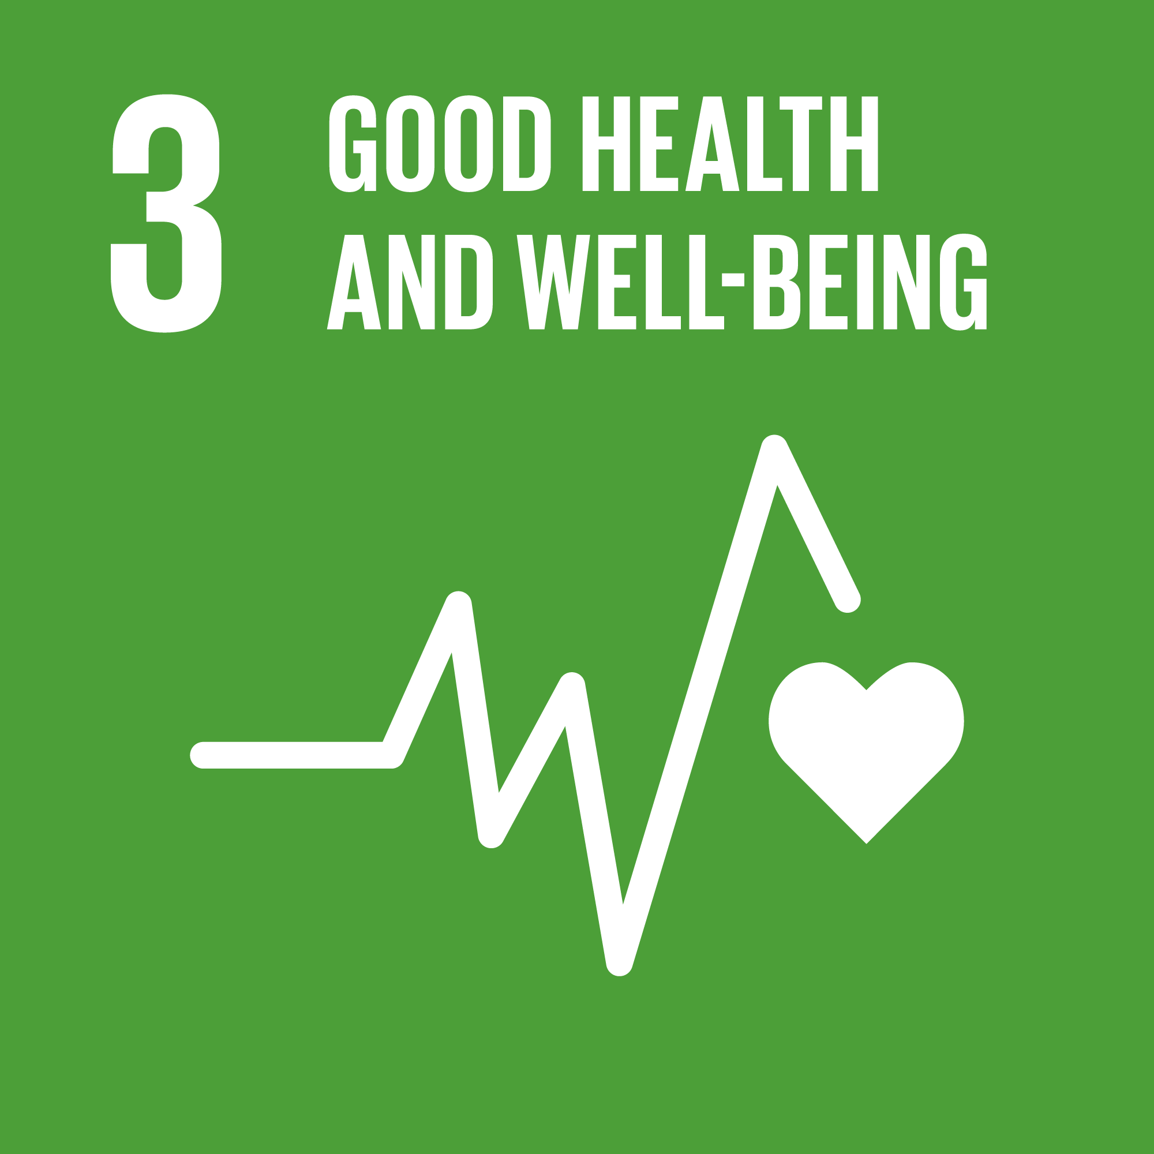
This goal emphasizes health among global populations. This includes both the ability to live a healthy lifestyle and access to reliable healthcare. Some of the targets related to this goal are concerned with reducing maternal mortality, improving childhood health, and ending all preventable deaths among children under 5 years of age. Another target of this goal is achieving universal health coverage, including essential services and vaccines.
Dr. Kari Watkins, a Georgia Tech faculty member, focuses her research on transportation. In her video for the 2019 Sustainability Showcase entitled “How Do We Build a Sustainable Transportation Infrastructure?”, she grounds her critique of our current transportation system in a public health perspective, emphasizing that cars pose the most direct threat to the lives of those under 45 and indirectly threaten older populations through the health risks caused by a sedentary lifestyle. This demonstrates the linkages between health and other aspects of the built environment.

SDG 4: Quality Education
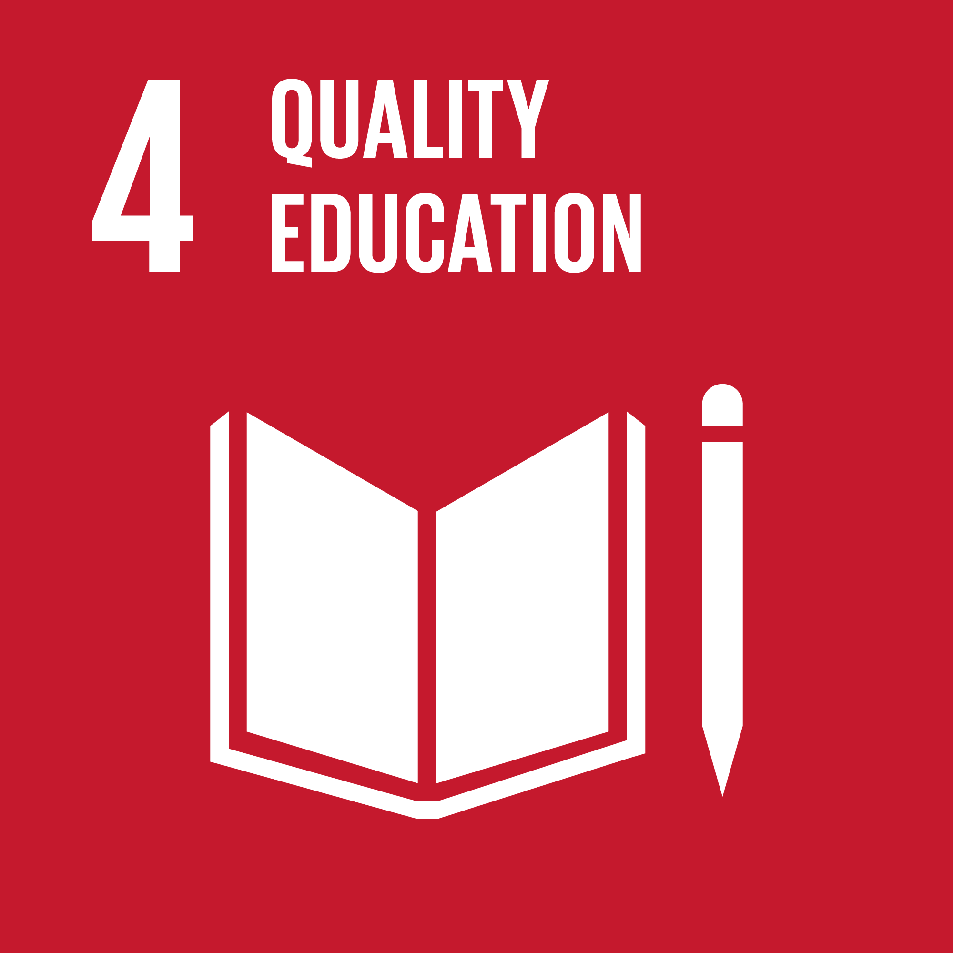
The fourth Sustainable Development Goal relates to education across primary, secondary and tertiary levels, asserting the necessity for people around the world to have access to high quality instruction. Key targets in making progress towards this goal include free primary and secondary education, equitable access to pre-primary education, and access to higher education, including university instruction and vocational and technical school.
While education is obviously one of the cornerstones of Georgia Tech’s existence, there are also research and activities taking place that aim to improve educational opportunities and related outcomes. Dr. Heidi Turcotte, who works with the Center for Education Integrating Science Math and Computing (CEISMC) at Georgia Tech, describes the programs offered by CEISMC in this video. CEISMC’s programs are aimed at building connections between K-12 educators and students and the Georgia Tech community to prepare young students for STEM careers and educate them about sustainability. In the School of Building Construction, Dr. Eunhwa Yang conducts research that looks at how spatial design and characteristics can increase productivity and mental health among college students. Her talk “Creating a Healthy Workplace for College Students” details the benefits that design can have for students.

SDG 5: Gender Equality
Why It Matters
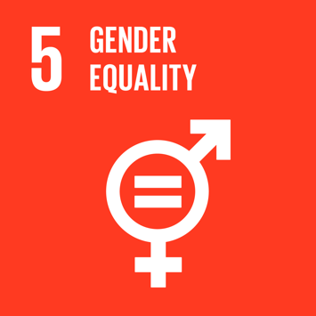
SDG 5 deals with equality among genders and focuses on ending gender-based discrimination globally by 2030. While the key target is an end to this form of discrimination, targets also include specific areas in which discrimination should be eliminated, such as ending violence against women and girls, ending forced marriages and genital mutilation, and ensuring universal access to reproductive health and reproductive rights.
Increased opportunities for girls and women can have far-reaching implications beyond just bettering the lives and outcomes of individuals. In his talk that explains the Georgia Drawdown Project, “Beyond Carbon Considerations in Georgia Drawdown,” Dr. Michael Oxman notes that better education for women and girls is one of the key aspects of the drawdown concept. He specifically highlights that research has shown that women in decision-making positions tend to make more sustainability-oriented decisions, which indicates that more women in key roles would have a positive effect on measures that increase the sustainability of systems and institutions.

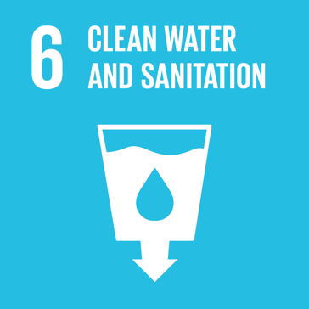
SDG 6: Clean Water and Sanitation
Why It Matters
The sixth Sustainable Development Goal is centered around the provision of potable drinking water and adequate sanitation resources around the globe. Clean water and sanitation are not only a goal in themselves, but also support other SDGs such as SDG 3: Good Health and Wellbeing, since unsafe water supplies and unsanitary conditions lead to disease. Key targets for this SDG include access to clean and affordable drinking water for all by 2030 and improved water resources management to further sustainable and safe sanitation.
Georgia Tech’s Dr. Anjali Thomas details efforts to provide Mumbai residents with safe municipal water in her Sustainability Showcase talk, “Improving Water Access in Mumbai Slums through Citizen Empowerment.” Her research explores the way people in Mumbai slums are currently meeting their need for water – through informal purchasing from private water providers – and analyzes the improvements in water quality and access when residents are given assistance in accessing municipal water through a formal grid.

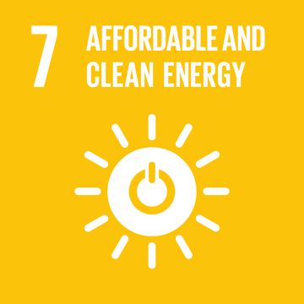
SDG 7: Affordable and Clean Energy
Why It Matters
The UN defines affordable and clean energy in terms of sustainability, framing this goal around the idea that energy sources must come from sources other than fossil fuels. This goal thus focuses on global access to renewable energy, with the primary target being universal access to “affordable, reliable and modern energy services.” Other target areas for this Sustainable Development goal are improvements in the share of renewable energy and increases in energy efficiency.
Georgia Tech’s Dr. Beril Toktay discusses the concept of energy burden in her talk, “Energy Affordability in Atlanta.” She details how the definition of unaffordable energy is spending more than 6% of one’s monthly income on expenses related to energy, and further describes how Atlanta is one of the top cities in the nation for the share of population that is energy burdened. She ties in this discussion to the contemporary plans of Georgia Power to raise their rates and explains how this will further increase the share of energy burdened Atlantans.

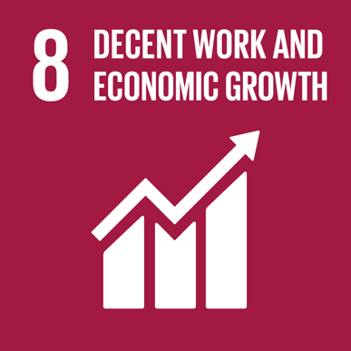
SDG 8: Decent Work and Economic Growth
The eighth Sustainable Development Goal is chiefly concerned with ensuring economic growth takes place in a way that empowers workers worldwide and occurs in a sustainable way rather than one that is exploitative or ecologically destructive. The key target associated with SDG 8 is sustainable economic growth, defined as at least 7% growth in GDP, while other targets are concerned with promoting conditions that lead to full employment, providing equal pay and eliminating pay discrimination, and protecting labor rights.
Several faculty members at Georgia Tech are currently undertaking research that relate to rapidly shifting modes of work and their impact on the economy and on people’s livelihoods. Dr. Manpreet Singh’s talk “Creative Destruction? Assessing the Impact of E-Commerce on Employees at Brick-and-Mortar Retailers” discusses how the rise of e-commerce is associated with a localized decline in retail employment, with ripple effects that include decreases in income, credit scores, and ability to keep up with payments for brick and mortar retail workers who suffer fewer hours or job loss as a result of the shift to e-commerce. Dr. Andras Danis explores “The Economic Impact of Right-to-Work Laws,” determining that right-to-work legislation is associated with a concomitant decrease in wages and negative wage growth but a rise in firm profitability. Dr. Qiuping Yu examines “Workplace Implications of Just-in-Time Scheduling” and finds that just-in-time scheduling makes workers less motivated.

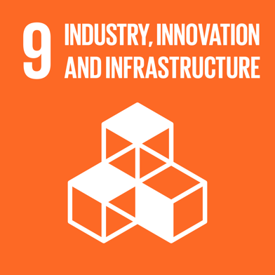
SDG 9: Industry, Innovation and Infrastructure
For the SDG pertaining to industry, innovation, and infrastructure, the UN has set targets that prioritize industrialization in developing nations, increasing innovation (with a measurable metric of increasing the share of research and development workers per 1 million people), and providing better access to information technology worldwide.
At Georgia Tech, Dr. Giovanni Circella’s research focuses on mobility studies and how new mobility services impact people’s travel behavior. His talk “Emerging Tech, New Mobility Services, & their Impacts on Urban Mobility & the Environment,” he discusses three emerging trends in mobility – shared mobility, vehicle automation, and vehicle electrification – and how these innovations play out in terms of their effect on the transportation sector and the built environment.

SDG 10: Reduced Inequalities
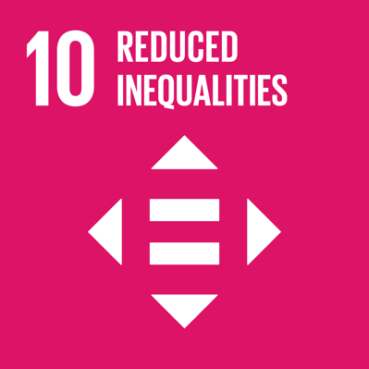
This Sustainable Development Goal focuses in on inequalities both within countries and between countries, acknowledging that an increasing share of the world’s wealth is held by a small share of the global population. The key target associated with this SDG is the growth in income of the bottom 40% of the population by 2030, while other targets relate to ending forms of discrimination which lead to unequal opportunities to earn income, as well as better regulation of financial institutions and policies.
Dr. Sudheer Chava, a Georgia Tech faculty member, addresses the concept of the environmental externalities caused by corporations in his talk “Environmental Externalities and Cost of Capital.” Such externalities include decreased air quality and disruptions related to climate change, which tend to effect vulnerable populations. Dr. Chava suggests that capital markets, along with regulation and taxation, could actually be used to protect these vulnerable populations from environmental externalities if companies that pollute were punished through a higher cost of capital. He points out that sustainable firms carry less risk and that investment in them is therefore incentivized.

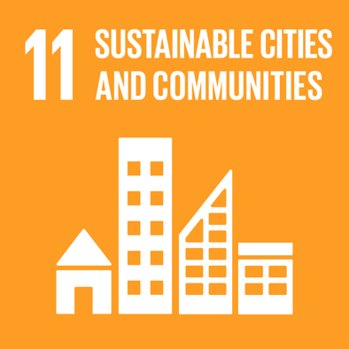
SDG 11: Sustainable Cities and Communities
The eleventh Sustainable Development Goal is entitled Sustainable Cities and Communities. Its purpose is to “make cities and human settlements inclusive, safe, resilient and sustainable.” Targets encompass various aspects related to urban infrastructure, such as affordable and high-quality housing, sustainable transportation systems, disaster resilience, and adequate green space for urban residents. This goal is directly related to the built environment and targets emphasize sustainable transitions in these areas by 2030.
Serve-Learn-Sustain has a teaching tool, Sustainable Communities: SDG 11 [link to tool here], that goes into detail about the targets and metrics included as part of this Sustainable Development Goal and uses the example of three large infrastructure projects to encourage students to evaluate them using the lens of SDG 11. Another related resource is Dr. Ellen Dunham-Jones’ talk, “Retrofitting Suburbia.” Her work is centered around building a database of sustainable retrofits of suburban communities and structures, such as transforming disused shopping centers into sustainable live/work communities. This demonstrates how some of the land uses and building structures of the past can be re-imagined as part of the sustainable cities and communities of the future.

SDG 12: Responsible Production and Consumption
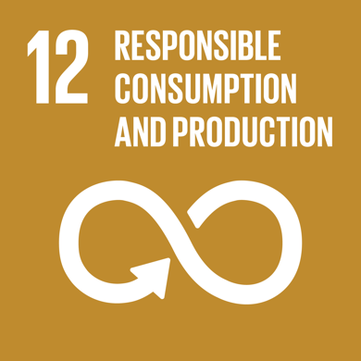
SDG 12: Responsible Consumption and Production is one of the most fundamental goals to be achieved in order to enable progress towards other SDGs that rely on transitions to sustainable systems. Acknowledging that existing systems of production and consumption create waste and harm the environment, the UN has set targets that include implementation of the 10-Year Framework of Programs on Sustainable Consumption and Production. Systems that can be made more sustainable according to this SDG are natural resources management, the food cycle, and chemicals and waste.
One of the projects that Dr. Hongnan “Conan” Cao is working on at Georgia Tech involves using food waste or sustainably grown plant matter, such as switchgrass, as biomass that can be converted into fuel. In this video he describes how bioreactors could be used to convert food waste into electricity using enzymes or microbes. This would take a waste product of one system – food waste – and use it to produce a renewable clean energy source of electric power, thus enabling responsible food production and energy production.

SDG 13: Climate Action
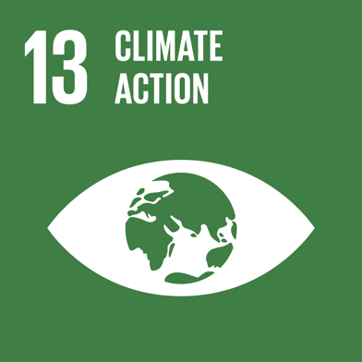
The focus of this Sustainable Development Goal is climate change and the steps that must be taken to increase climate resilience in all countries around the world. Targets include incorporating measures of climate change into planning strategies, building adaptive capacity through planning strategies, and implementing the UN Framework Convention on Climate Change to allocate $100 billion annually to fund mitigation and adaptation efforts in developing nations.
Dr. Kim Cobb, a Georgia Tech faculty member, conducts research relating to the impacts of climate change. Her talk “’Smart’ Solutions for Climate Change Resilience” details her involvement with the Savannah Smart Sea Level Sensors project, which tracks sea level rise over time along the Georgia coast to better anticipate the impact of both storms and sunny day flooding in the area. Her description of the project also reveals the multifaceted nature of planning for climate resilience, as she describes how air quality is a much more pressing concern to vulnerable communities in the region.

SDG 14: Life Below Water
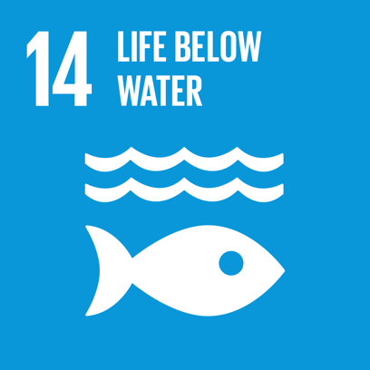
The fourteenth Sustainable Development Goal is centered around the world’s oceans and waterways and is undergirded by the knowledge that clean water and healthy marine and freshwater ecosystems are key to the continuing existence of humanity. One of the main targets is the reduction of marine pollution by 2025, along with other targets that address sustainable and small-scale fishing, efforts to de-acidify the ocean, and ecosystem protection and conservation.
Georgia Tech’s Dr. John Crittenden lays out the ways in which anthropocentric environmental impacts affect freshwater and ocean systems in his talk “Improved Sustainability & Resilience Using Decentralized H2O & Energy Infrastructure.” He notes that humans use 43% of fresh water, and that the generation and use of plastics has resulted in a situation where 100% of fish that are fished from the Atlantic Ocean contain plastic particles. His work involves engineering sustainable systems that will more responsibly use natural resources as they serve the needs of the human population.

SDG 15: Life on Land
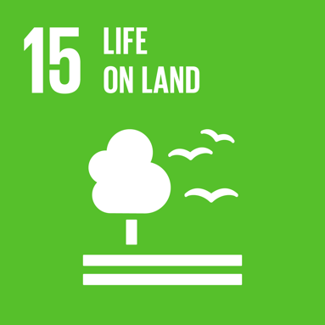
A complement to SDG 14, SDG 15 addresses land-based ecosystems and biodiversity. Targets that concern life on land include ecosystem protection and restoration of degraded land, with a focus on preserving existing natural habitats and encourage reforestation in areas that have seen a reduction in natural habitat. Other targets that relate to preservation of wild species include harsher regulations concerning poaching and greater protections for endangered species.
The Georgia Drawdown Project includes research relating to sustainable agricultural lands as well as reforestation for carbon capture purposes. In his brief talk about the project, Dr. Michael Oxman stresses that any proposed strategy for non-carbon technology implementation must include an analysis of the environmental impact such a technology might have, including its impact on biodiversity and surrounding ecosystems. This shows how life on land can be an important consideration in any sustainability-related undertaking.

SDG 16: Peace, Justice and Strong Institutions
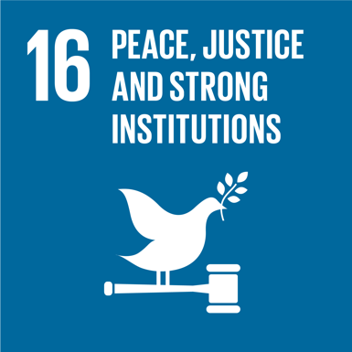
This Sustainable Development Goal is chiefly concerned with strengthening democratic institutions worldwide and their contributions to a more just and peaceful world. Targets focus on the reduction of violence and exploitation, promotion of the rule of law, reductions in corruption and bribery, and the promotion of non-discriminatory laws and policies.
The public sector is one such institution which can have a profound effect on sustainable systems and sustainable cities. PhD student Yunping Liang describes the role of the public sector through the lens of public-private partnerships in his talk, “The Use of Public-Private Partnerships to Facilitate Sustainable & Smart City Development.” He asserts that municipal governments can encourage individuals to invest in electric vehicles by partnering with private entities to build better and more widespread public charging infrastructure. This shows that governmental institutions can play a role in encouraging greater sustainable undertakings in the private sector.

SDG 17: Partnerships for the Goals
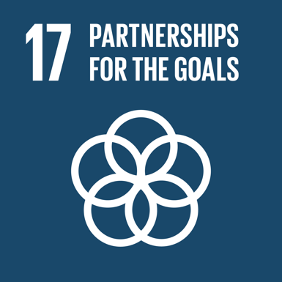
Recognizing that alliances and partnerships are essential to achieve progress towards the other 16 SDGs, the UN’s final goal is related to growing the network of partners who can work towards implementation of the goals. Most of the targets are concerned with ensuring developing countries have the financial means to achieve progress on the SDGs, which the UN envisions being enabled through funding partnerships with wealthier developed nations.
Sebnem Ozkan, David Eady, Alice Favero, and John Taylor each present aspects of how Georgia Tech is partnering with organizations such as RCE Greater Atlanta in order to advance knowledge and implementation of the United Nations Sustainable Development Goals. Their talk “Advancing the UN SDGs & Education for Sustainable Development at Georgia Tech and Across the Greater Atlanta Region” goes into detail on the impact that the goals can have on the Georgia Tech community and on the Atlanta area as a whole.

SLS Student Learning Outcomes

- Identify relationships among ecological, social, and economic systems.
- Demonstrate skills needed to work effectively in different types of communities.
- Evaluate how decisions impact the sustainability of communities.
- Describe how to use their discipline to make communities more sustainable.*
* Note: SLO 4 is intended to be used by upper division, project-based courses such as Capstone.

