Proposals: The Big Picture
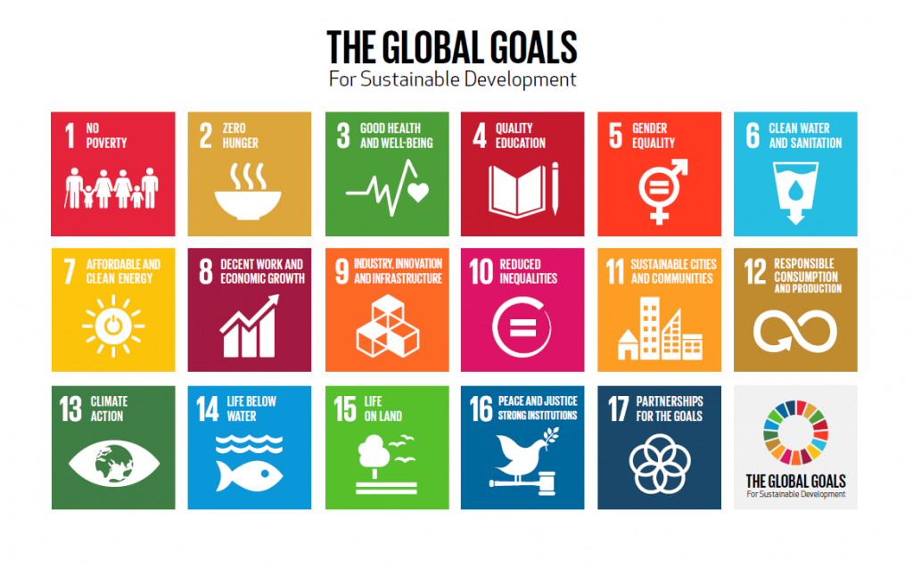
The United Nations has set forth 17 goals for ‘people and planet’ which focus on sustainability.

In total, 5 million people from across 88 countries worldwide took part in designing these goals. These goals are supported by a range of measures, and importantly the transfer of technologies and scientific know-how, to meet these big challenges. Multiple stakeholders exist, as we all stand to benefit, but this requires partnerships between government, the private sector and civil society.

During the course of this semester, you have conducted several lab exercises designed to build your ecology skills, and you have examined two habitats: Proctor Creek (aquatic) and Georgia Tech’s campus (terrestrial). This week in lab is dedicated to sharing ideas from your group on how to best quantify, monitor, and improve the natural ecology of Atlanta, beyond these two specific areas.

Applying what you have learned in Ecology Lab, your task is to devise a project proposal to:

- Identify an ecological (or ecologically-related) problem and its scope (What’s not working?)
- Analyze what is known (What data or tools already exist to help me solve the problem?)
- Target the key partners (Who can help me fix it?) and 2-3 potential funders (Who’s going to pay for the work? Are there ways around needing lots of funds?)
- Devise a plan and timeline (How do I get people to help me do these tasks, and by when?)
- Explain how such a project incorporates and/or achieves at least THREE of the UN goals.
Your proposal should have the following components (see rubric for point breakdown):

- Introduction: Clearly states the question/problem to be addressed (What is our gap in knowledge that this project addresses?); Where specifically you intend to address; Describes what is already known (general background); Describes why/how ecology can be used to achieve UN goals

- Plan of Attack: Describes the methods/procedures planned to solve the ecological problem (including statistical or other data analysis procedures), using pictures and diagrams to clarify the approach where appropriate; Identifies tools or data to build on; Identifies potential partners in the government, private sector, or civil society (including Georgia Tech) who could be approached to collaborate to address this problem; Identifies potential funders and/or cost-cutting measures of existing techniques that would allow for the project to take place.

- Timeline: Provides a reasonable timeline of what work needs to be done, by whom, and by what target dates. Note on the timeline your sampling schedule, GT semester calendar dates, large community events related to your project, or other dates as appropriate.

- Anticipated Results: Summarizes predicted results/outcomes; Graphs and tables of predicted results are used and labeled appropriately.

- Significance of Proposed Work: Explains how such a project incorporates and/or achieves at least THREE of the UN goals; Provides a biological explanation for the importance of collecting the data and carrying out the project; Includes suggestions of future directions for this research question/project that future Ecology Lab students might investigate/work on.
Tips for your proposal:

- Do not simply repeat or slightly tweak our lab activities. Build on what you have learned to contribute more and find new connections, data sources, and partners across Atlanta.
- Citations are great support. You should include citations where appropriate for text and pictures, and don’t forget to include properly-formatted citations on an additional page.
- Use the rubric to help you decide how to structure your presentation and what to include.
- Be mindful of the length limit; you may need several drafts to concisely fit all of your ideas into just 2 pages (+ any additional pages for citations)
These are lofty goals. We want you to think big!

Proposal Rubric

Introduction
Clearly states question/problem and knowledge gap | /1
Describes background info, including specific locations | /2
Identifies importance of work  Clearly states the question/problem to be addressed; Describes what is already known (general background); Describes why/how ecology can be used to achieve UN goals | /1
Describes why/how ecology can be used to achieve the specific 3+ UN goals | /2
Plan of Attack
Describes procedure (Using pictures/diagrams as appropriate) | /2
Identifies tools or data to build on | /2
Identifies potential funders and/or cost-cutting measures within a detailed budget | /1
Identifies potential partners | /1
Timeline
Provides a reasonable timeline (including dates, tasks, and task-doers) | /2
Anticipated Results/Significance
Summarizes predicted results/outcomes | /2
Explains how the finished project will have impacted at least THREE of the UN goals | /2
Provides a biological explanation for project importance | /2
Suggests future directions | /1
Formatting and Style 9
12 pt Times New Roman Font, single-spaced | /1
2 pages long (not including pages for references) | /3
Citations are included and appropriately formatted (Min. 5 citations) | /5
GRAND TOTAL: | /30

