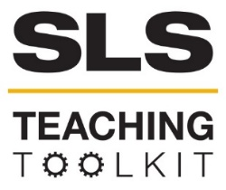 | SLS Case Study: Maker Culture and Sustainable Transportation (GT Mechanical Engineering)
Discipline: Mechanical Engineering | Type: Reading; Discussion; Take-home assignment, project; In-class exercise | Time Commitment: 30-60 mins | Category: Case Studies on Sustainable Communities; Sustainability in Atlanta
Big Ideas: Prototyping; Problem-Based Learning; Doing Good in Your Neighborhood
OVERVIEW:
While recycling is a time-honored tradition of the environmentally-conscious, an equally powerful way to build sustainable communities is by learning to reuse and repair damaged materials. Maker culture, a version of DIY culture that delights in creation and repair, offers a model for sustainability. In this case study, follow the adventures of GT student Buzz as he sets out to repair his bike using two Georgia Tech Maker Spaces: The Starter Bikes bike repair cooperative, and the Invention Studio. By learning how to restore his bike, Buzz empowers himself to live a sustainable life in another important way: as a bike commuter. Read on to consider the intersections of maker culture and sustainable transportation.
This tool was contributed by Arkadeep Kumar, Bob Myers, and Bethany Jacobs.
INSTRUCTIONS:
- Use this case study in the way that works best for your class: assign it as a take-home reading, or as an in-class reading.
- Either as a take-home assignment or in-class discussion, answer the Discussion Questions, or craft your own.
SLS STUDENT LEARNING OUTCOMES & ASSESSMENT:
The Serve-Learn-Sustain toolkit teaching tools are designed to help students achieve not only SLS student learning outcomes (SLOs) but the unique learning outcomes for your own courses. Reflections, concept maps, rubrics, and other assessment methods are shown to improve student learning. For resources on how to assess your students’ work, please review our Assessment Tools.
This tool achieves SLOs 1 & 3. See the end of this tool for further details.

Want Help?
Jennifer Hirsch is the contact for this tool. You can reach her at jennifer.hirsch@gatech.edu

Maker Culture and Sustainable Transportation

Buzz’s bike
Buzz is having a bad day. He just wrecked his bike, and while he’s okay it looks like one of the gears is broken. He can’t use the bike in this condition, but leaving it broken isn’t an option. This isn’t just any bike. It’s a 1949 Schwinn B6 originally owned by the legendary Bobby Dodd and given to Buzz by his family. It’s irreplaceable.
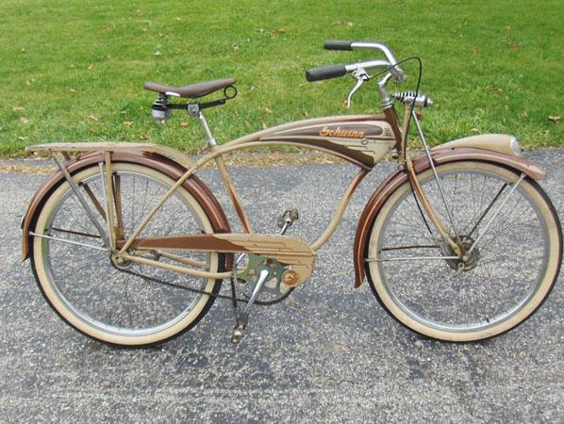Even worse, without the bike, he’ll have to walk to classes and other events on campus. Normally this wouldn’t be a big deal, but this semester he has back-to-back classes on opposite ends of the campus. That’s a 20-minute walk with only 15 minutes between classes.
Buzz’s Bike, a 1949 Schwinn B6
The good news is, Spring Break is next week. Buzz has a week to assess the damage and get his bike fixed. He’ll need some help to do it, but where can he start? Will the Georgia Tech campus offer any solutions?

Biking at Georgia Tech
The fact is, lots of students share Buzz’s dependence on bicycle transportation. Georgia Tech is an urban campus at the heart of midtown in the city of Atlanta, Georgia. The campus extends over 400 acres and walking from one end to the other can take 25 minutes. As a result, many students typically travel within and around campus on bicycles.
GT has taken many steps to encourage bike use. This includes creating bike lanes, providing lessons on bike safety (courtesy of the GT police department), and organizing Bike Week, with giveaways, scavenger hunts, and free repair stations. In addition, there are several campus-wide initiatives that promote bike use:
- Buzz Bikes, a bike share program that allows students to rent a bike from GT at around $50 per semester. GT handles all bike maintenance.
- Relay Bikes, another bike share program implemented by the City of Atlanta, with six locations across campus. Students can reserve bikes through a smartphone app. It uses RFID on chip cards, which help users lock the bikes to the relay bikes rack.
- The Bicycle Infrastructure Improvement Committee (BIIC), whose student, staff and faculty members are tasked with improving bicycle infrastructure on campus through the evaluation of existing facilities, the creation of events and programs, securing funding for facility improvements, and other related endeavors.
- Serve-Learn-Sustain (SLS), a campus-wide initiative which promotes sustainability in many forms, be it smart cities, energy efficiency, water usage, and sustainable transportation—including bicycling!
In fact, it’s while walking through the Clough commons that Buzz notices an SLS event on sustainable transportation. Stopping to hear what it’s all about, he finds a flyer advertising an organization called Starter Bikes, which teaches students how to repair their own bikes. To Buzz’s delight, the group is meeting the following afternoon, so he decides to visit the repair location after classes.
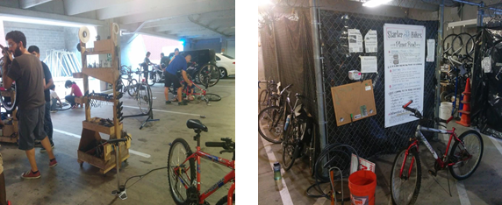
(Starter Bikes workshop, image by Arkadeep Kumar)

Bike Repair at GT
The bike shop Starter Bikes, a major initiative of Bikes@GT, formed as a result of enthusiastic bicycle users who identified the need for a repair shop on campus. Starter Bikes refers to itself as a bike cooperative. Volunteers fully run the shop, offering instruction on how to fix bikes and, in some cases, providing bike parts. The volunteers also help refurbish abandoned and donated bicycles for those in need.
Starter Bikes is a reliable and sustainable option for students on a tight budget. They can access tools for free, and benefit from the expertise of volunteers, who are openly enthusiastic about helping more people use bikes for transportations. Though Starter Bikes’ hours are 4-6pm on Fridays, these volunteers often stay open until 7 or 8 pm so that people can finish up repair work; other times, they’ll provide safe storage for the bike so the owner can finish the repairs at a later date.
When Starter Bikes refurbishes and sells bikes (usually at a price under $100) they use the proceeds to buy tools and other supplies. The sale of helmets and safety lights also helps to supplement the costs of keeping Starter Bikes up and running
Buzz Goes to Starter Bikes

How do abandoned bikes end up at Starter Bikes?
Volunteers identify ‘unused’ bikes by checking the location and signs of use frequently. After about one semester, they tag the bikes, notifying the owner (with GT police’s approval) that the bikes will be removed. After 1 month, GT police break/cut the lock, and take the bike to Starter Bikes storage. Thus, a new supply of abandoned bikes comes in on a rolling basis, with the highest volume comes one month after the start of the new semester. Starter Bikes fixes them up, and sells them on to new users, thus extending the life of the bike.

When Buzz rolls into Starter Bike, a crowd immediately gathers around him. All the volunteers know about Buzz and his Bobby Dodd bike, a special piece of Georgia Tech memorabilia. Buzz quickly shows them how a broken part on the handle makes it difficult for him to shift gears. When one team member, Mike, takes a closer look, he discovers that a small gear inside the gear shifter controls has lost teeth. However, when Mike looks the part up online, he quickly discovers that the age of the bike means that spare parts are impossible to find. Yet without this part, it will be very difficult for Buzz to use the bike. He’s about to give up when Lisa, a Starter Bike volunteer, mentions a recent course she took. In this course, Lisa used a makerspace called the Invention Studio. Is it possible that Buzz could use this space to “make” the part he needs? Time to find out!

Invention Studio makerspace
The Invention Studio is a student-run makerspace where volunteers, also known as Prototyping Instructors (PIs), train students on how to use maker tools like 3D printers, woodworking tools, and laser cutters. Founded by students with a love for using their hands and do-it-yourself culture, the Invention Studio is a welcoming space for everyone. Students can use the space for work, for research, or simply as a creative outlet. Over the years they have added rooms and more capabilities.
Located in the MRDC (Manufacturing Related Disciplines Complex-I) Level I, the Invention Studio spans multiple rooms, each categorized on the basis of work type (woodwork, metalwork, and electronics) or machine type. Recognizable by their fluorescent yellow armbands, the PIs are always on hand to help students get the job done, whether that means teaching them how to use a machine or tool, making recommendations, troubleshooting in the event a job fails or ensuring safety. In exchange for volunteering three hours a week, PIs gain after hours, unlimited access to the Invention studio.
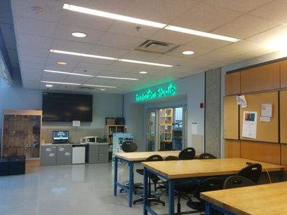In the Invention Studio, Buzz quickly finds a helpful PI named Aman who listens carefully to Buzz’s problem and desire to create a replacement gear for his bike. Aman asks if he has any experience in making things. When Buzz admits he doesn’t, Aman advises him on how to design the gear on a solid modeling software like SolidWorks. He also remembers that they can use a 3D scanner to scan the damaged part.
MRDC Invention Studio (photo courtesy Arkadeep Kumar)

In the 3D printing room, they scan Buzz’s gear and then isolate the damaged edges. After cleaning up the design file, they consider their options:
- Make a 3D printing, using metal or plastic.
- Recreate the 2D gear with laser cutting, using wood or plastic
- Recreate the 2D gear with water jet machining, using metal.
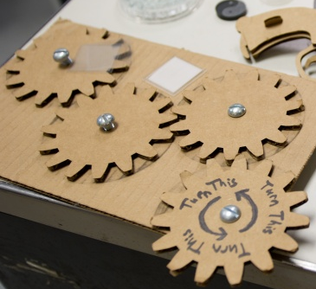Buzz now has to learn how to select an appropriate material, based on what the part does. He and Aman quickly realize they can’t use wood because this gear is a load-bearing part, so they decide to try plastic instead. Aman explains that they can either use a laser cutter or a 3D printer. For better mechanical strength they agree on the laser cutter.
A cardboard prototype, Invention Studio
First, Buzz will need to create a cardboard prototype. Next, he’ll laser cut the gear in a plastic acrylic material. Aman tells Buzz that if he wants, he can then go into the machining mall and mill out the gear in metal. Buzz decides to try the plastic first. He works hard over the next few days to create his part, taking help from Aman and other PIs.

Success!
The following Friday, Buzz returns to Starter Bikes with his brand-new gear. And it works! Buzz happily relays to the volunteers his experience working with Aman, not to mention his gratitude to Starter Bikes for helping him identify and repair the problem with his beloved bike.
So, with the help of the Starter Bikes bike repair, and the Invention Studio makerspace, Buzz has saved his bicycle. Rather than scrapping his bike and buying a new one, he was able to take a sustainable route to getting back on his bike, as well as contribute to the community of bike enthusiasts at Georgia Tech.

Discussion Questions
- Starter Bikes offers a road to sustainable transportation for GT students. How could activists at the community level implement this model? What challenges would they face?
- The Invention Studio proved to be very useful in replicating a hard to find part and in conjunction with Starter Bikes a complete repair of Buzz’s vintage bike. What might be some other examples where the Invention Studio could be leveraged to repair or refurbish an item?
- How can Georgia Tech encourage students to make use of the Invention Studio and Starter Bikes? What benefits would this have for Georgia Tech?
- Thinking bigger, how could this combination of the Invention Studio and Starter Bikes move beyond just the GT campus? How could it look in a community in downtown Atlanta or along the Silver Comet Trail?

SLS Student Learning Outcomes

- Identify relationships among ecological, social, and economic systems.
- Demonstrate skills needed to work effectively in different types of communities.
- Evaluate how decisions impact the sustainability of communities.
- Describe how to use their discipline to make communities more sustainable.*
* Note: SLO 4 is intended to be used by upper division, project-based courses such as Capstone.

