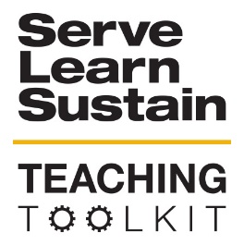 | Parkway Community ABCD Exercise:  Exploring the Implications of Asset-based Community Development
OVERVIEW:
The Parkway Community ABCD Exercise invites students to engage in an exercise to explore what it means to take an asset-based approach to community development (“an ABCD” approach), versus a “needs” or “deficit” approach. Students are broken into groups and given a description of the Parkway Community. One group is given a list of assets while another group is given a list of needs. Students come up with recommendations for a nonprofit to engage with the community and then compare and contrast the recommendations. The exercise concludes with an explanation of ABCD principles.
INSTRUCTIONS:
- Familiarize yourself with the Asset-Based Community Development PowerPoint (include link).
- Read or ask students to read the “Session Opening” (3 mins).
- Break students into teams of 5-7 people. Split the groups 50/50 into “Group A” and “Group B.” Optional: provide groups with a piece of poster paper and writing device.
- Distribute a Situation Analysis to each student. Teams in Group A receive Situation Analysis – A. Teams in Group B receive Situation Analysis – B.
- Activity - Teams review situation analyses and come up with a list of recommendations for a nonprofit looking to work in the community (20 minutes).
- Report Back – Each group reports 2 recommendations to the entire class. All Group A teams report back until no new ideas are offered. Ideas should not be repeated. (8 minutes). As teams report back, write recommendations so they are accessible as a list to the whole class.
- Repeat for Group B (8 minutes).
- Present the ABCD PowerPoint and facilitate a discussion about its applicability to the Parkway exercise (20 minutes).
SLS LEARNING OUTCOMES:
- Students will be able to analyze how decisions impact the sustainability of communities
- Students will be able to describe how they can use their discipline to make communities more sustainable
- Students will be able to develop approaches to sustainability challenges in communities
TOOL CATEGORY
- Community Engagement, Introduction to SLS & Creating Sustainable Communities
TOOL TYPE
- Discussion
- In-class exercise
AUDIENCE:
- N/A
DISCIPLINE
- N/A
BIG IDEAS
- Asset-based Community Development
KEY WORDS
- Asset-based Community Development, Community Development
MATERIALS
- Optional: Poster board paper and writing tool
TIME COMMITMENT
- 60 min

