Resources for Incorporating SDG-related Instruction into Courses

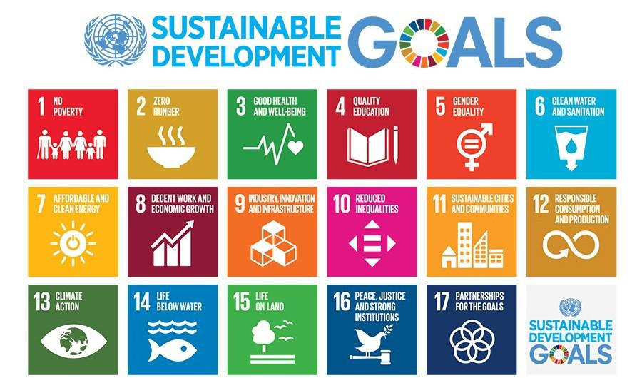

Examples of activities and extension ideas:
Several of the resources shared in Resources on Teaching with the SDGs provide examples of activities related to specific SDGs. For example, this UNESCO resource provides ideas for “learning approaches and methods” with respect to each SDG. To give you a sense of some of the suggested activities, here are a few of the ideas provided for SDG 6: Clean Water and Sanitation:
- Calculate one’s own water footprint (WF)
- Develop a local plan for sustainable water use and supply based on success stories (see case study section, below)
- Explore sites of local water infrastructure
- Plan and develop an online action project related to water quality and/or collaborate with a local organization to test water samples
- Identify “invisible water”, e.g. how much water is required to make a bottle of beer, a pound of beef, a t-shirt, etc.
Sustainable Foundations: A Guide to Teaching the SDGs also provides links to suggested activities and case studies for each SDG.
The Take Action for the SDGs web site has further information organized by SDG. Click on the SDG of interest and you will find infographics, COVID-19 connections, videos, facts and figures, relevant news articles, and more.
Case Studies
Using case studies in SDG education can help bring the complex, global challenges described in the SDGs “down to earth” for students. Case studies also provide a great way to link local and global initiatives and help students identify connections across regions. Case studies also can support student understanding of local, regional, and international forms of organization and governance that are critical to meeting SDG targets.
There are several helpful online sources for global case studies linked to one or more SDGs. Browse through these resources to identify cases linked to the learning objectives you have developed for your course:
The Sustainable Development Goals Fund: Case Studies – Achieving SDGs
Sustainable Development Goals: Case Studies
UNECE Case Studies aligned with standards for meeting SDG targets (may be most useful for business, economics, and policy courses)
In addition, the SLS Teaching Toolkit includes this case study-based tool that makes a direct connection to SDG 11:
Sustainable Cities and Communities: SDG 11

These additional SLS Teaching Tools do not specifically discuss the SDGs but provide case studies that could be easily connected to an SDG:
SLS Case Study: Edwards Aquifer (SDGs 6, 14, and 15)
SLS Case Study: Proctor Creek (SDGs 6 and 10)
SLS Case Study: The 1995 Chicago Heat Wave (SDGs 10, 11, and 13)
ReGenesis Case Study: Chemical Safety and Ethics (SDGs 3 and 12)
SLS Case Study: The Flint Water Crisis (SDGs 3, 6 and 11)
SLS Case Study: The Atlanta Beltline (SDGs 10 and 11)
Beyond the Haircut: A University Barbershop Case Study (SDGs 1 and 11)
SLS Resources: Multidisciplinary Case Studies (most SDGs)
Incorporating Service-Learning and Community Engagement (SLCE)
Experiential learning and, specifically, service-learning, can extend classroom discussions to the “real world,” expanding opportunities for socio-emotional and behavioral learning related to the SDGs. In addition, as the 2020 National Academies of Science report Strengthening Sustainability Programs and Curricula at the Undergraduate and Graduate Levels notes, service-learning also can deepen student understanding of complex challenges such as climate action. SLS can help you identify appropriate community-based partners for course-based collaboration and design service-learning opportunities for your students. In addition, the SLS toolkit and SLS staff support student preparation for effective community partnerships. Contact Ruthie Yow or Rebecca Watts Hull, Service Learning and Partnership Specialists, to talk through “SLCE” opportunities.
Related SLS Teaching Tools:
Community Engagement and Reflection Tool
Exploring Asset-Based Community Development: The Parkway Community

