Assessing Student Progress through Reflection or Storytelling

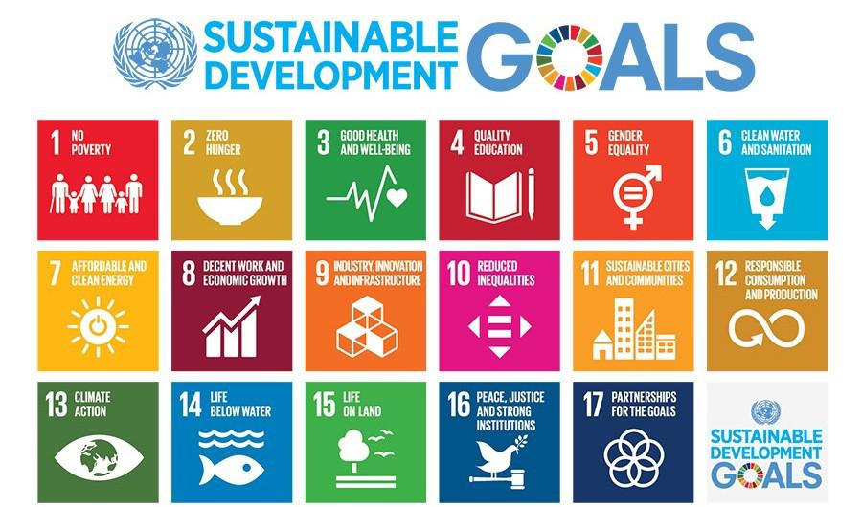

- List a learning objective and/or component skill for which you would like to assess student learning.

- Consider what type of assessment will enable students to demonstrate they have met that objective or developed that component skill. If reflection, consider how your prompts might evolve during the semester. For example, the first reflection might ask students to relate new information or experiences to past courses, other experiences, or perceptions they held before their introduction to the SDGs. Subsequent prompts would require more analysis and synthesis. You may also find it helpful to see if you can incorporate socio-emotional as well as factual elements in your prompts.

Early prompt:

Mid-semester prompt:

End-of-semester prompt:

