Framework for Planning SDG(s) Course Integration

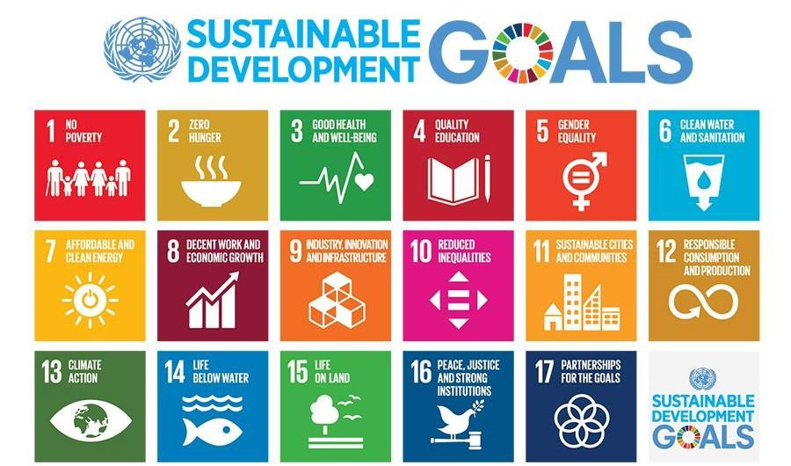

- After browsing through the SDG descriptions, targets, and suggested learning objectives in Sustainable Foundations: A Guide for Teaching the Sustainable Development Goals and/or Education for Sustainable Development Goals: Learning Objectives, which SDGs seem like the most obvious candidates for your course?

- Consider some of the key elements of Education for Sustainable Development and Sustainability Competencies. Use the following questions to prioritize the elements that best align with your course.

What opportunities do the SDGs provide to incorporate transdisciplinary learning in your course?

What are some ways that you might use the SDGs to empower students as change agents, now and in their future careers (contribute to societal transformation)?

What kinds of case studies aligned with your course might help students understand complex global problems and also help them develop the skills to evaluate and imagine potential solutions?

- Which of the SDGs have associated learning objectives that overlap with the learning objectives for your course? List them below.

- For some courses, such as mathematics, data analysis, and econometrics, you may be able to incorporate just about any of the SDGs. If that is the case, consider the pros and cons of allowing students, or student teams, to explore data relating to an SDG of their choosing, versus selecting a single SDG as the focus of your investigations throughout the course.

Pros and cons of student choice:

Pros and cons of single SDG focus:

- Of the SDGs listed in #1 and #3, above, consider how they align with your interests, expertise, and available resources.

I am most interested in learning more about these SDGs:

I feel I have the most resources and expertise in relation to these SDGs:

- Given all these considerations, I think I will incorporate the following SDG(s) in my course:

- [optional] I also want to be sure that students understand _________________ about the SDGs as a global framework of social change and are able to evaluate/analyze/design/apply/imagine _______________________________.

