 | An Introduction to Green Infrastructure
Discipline: All | Type: Reading Assignment; Take-home assignment; Lecture; In-Class Activity; Discussion | Time Commitment:  1-2 hrs | Category: Green Infrastructure; Equity, Justice & Sustainability
Big Ideas: Sustainable Urban Development, Infrastructure: Physical, Technological, Social,;Participatory Processes and Collaborative Governance, Voice & Agency; Systems Thinking; Inequality, Poverty and Sustainable Development
OVERVIEW:
Green infrastructure refers to an interconnected, multifunctional network of greenspace and natural areas that shapes and is shaped by environmental, economic, social, and health outcomes in communities. It may refer to a wide array of natural features, engineered structures, or managed interconnected networks of green space and their associated ecosystem services, including parks, stormwater management features, greenways and trails, green streets, and watershed restoration projects, among other types of green spaces.
Use this tool to explore green infrastructure and its relationship with environment and health qualities, housing, economic development, and the social fabric of our communities. Students will learn how all of these aspects of green infrastructure interact to shape community empowerment, quality of life, and wellness. The discussion questions will aid students in breaking down the multiple impacts of green infrastructure, the importance of community engagement and leadership in green infrastructure planning processes, and the role of local policies and programs in shaping how green infrastructure impacts communities.
This tool was contributed by Jessica Fisch.
INSTRUCTIONS:
This tool has three parts. The first is a reading assignment, followed by a slide lecture, and an in-class discussion. See below for detailed instructions.
SLS STUDENT LEARNING OUTCOMES & ASSESSMENT:
The Serve-Learn-Sustain toolkit teaching tools are designed to help students achieve not only SLS student learning outcomes (SLOs), but the unique learning outcomes for your own courses. Reflection, concept maps, rubrics, and other assessment methods are shown to improve student learning. For resources on how to assess your students’ work, please review our Assessment Tools.
This tool achieves SLOs 1 and 3. See the end of this tool for further details.

Want Help?
Serve-Learn-Sustain is the contact for this tool. You can reach us at serve-learn-sustain@gatech.edu

Worksheet 1: Green Infrastructure Key Concepts
In the coming weeks, consider how the issues we’re discussing connect to you. You are many things: a citizen, a human being, and a future professional in your discipline. In all of those capacities, you have a responsibility to think about the impacts of your choices on society, culture, the economy, and the environment. Let the key concepts below guide your thinking and learning as we move forward.
#1 | Green infrastructure and its spatial distribution in communities has environmental, economic, and social impacts. These impacts drive government agencies, nonprofits, community groups, and others to invest in green infrastructure. | Green infrastructure is an interconnected, multifunctional network of greenspace and natural areas that shapes communities’ environmental, economic, social, and health qualities. Local governments, nonprofit organizations, neighborhood groups, and other actors may invest in green infrastructure to respond to environmental quality/ justice concerns (e.g., climate change adaptation, stormwater management), to promote local economic development (e.g., attracting workers and businesses, creating jobs and workforce development opportunities), and to address social goals (e.g., access to parks, nature, and recreation opportunities, cultural and educational opportunities). The distribution of green infrastructure projects throughout communities shapes environmental, economic, and social outcomes. For example, wealthy neighborhoods may have more resources to invest in green infrastructure, and may thus be more likely to receive its environmental, economic, and social benefits.
#2 | By improving environment and health qualities, green infrastructure may drive gentrification and displacement in vulnerable communities. | With regard to social and economic impacts, gentrification and displacement are often of particular concerns with the development of green infrastructure amenities, particularly in low-income communities of color. Displacement may include:  - Direct displacement of residents due to increases in housing costs;  - Indirect displacement, in which low-income residents cannot afford to move into the area;  - Cultural displacement, or the loss of community culture and institutions due to population shifts within a neighborhood, and  - Political displacement, in which residents may feel that they have the ability to participate in and shape neighborhood change.
#3 | Green infrastructure can support the development of community social capital, which in turn shapes how projects impact communities. | In addition to shaping environmental and economic outcomes, green infrastructure can also support the community engagement and leadership as stakeholders come together to promote the benefits of green infrastructure while reducing threats of gentrification and displacement.  Engaged communities can in turn shape green infrastructure projects and planning processes, as well as how green infrastructure impacts their communities. For example, residents can shape the design of green infrastructure projects, the amenities included, and how projects plan for and address concerns such as job creation for neighborhood residents, workforce development, and housing affordability.
#4 | Meaningful community participation in planning for green infrastructure is vital to ensuring projects benefit and empower communities. | Projects that engage communities in-depth and that have residents in leadership roles are more likely to make decisions that empower and benefit neighborhood residents. For example, an advisory board comprised of neighborhood residents would have knowledge of community assets, needs, and priorities that a board comprised of elected officials and government agency staff would not. Projects with strong community engagement and ownership components are more likely to incorporate residents’ concerns into green infrastructure projects and planning processes. In this way, meaningful community participation and ownership can shape projects in ways that support community wellbeing and quality of life.
#5 | The broader political context in which green infrastructure is implemented in communities shapes the outcomes of green infrastructure projects. | Political context shapes the ability of local governments, nonprofit organizations, community groups, and other actors to shape the impacts of green infrastructure projects. For example, cities with strong affordable housing policies, programs, and funding in place are more easily able to address gentrification and displacement concerns associated with green infrastructure than cities that don’t have these strategies in place.

Worksheet 2: Green Infrastructure Model
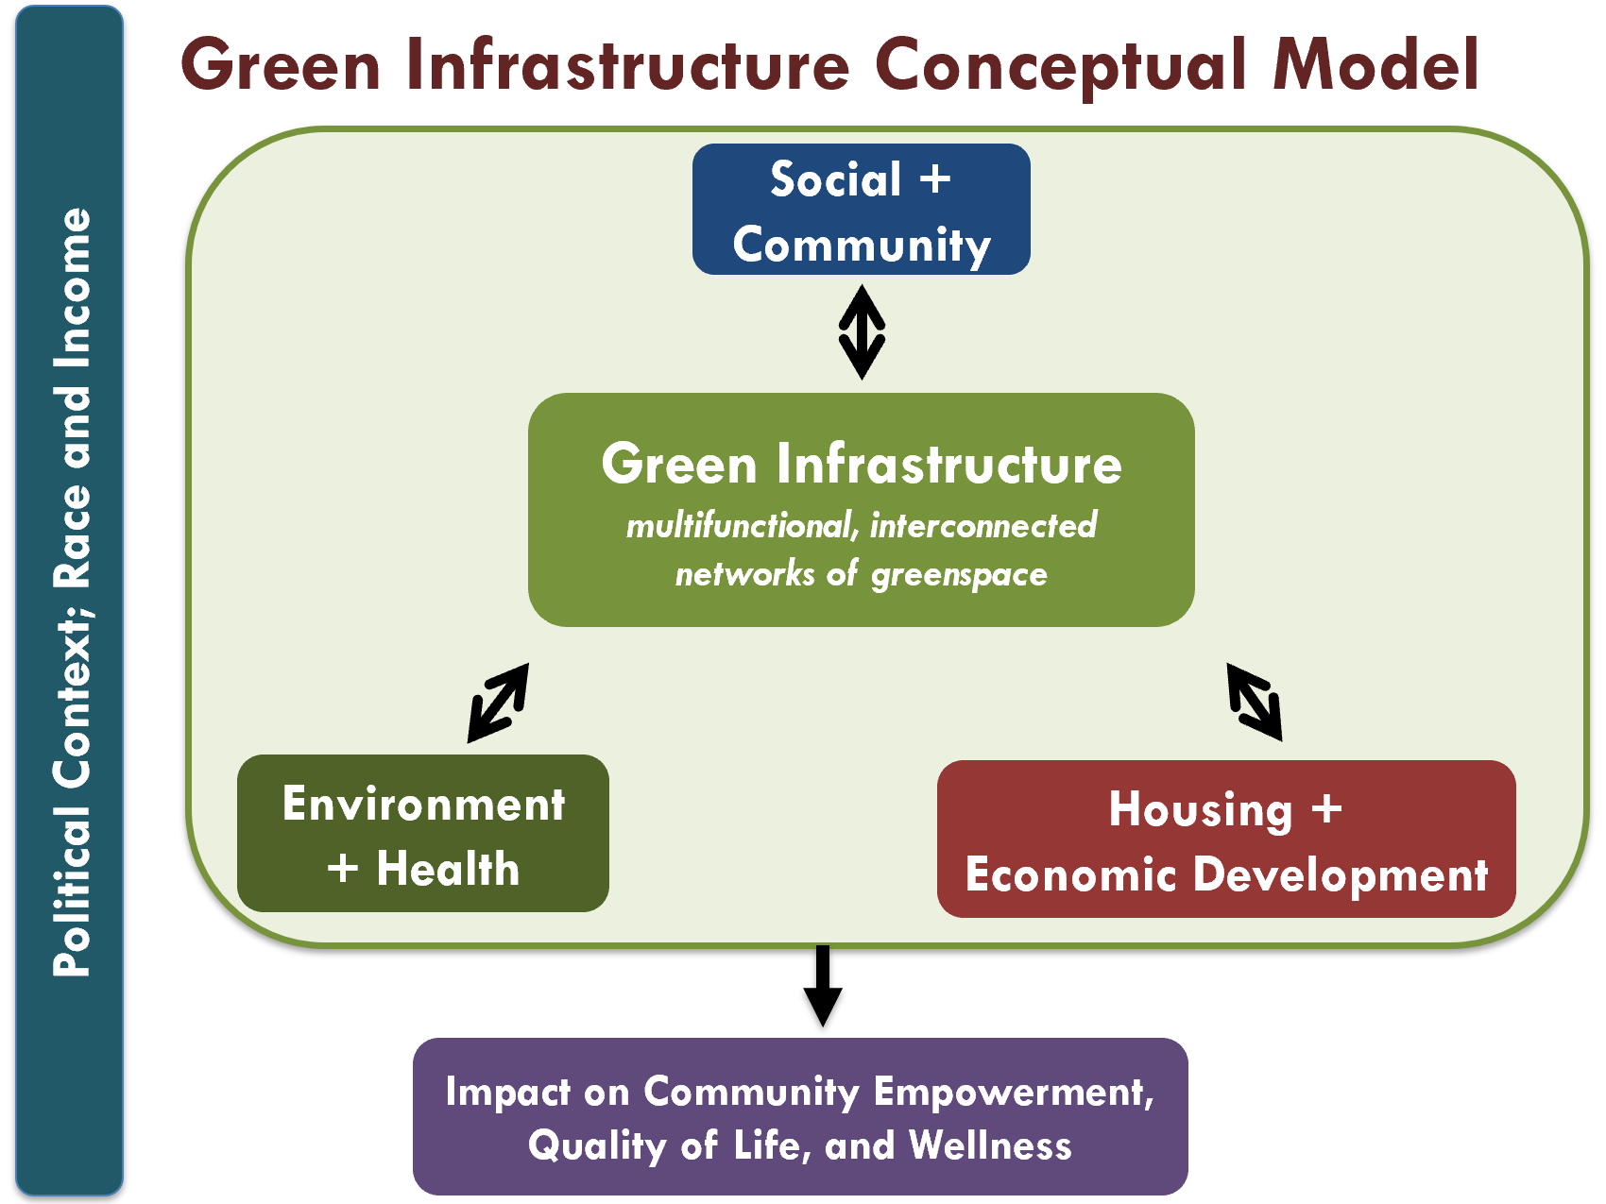

An Introduction to Green Infrastructure
Instructions
- Before class, ask students to read:

Wolch, J. R., Byrne, J., & Newell, J. P. (2014). Urban green space, public health, and environmental justice: The challenge of making cities ‘just green enough’. Landscape and urban planning, 125, 234-244.

- In class, deliver the slide lecture, titled “An Introduction to Green Infrastructure.” Distribute the Green Infrastructure Key Concepts and Green Infrastructure Model handouts for students to refer to during the lecture (15 minutes).

- Prompt discussion – either individually or in teams – using the discussion questions below. Prioritize questions based on the learning needs of your class.
Discussion Questions
- How does green infrastructure impact communities environmentally, economically, and socially? How have you seen green infrastructure impact your neighborhood, community, city, or region?

- What types of programs and policies might go alongside planning for green infrastructure to ensure projects benefit residents of surrounding neighborhoods? How did the HABESHA, Living Cully, and Unity Park projects incorporate equitable development concerns? What else might be considered or included as green infrastructure projects are developed in low-income communities?

- Why does it matter whether green infrastructure projects support meaningful community participation, leadership, and sharing of local knowledge? How might a green infrastructure project look different if residents of the surrounding neighborhood had a leadership role in planning it, as opposed to a project led by government agencies with very few opportunities for community input?

- How might local policies, programs, and funding shape the ways in which green infrastructure projects impact communities vulnerable to gentrification and displacement? What types of policies and programs might help reduce these concerns and ensure residents benefit from investments in green infrastructure? Can a combination of ‘just green enough’ strategies and policy change sufficiently prevent impacts of gentrification and displacement?

- You work for the City of Atlanta Department of Watershed Management and are put in charge of a green infrastructure planning process for a new park in Atlanta’s Westside neighborhoods. What are some important things to consider as you get started? How would you go about your role?

Resources for Further Reading
Defining Green Infrastructure/ General Overview
Rouse, D. C., & Bunster-Ossa, I. F. (2013). Green infrastructure: A landscape approach. American Planning Association Planning Advisory Service Report Number 571.
Benedict, M. A., McMahon, E. T. (2006). Green infrastructure: Linking landscapes and communities. Washington, DC: Island Press.
Environmental and Health Impacts of Green Infrastructure
Tzoulas, K., Korpela, K., Venn, S., Yli-Pelkonen, V., Kaźmierczak, A., Niemela, J., & James, P. (2007). Promoting ecosystem and human health in urban areas using green infrastructure: A literature review. Landscape and Urban Planning, 81(3), 167-178.
Lee, M. (2017, July 7). Two parks, multiple benefits on schedule for westside next year. Saporta Report [Atlanta]. Retrieved from https://saportareport.com/two-parks-multiple-benefits-schedule-westside-next-year/
Green Infrastructure and Economic Development
Daniels, T. (2008). Taking the initiative: why cities are greening now. In Birch, E. L., & Wachter, S. M. (2008). Growing greener cities: Urban sustainability in the twenty-first century. Philadelphia: University of Pennsylvania Press.
Social Outcomes of Green Infrastructure
Tidball K.G., Krasny M.E. (2009). From risk to resilience: what role for community greening and civic ecology in cities? In Wals, A. E. (Ed.). (2007). Social learning towards a sustainable world: Principles, perspectives, and praxis. Wageningen Academic Pub.
Wilker, J., Rusche, K., & Rymsa-Fitschen, C. (2016). Improving participation in green infrastructure planning. Planning Practice & Research, 31(3), 229-249.
Environmental Gentrification
Sisson, P. (2018, July 17). Can high-profile park projects, catalysts for development, play nice with neighboring communities? Curbed. Retrieved from https://www.curbed.com/2018/7/17/17581456/park-high-line-606-affordable-housing-development
Abello, O. (2019, March 7). Why history matters in equitable development planning. Next City. Retrieved from https://nextcity.org/daily/entry/why-history-matters-in-equitable-development-planning
Bogle, M., Diby, S., & Cohen, M. (2019). Equitable development and urban park space: Results and insights from the first two years of implementation of the Equitable Development Plan of DC’s 11th Street Bridge Park project. Retrieved from Urban Institute website: https://www.urban.org/sites/default/files/publication/99850/equitable_development_and_urban_park_space_1.pdf
Anguelovski, I. (2015). From Toxic Sites to Parks as (Green) LULUs? New Challenges of Inequity, Privilege, Gentrification, and Exclusion for Urban Environmental Justice. Journal of Planning Literature, 0885412215610491.
Immergluck, D., & Balan, T. (2018). Sustainable for whom? Green urban development, environmental gentrification, and the Atlanta Beltline. Urban Geography, 39(4), 546-562.
Curran, W., & Hamilton, T. (2012). Just green enough: Contesting environmental gentrification in Greenpoint, Brooklyn. Local Environment, 17(9), 1027-1042.
Sustainable and Equitable Development
Agyeman, J. (2013). Introducing Just Sustainabilities: Policy, Planning and Practice. Zed Books.
Zavestoski, S., & Agyeman, J. (Eds.). (2014). Incomplete Streets: Processes, Practices, and Possibilities. Routledge.

SLS Student Learning Outcomes
- Identify relationships among ecological, social, and economic systems.
- Demonstrate skills needed to work effectively in different types of communities.
- Evaluate how decisions impact the sustainability of communities.
- Describe how to use their discipline to make communities more sustainable.*
* Note: SLO 4 is intended to be used by upper division, project-based courses such as Capstone.

