CRITICAL COMMUNITY ENGAGEMENT
SUPPORT STUDENTS AND COMMUNITY PARTNERS: Establish Partners and Students as Leaders
As service learning has matured over the years, critical questions have come up around whose needs are being met in projects and engagements; As a result, a canon of work on different types of service learning—and the benefits and drawbacks to the different models—has emerged. This resource is for those interested in developing “critical” community engagements and has been adapted from Tania Mitchell’s article “Traditional vs. Critical Service-Learning: Engaging the Literature to Differentiate Two Models,” in which she conducts an expansive review of the literature, and from the Data Center’s Toolkit on Research Justice, which provides a number of tips on working in just ways with communities.
Simply put, Mitchell defines the traditional approach to service learning as one that “emphasizes service without attention to systems of inequality.” She argues that a critical approach is essential, given the ethical demands of the historical moment and the promise of service learning, adding that critical service learning is “unapologetic in its aim to dismantle structures of injustice.” Extrapolating on the definition, she notes:
Developing experiences with greater attention to equality and shared power between all participants in the service experience and challenging students to analyze the interplay of power, privilege, and oppression at the service placement and in their experience in that placement will ensure that a critical service-learning pedagogy questions and problematizes the status quo.
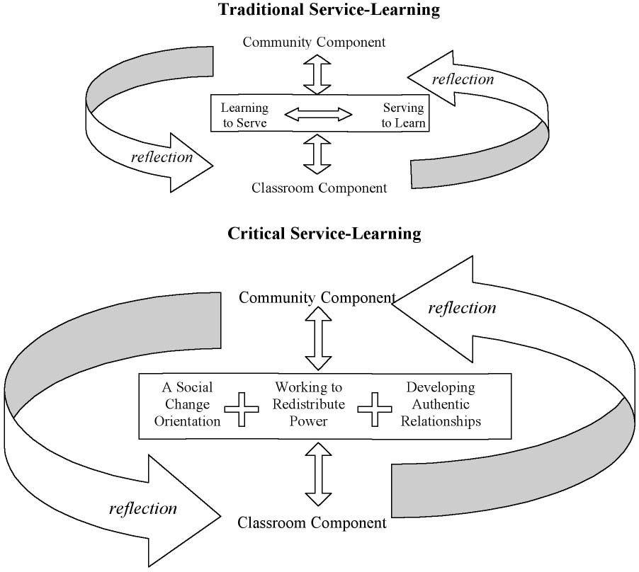
Image Credit: Tania Mitchell, “Traditional vs. Critical Service-Learning: Engaging the Literature to Differentiate Two Models,” 53
According to Mitchell’s review of the literature and accompanying case studies, critical service learning includes three essential components:
- A social change orientation
- Working to redistribute power
- Building authentic relationships
A social change orientation “requires rethinking the types of service activities in which students are engaged, as well as organizing projects and assignments that challenge students to investigate and understand the root causes of social problems and the courses of action necessary to challenge and change the structures that perpetuate those problems.” For instance, critical community-engaged projects at Georgia Tech might explore questions such as: Why does Atlanta (as of 2016) have the highest income inequality in the U.S.? In examining this question, students should be asked to think not only about the structural conditions and policies that may have led to this circumstance but they should also work to understand the social policies at play—and how they participate in them.
Working to redistribute power, explains Mitchell, means adding in discussions and readings about “biases, unearned privilege, and power” … A critical community engagement practice facilitates “analysis and dialogue that allows students to identify and challenge unequal distributions of power that create the need for service.” Once awareness is established among students, “working to redistribute power” looks much like the practice encouraged throughout this playbook: honoring and centering the experiences and knowledge of the community, creating equal and truly cooperative partnerships, allowing community-based groups to not only make decisions but to lead, and providing ongoing resources and support to community partners.
Perhaps most important to Mitchell and other critical service learning proponents, and central to the tenets of this playbook, is the attention paid to “how relationships are developed and maintained.” As Mitchell explains, “the challenge is to create relationships that neither ignore the realities of social inequality in our society nor attempt to artificially homogenize all people in the service-learning experience.” It is important for students to see connections with those they are working with or serving, but it is equally important for them to critically understand difference and how it has been created and perpetuated. The ultimate focus, explains Mitchell, should be on understanding difference but searching for the small areas of shared experience where relationships can develop and grow, and which, over time, might develop into “authentic relationships.” According to Mitchell, there are a number of ways to help facilitate the development of authentic relationships: through conversation, by being and working together, through informal events and gatherings, and through structured conversations about identity and difference. You can work intentionally to help facilitate authentic relationship building by creating as much space for community partners and students to work closely and independently from you as possible.
While it may be more difficult to plan your community-engaged work so that critical engagements can emerge, if sustainability, social justice, and long-term impact are among the reasons you are doing this work, it is worth the effort. It is also important to note that you may need to take these recommendations into account as you build new relationships with partners, decide on communication strategies, and work to collaborate with partners to structure the course.

Mitchell, Tania D. “Traditional vs. Critical Service-Learning: Engaging the Literature to Differentiate Two Models.” Michigan Journal of Community Service Learning 14, no. 2 (Spring 2008): 50-65; Reem Assil, Miho Kim, Saba Waheed. An Organizer’s Guide to Research Justice. DataCenter, 2015. http://www.datacenter.org/wp-content/uploads/Intro_Research_Justice_Toolkit_FINAL1.pdf.
Mitchell, 50.
Mitchell, 62.
Mitchell, 53.
Mitchell, 57.
Mitchell, 59.

