THE SMART CITY KIT GUIDE

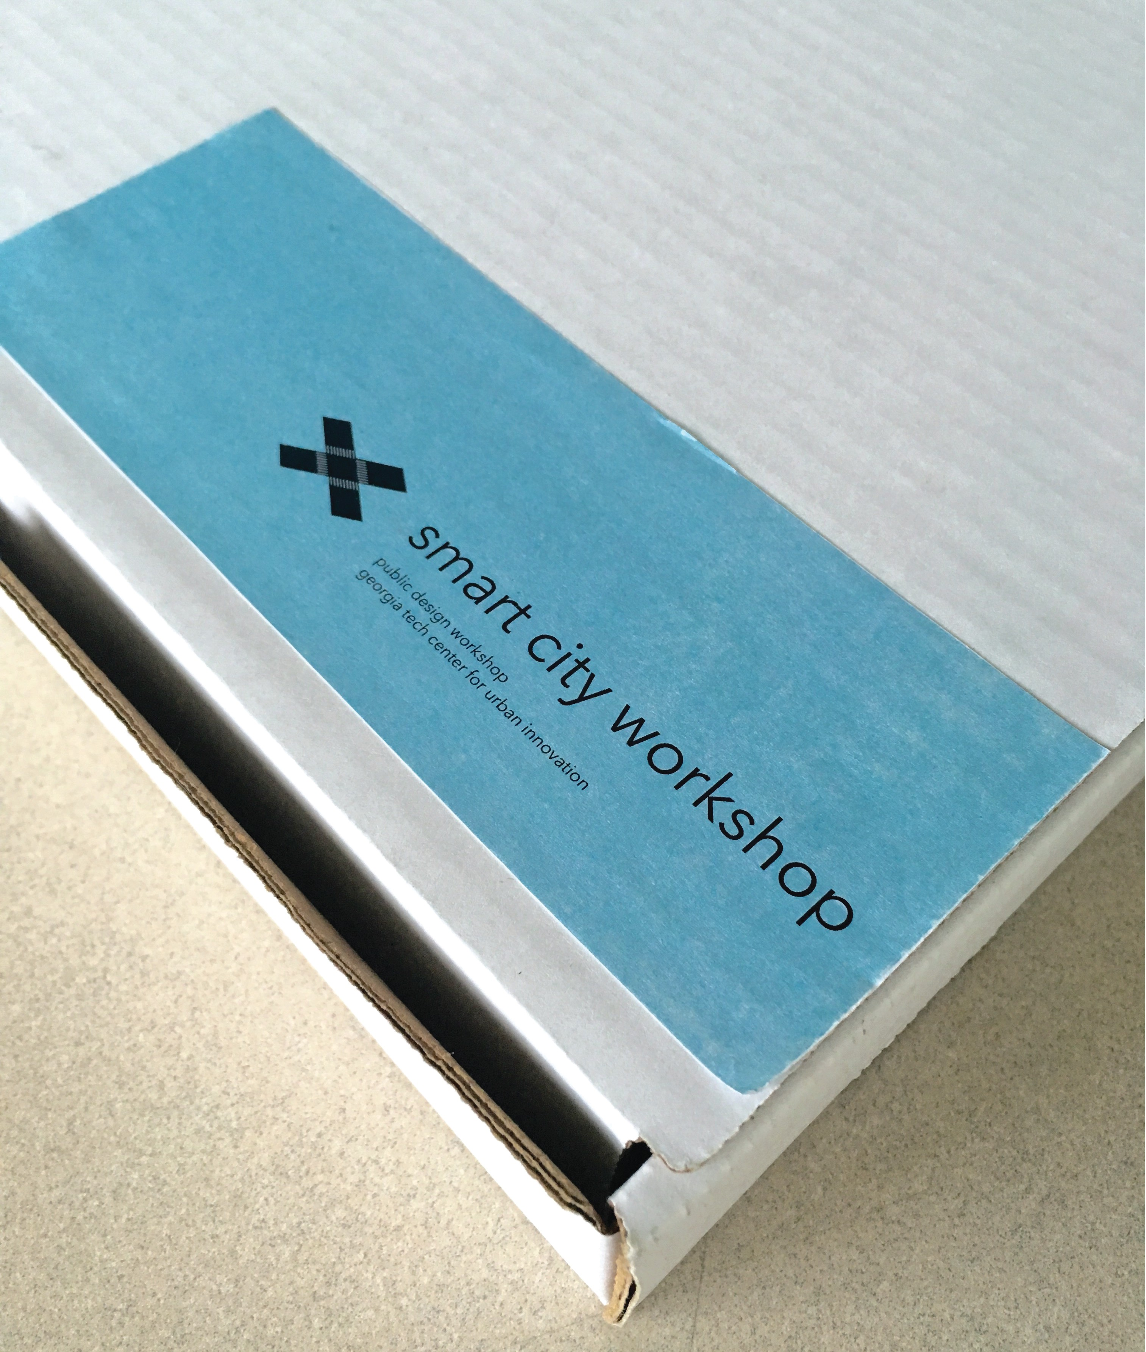

CONTENTS

Introduction | 3
Activity Structure | 4
Facilitating the Activity | 6
Activity Duration | 7
30-Minute Activity | 8
1-Hour Activity | 10
1.5-Hour Activity | 12
Community Workshop Insights | 14

The Smart City tool is available for check-out from the Serve-Learn-Sustain office. Each kit imagines a team of 5-10 students, but it is possible to make a single kit stretch over twenty students. Email Serve-Learn-Sustain for more details, and to inquire about check-out!

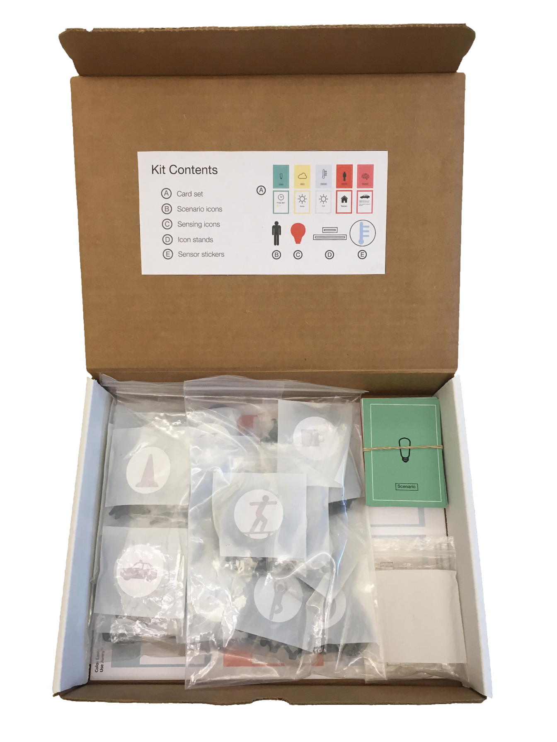
INTRODUCTION
THE SMART CITY KIT IS A SET OF MATERIALS THAT SUPPORTS PARTICIPATORY, HANDS-ON SCENARIO BUILDING ACTIVITIES. THE KIT PROVIDES STUDENTS A FRAMEWORK IN WHICH THEY CAN CONSIDER DIFFERENT IDEAS AROUND WHAT IT MEANS TO DESIGN AND PARTICIPATE IN A SMART CITY.
The Public Design Workshop at Georgia Tech’s Digital Media department produced a previous version of this kit (see left) for a series of workshops that brought together residents, business owners, city officials, and industry partners to collaboratively explore the issues and possibilities of civic sensor networks in Atlanta neighborhoods. Similarly, the kit can be used in classroom settings to facilitate similar conversations around the socio-technical implications of the smart city.
Because the smart city space can extend to many disciplines, the kit can be customized to extend to a broader range of discussions that can include but is not limited to IoT technologies, infrastructure, governance, privacy, security, and equity in a smart city. The activity structure also provides students the opportunity to understand the value of incorporating participatory and collaborative practices in decision-making processes.
The following instructions provide you with a detailed guide on how to use the kit. This guide also includes general insights from the Public Design Workshop’s experiences facilitating community workshops using this kit.
If you’re interested in creating your own kit, or customizing one, refer to our Kit Building Resources. Finally, check out Fictions of a Smart Atlanta: An Anthology of Smart City Use Cases. Consider assigning some or all of these cases as readings for your students. This will enhance their understanding of Smart Cities, and of this activity.
ACTIVITY STRUCTURE

01
- Map
- Card set
- Icon set
- Sensor/Device Disks

02

03

04

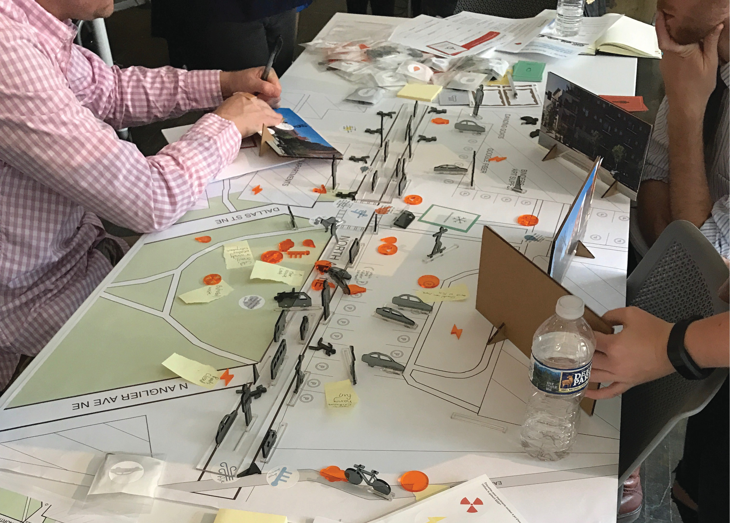

Students will work in groups to build scenarios using the kit materials.

- A map of a specific location of interest will serve as the “game board” for the activity.
- Students will use the card set to pick a specific scenario (i.e., “a warm, sunny Monday evening”). Students will use the “Stakeholder” cards as prompts for thinking about the smart city from different perspectives of various stakeholders.
- Students will use the icon disks and place them on the map to build out the scenario (i.e., students might put several car icons along the road to show that it is rush hour).

Students will use the sensor/device disks to indicate areas on the map where they would want to know or collect specific kinds of data and information (i.e., a student wants to know the air quality in the park and on the BeltLine trail).

FACILITATING THE ACTIVITY

ACTIVITY DURATION
The previous version of the kit was designed to support a 2-hour workshop event. For instructional purposes, the activity can be adjusted for different class schedule

30-MINUTE ACTIVITY
Both students and instructors should make sure to review activity materials prior to class. The room should be set up with materials at each table so that students can come into class and quickly form groups.
More facilitation will be needed, as students will have less time to work. Instructors can also have the post-activity discussion the next period or assign discussion questions for students to reflect on and answer.
1-HOUR ACTIVITY
Though it is recommended for students to review the activity before class, facilitators can also spend time briefly walking students through the activity. The structure is the same as the 30-minute version, but students will have more time for the activity and discussion.
1.5-HOUR ACTIVITY
This is more than enough time for students to comfortably complete the activity and participate in a lengthier post-activity discussion. Depending on each group’s pace, students might be able to build more than one scenario.

ROOM SETUP
The classroom should have tables set up for each group. On each table should be printed instructions, and discussion questions, a map, a card set, icon disks, and sensor/device disks.
DOCUMENTATION
Groups should report back to the class as a way of making sense of the activity.
Encourage students to assign a group note taker who can take quick notes and pictures of the map as they work through the activity.

30 MINUTE ACTIVITY
MATERIALS

Provide before class:
Activity instructions
Discussion questions

For activity:
Card set Icon set
Device/sensor disks Map
Activity instructions Discussion questions
PROVIDE MATERIALS TO STUDENTS BEFORE CLASS
Students should receive a copy of activity instructions, and discussion questions via e-mail or the class period prior to the scheduled activity so that they can review and familiarize themselves with the activity. Given the short timeline, students should be able to start the activity quickly.
TABLE SETUP
You should have tables set up with the materials needed for the activity. As students come into class, they can situate themselves at each table and form groups prior to the start of class.
TIMELINE
Facilitator(s) will need to keep track of time to keep students moving according to schedule. The following is a suggested timeline for a 30-minute activity.
Introduction (1 minute)
Instructor(s) can give a broad overview of the activity and timeline for the class period so that students can begin the activity quickly. Remind students to assign their group a note taker to write down highlights in their instruction packet.
Activity (18 minutes total)
During the activity, facilitator(s) should be walking around the room to help students understand what they are doing and move them along the activity.
Scenario Building (5-6 minutes)
Each group should choose a Scenario card and work through what that scene looks like on the map using the icon disks.
Stakeholder Perspective (4-5 minutes)
Each student in the group should choose a Stakeholder card and discuss the scenario through different stakeholder perspectives.

Information Collection (5-6 minutes)
Each group should work through what kinds of information
are in the space, what they (or their stakeholder) would want to
collect/measure/track in that space, and why.
Discussion (10 minutes)
Groups should spend this time-sharing insights and thoughts about the activity. Using the discussion questions to facilitate the conversation might help students make sense of the activity, especially in the context of the course.
Post-Activity Assignment (optional)
There is a high possibility that the activity will go over time. If there is not enough time for sufficient discussion, a short assignment could be assigned for students to have the opportunity to reflect on the activity and answer discussion questions.

1-HOUR ACTIVITY

MATERIALS

Provide before class:
Activity instructions
Discussion questions

For activity: Card set Icon set
Device/sensor disks Map
Activity instructions Discussion questions
PROVIDE MATERIALS TO STUDENTS BEFORE CLASS
Students should receive a copy of activity instructions, and discussion questions via e-mail or the class period prior to the scheduled activity so that they can review and familiarize themselves with the activity.
TABLE SETUP
You should have tables set up with the materials needed for the activity. As students come into class, they can situate themselves at each table and form groups prior to the start of class.
TIMELINE
Facilitator(s) will need to keep track of time to keep students moving according to schedule. The following is a suggested timeline for a 1-hour activity.
Introduction (3-5 minutes)
Instructor(s) can give a brief overview of the activity and quickly demonstrate what the activity looks like, so that students have a better idea of what to do. Remind students to assign their group a notetaker to write down highlights in their instruction packet.
Activity (35 minutes total)
During the activity, facilitator(s) should be walking around the room to help students understand what they are doing and move them along the activity.
Scenario Building (12-13 minutes)
Each group should choose a Scenario card and work through what that scene looks like on the map using the icon disks.
Stakeholder Perspective (10 minutes)
Each student in the group should choose a Stakeholder card and discuss the scenario through different stakeholder perspectives.

Discussion (15-20 minutes)
Groups should spend this time sharing insights and thoughts about the activity. Using the discussion questions to facilitate the conversation might help students make sense of the activity, especially in the context of the course.
Post-Activity Assignment (optional)
Though there will be enough time for discussion, a short assignment could be assigned for students to have further opportunity to reflect on the activity, such as a write-up answering some of the discussion questions.

1.5-HOUR ACTIVITY

MATERIALS

Provide before class:
Activity instructions
Discussion questions

For activity: Card set Icon set
Device/sensor disks Map
Activity instructions Discussion questions
PROVIDE MATERIALS TO STUDENTS BEFORE CLASS
Students should receive a copy of activity instructions, and discussion questions via e-mail or the class period prior to the scheduled activity so that they can review and familiarize themselves with the activity.
TABLE SETUP
You should have tables set up with the materials needed for the activity. As students come into class, they can situate themselves at each table and form groups prior to the start of class.
TIMELINE
Facilitator(s) will need to keep track of time to keep students moving according to schedule. The following is a suggested timeline for a 1.5-hour activity.
Introduction (5 minutes)
Instructor(s) can give a brief overview of the activity and quickly demonstrate what the activity looks like, so that students have a better idea of what to do. Remind students to assign their group a note taker to write down highlights in their instruction packet.
Activity (60 minutes total)
During the activity, facilitator(s) should be walking around the room to help students. Given a longer timeline, groups might be able to go through two rounds of the activity.
Scenario Building (25 minutes)
Each group should choose a Scenario card and work through what that scene looks like on the map using the icon disks.
Stakeholder Perspective (15 minutes)
Each student in the group should choose a Stakeholder card and discuss the scenario through different stakeholder perspectives.

Information Collection (20 minutes)
Each group should work through what kinds of information
are in the space, what they (or their stakeholder) would want to
collect/measure/track in that space, and why.
Discussion (25 minutes)
Groups should spend this time-sharing insights and thoughts about the activity. Using the discussion questions to facilitate the conversation might help students make sense of the activity, especially in the context of the course.
Post-Activity Assignment (optional)
Though there will be enough time for discussion, a short assignment could be assigned for students to have further opportunity to reflect on the activity, such as a write-up answering some of the discussion questions.

COMMUNITY WORKSHOP EVENTS
Workshop overview and goals
The original version of this kit was produced as part of Participatory Approaches to Researching Sensing Environments, a research collaboration between Georgia Tech’s Center for Urban Innovation and the Public Design Workshop. The Public Design Workshop hosted a series of workshops with Atlanta residents, business owners, city employees, and industry partners to collaboratively explore the issues and possibilities of civic sensor networks in Atlanta neighborhoods. We facilitated three workshops, where participants spent 1.5 hours working with the kit materials in groups. The goal of these workshops was to produce a set of use cases for the Smart Atlanta that were informed by our research with stakeholders from the Atlanta neighborhoods slated to be the sites of sensor deployments. Because these workshops occurred in the early stages of the Smart Atlanta initiative, the use cases would present community perspectives for industry partners, engineers, and city officials to consider in their decision-making.
City and community partnerships
Two workshops were hosted at the Atlanta City Studio in Ponce City Market. The Atlanta City Studio is a pop-up design studio within the City of Atlanta's Department of Planning and Community Development. As the workshop aligned nicely with their desire to serve as a gathering space for residents, visitors, and design professional, Atlanta City Studio offered us their space for the workshop and reached out to their network to invite participants. In return, the faculty member on the project offered to lead one of the studio’s book club discussions.
The third workshop was hosted at a local coffee shop in the Westside community. Researchers from the Public Design Workshop had developed relationships with community partners from the Westside neighborhoods from prior projects, leading to a connection with the coffee shop owner. The shop owner offered his space to host the workshop due to both his general interest in technology and promoting his new coffee shop as a community space. He also reached out to his network and handed out flyers in his shop to share the event with residents. The shop owner was compensated for his space, and another community member was hired to cater the event. The purpose of describing these interactions is not only to highlight these partnerships but to emphasize the importance of recognizing and valuing these community members as partners in these kinds of community research projects.
Community engagement strategies
We specifically hosted the workshops in community spaces, close to the Atlanta neighborhoods chosen as sites for sensor deployment. Most of the participants from the first workshop were municipal employees, designers, and Georgia Tech employees and students. Very little to no community residents attended; in retrospect, the time of the event (Friday afternoon at 2 p.m.) did not accommodate most work schedules, and we advertised the event mostly within our own networks. For the second workshop, we specifically targeted residents by sharing the event via NPU mailing lists and changing the event time to a weekday evening so that more residents could attend after work.
Again, we hosted the third workshop in the evening to accommodate for residents’ work schedules and provided dinner. We advertised the event at a NPU meeting and passed out flyers and provided flyers to the coffee shop owner to invite residents as well. However, only a handful of residents attended the event. It became clear that our previous approaches did not translate well for this particular community. The avenues through which we extended these invitations were limited to social media, a NPU meeting, and any residents who might go to the coffee shop or know the coffee shop owner — in short, we excluded a large subset of the community. This issue of exclusion particularly came to the fore during the workshop activity itself, where two participants noted that most residents were unaware of the workshop event and even the coffee shop (“you need to knock on doors”).
Because these community workshops served as a means of capturing voices that might not necessarily be represented in city decision-making processes, it becomes problematic when our modes of engagement fail to even get residents to the table. For any community engagement work, we must remember to meet communities “where they are at”, where our engagement strategies are tailored to the ways that specific communities already disseminate information.
Addressing community concerns
Though the kit and activity engaged participants and sparked discussion around many opportunities and issues within the smart city space, some assumptions were designed into the activity that became more apparent during the third workshop. The kit failed to specifically address the community’s values and concerns; when the activity segued into a discussion about sensors in the neighborhood, some participants expressed their disgust and anger at the idea and could not find any value in these kinds of sensing technologies. However, it is crucial to note that, though participants did not exactly follow the activity, the workshop gave participants a space in which they could express their concerns. Ultimately, the insights and ideas produced from these workshops illustrate that this kind of participatory-based work is crucial in surfacing the assumptions we might have about different communities and better addressing the issues of social sustainability in a smart city.

