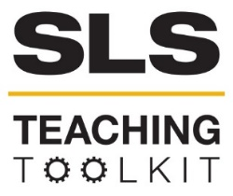 | SLS Case Study: The Kendeda Building for Innovative Sustainable Design
Discipline: All | Type: Reading; Discussion; Take-home assignment; In-class exercise | Time Commitment: 30-60 mins | Category: Case Studies on Sustainable Communities; Equitable and Sustainable Development
Big Ideas: Inequality, Poverty, and Sustainable Development; Infrastructure: Physical, Technological, Social
OVERVIEW:
The Kendeda Building for Innovative Sustainable Design at Georgia Tech promises to be a flexible, multi-use academic space as well as the most environmentally advanced educational and research building in the Southeast. In this case study, learn about what it means for the Kendeda Building to receive certification as a “living building.” Serve-Learn-Sustain interprets sustainable communities as integrated systems, wherein environment, economy, and society all inform each other. As you read this case study, consider these terms as discrete factors, but also as connected.
This tool was contributed by Christina M. Colvin.
INSTRUCTIONS:
- Use this case study in the way that works best for your class: assign it as a take-home reading, or as an in-class reading. Supplement the case study with sources from the Resources for Further Reading section.
- Either as a take-home assignment, or in-class discussion, answer the Discussion Questions, or craft your own.
SLS STUDENT LEARNING OUTCOMES & ASSESSMENT:
The Serve-Learn-Sustain toolkit teaching tools are designed to help students achieve not only SLS student learning outcomes (SLOs), but the unique learning outcomes for your own courses. Reflection, concept maps, rubrics, and other assessment methods are shown to improve student learning. For resources on how to assess your students’ work, please review our Assessment Tools.
This tool achieves SLOs 1 & 3. See the end of this tool for further details.
Want Help?
SLS is the contact for this tool. You can reach us at serve-learn-sustain@gatech.edu

SLS Case Study: The Kendeda Building for Innovative Sustainable Design

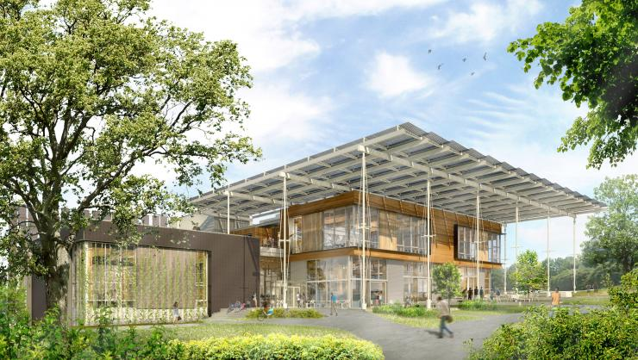
Introduction
The Kendeda Building will include a porch that connects to the Eco-commons (Wallace).

Construction on Georgia Tech’s Living Building, the Kendeda Building for Innovative Sustainable Design, is currently underway. The building promises to be a flexible, multi-use academic space as well as the most environmentally advanced educational and research building in the Southeast (Pocklington). Georgia Tech’s commitment to obtaining Living Building certification testifies to the Institute’s ongoing commitment to environmental sustainability. It also provides an important model for how environmental, societal, and economic concerns can intersect. But what does “Living Building” mean?

The Living Building Challenge is a sustainable building certification program that aims to dramatically diminish the harmful environmental effects of human construction projects. More than simply a brand of distinction, the designation of a building as “living” has the potential to remodel our notion of what built environments can provide for communities both human and nonhuman. Indeed, the Challenge is the most rigorous green building certification program: for example, it has requirements more demanding than the US Green Building Council’s highest LEED. According to the International Living Future Institute, the nonprofit organization that administers the Living Building Challenge, the Challenge “provides a framework for design, construction, and the symbiotic relationship between people and all aspects of community” (“Living Building Challenge 3.0” 6). Georgia Tech’s Kendeda Building will be an active example of this relationship.
Key Takeaway: A Living Building must meet demanding requirements. Click here to compare the Living Building Challenge with the US Green Building Council’s LEED certification.

Most modern buildings continuously consume energy and natural resources like water simply in order to function. In contrast, Georgia Tech’s Living Building will not be merely “sustainable” in terms of maintaining a steady level of resource consumption. Rather, the Kendeda Building will be regenerative: it will imitate natural processes to produce
Serve-Learn Sustain interprets sustainable communities as integrated systems, wherein environmental, economic, and social factors all inform each other. As you read this case study, consider these terms as discreet factors, but also as connected. Ask yourself, how does the economy impact the environment? How does the environment affect society?

more energy than it uses, and it will capture and treat its own water (Schaefer). Because of such rigorous performance standards, the Kendeda Building’s planned certification as “Living” will represent an achievement of environmentally conscious planning and design.
The Living Building Challenge promotes sustainable communities by mandating a set of “performance requirements.” These performance requirements, or Petals, are both practical and philosophical. For example, the Petal imperatives dictate that living buildings should evoke “beauty” and that only select resources may be used to construct them. Taken together, living building “Petals” form a flower, a metaphor for how “the ideal built environment should function...cleanly and efficiently” (“Living Building Basics”). The seven Petals include Place, Water, Energy, Health & Happiness, Materials, Equity, and Beauty. The practical and philosophical ideas contained in these petals show that living buildings like Tech’s Kendeda Building aim to represent the imbrication of aesthetic and applied expressions of sustainability.
The Living Building Challenge petals form a flower (The Hourigan Team).

Environment
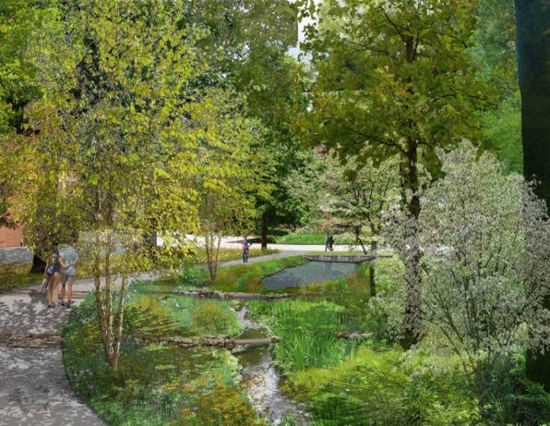
Georgia Tech’s Living Building will serve as an example of a building’s capacity to give back rather than take from the environment. As a “green” building certification program, the Living Building Challenge is thoroughly invested in the possibility that buildings can enrich society’s connection and contributions to the environment. Three of the Challenge’s petals--Place, Water, and Energy--offer the clearest articulation of the program’s approach to environmental sustainability.
A proposed path through the GT eco-commons will connect green spaces, including the Kendeda Building. Image source: “A River Runs Through It”

With their emphasis on Place, buildings certified as “living” must prove that their presence and construction will give back to, rather than detract from or deplete, the surrounding environment. Georgia Tech’s own Living Building is built on a grayfield: specifically, a former parking lot. Construction of a living building may only occur on grayfields, or brownfields. By restricting construction to areas of land already developed and therefore leaving never-developed areas of land alone Georgia Tech’s Living Building encourages the preservation (as opposed to the use) of natural areas.
There are a number of other ways that the Kendeda building will support the natural environment:
- It connects green spaces across campus. Specifically, the Living Building opens onto the Eco-commons, an integrated, ecologically-based landscape that circles Georgia Tech, connecting Tech’s system of natural resources with the larger community.
- One of its key features is a 45,000 gallon cistern, which is a key piece of the building’s net positive water requirement. The Living Building Challenge’s Water petal mandates that living buildings must satisfy their own water needs through means that include capturing rainwater and purifying used water without the use of chemicals. For the Kendeda Building, achieving “net-positive water” means “mimicking the Piedmont forest in the way it absorbs and releases water,” in particular through the use of stormwater (English, Koti, Mandel, and Pankopp).
Key Takeaway: A Living Building must give back to the environment, not detract from or deplete it.
- No fewer than 900 photovoltaic panels will be installed across Tech’s Living Building: in addition to their practical use, these panels will provide a visible reminder of the building’s commitment to renewable forms of energy, such as solar. Tech’s building will not use any polluting forms of energy such as coal, gas, and oil. These features are central to Tech’s building accomplishing one of the most memorable and difficult-to-implement design challenges of a Living Building: “net positive energy” (U.S. Green Building Council).
The users of Georgia Tech’s Living Building will also play a central part in helping the building meet its performance requirements. As Michael Gamble, director of Graduate Studies and associate professor for the School of Architecture, told the Georgia Tech News Center, “Everyone in the building, including students, staff, and faculty, is responsible for complementing and upholding the basic building principles in how we learn and teach” (“Taking Shape”). Tech’s Living Building therefore takes seriously that it is the interaction between people, economy, and environment that makes truly green infrastructure possible.

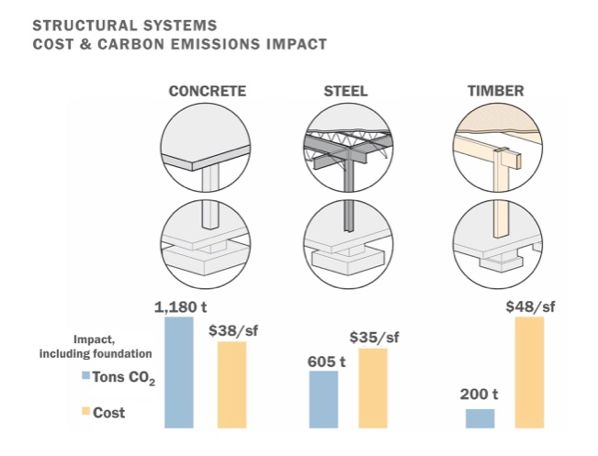
Economy

Costs and carbon outputs for concrete, steel and timber. Image by Eskew, Dumez & Ripple
Even for a major public research institution like Georgia Tech, the cost of designing and constructing a Living Building remains high. Georgia Tech received a grant from The Kendeda Fund, a private foundation based in Atlanta Georgia, in the amount of $25 million to fund the design and construction costs of its living building. Kendeda will support living building programming activities with another $5 million. As Georgia Tech News Center reports, “The investment represents The Kendeda Fund’s largest single grant and ranks among the largest capital gifts ever received by Georgia Tech” (Wallace).
Having access to these resources is a boon for the university, but an SLS approach to economy requires us to consider a range of costs, including societal and environmental. To that end, Tech’s Living Building intends to use its financial resources to buttress the local economy and preserve the natural world.
Key Takeaway: Costs are never exclusively economic. They are also environmental and societal.
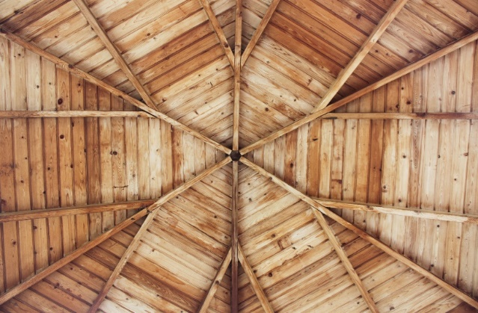
The Living Building Challenge Materials petal is a useful tool for thinking about how financial interests can serve environmental interests. To fulfill this Petal’s requirements, Tech’s Kendeda Building will not include any materials or chemicals included in the Living Future Institute “Red List,” or list of worst known offending materials to human and environmental health. In addition, the majority of its materials will be sourced from regions in the immediate vicinity of the living building itself in order to contribute to the local economy (“Living Building Challenge 3.0” 47).

Included on the Living Future’s Red List are traditional wood treatments containing creosote, pentachlorophenol, or arsenic. Photo by Hudson Hintze on Unsplash.

The Living Future Institute remains clear about the challenges associated with sourcing the non-toxic, socially equitable, and ecologically-beneficial materials required of living buildings. It writes that, “While there are a huge number of ‘green’ products for sale, there is also a shortage of good, publicly available data that backs up manufacturer claims and provides consumers with the ability to make conscious, informed choices” (“Living Building Challenge 3.0” 43). To help foster a culture of transparency in the building materials industry, the Living Future Institute maintains Declare, a labeling system and product database for building projects.
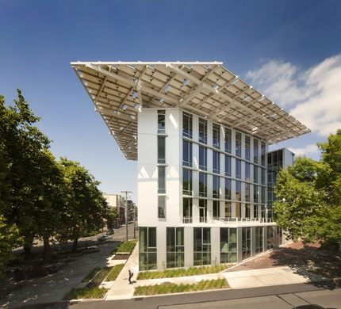
Regardless of the assistance the Living Future Institute provides the industry when it comes to sourcing materials, the construction of living buildings, particularly living buildings of Georgia Tech’s size and function, is certainly no small expense. The construction and design costs associated with living buildings vary according to the size and scope of proposed projects. Richard Graves, Executive Director of the Living Future Institute from 2012 to 2014, explains that, in the case of The Bullitt Center in Seattle, Washington--a certified Living Building and commercial office space--construction costs were “10 to 15 percent more expensive than a typical Seattle office building, but because of energy and water savings the payback could be two or three years” (Jossi). Such an expense prevents builders who do not have access to Georgia Tech’s resources and connections from taking on the Living Building Challenge.
The Bullit Center in Seattle Washington, another Living Building (Bullit Center).
Given that living buildings are not equally accessible to many members of society due to their high initial construction costs, meeting the Living Building Challenge’s emphasis on social equity through engagement with the local community emerges as a particularly necessary component for Tech’s Kendeda Building to be truly sustainable.

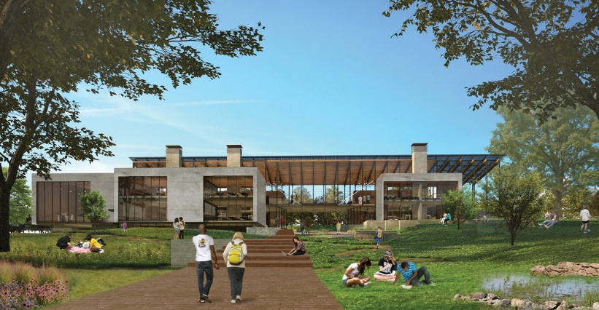
Society

Public accessibility will be a key feature of the design of the Kendeda Building (Endolyn).
Georgia Tech’s Living Building understands human society as part of and dependent on, rather than separate from, the environment or “nature.” Together, its integration of the Equity, Beauty, and Health and Happiness Petals of the Living Building Challenge promises to embody rich connections between human structures, Kendeda Building users, and the larger campus community.
The Living Building Challenge’s Equity Petal is informed by the ongoing environmental justice movement. Environmental injustices exist when members of disadvantaged, ethnic, minority or other groups suffer disproportionately as the result of environment-related matters such as increased levels of pollution in their communities, or lack of basic access to natural resources due to unchecked development or governmental neglect. In response, Georgia Tech’s Living Building will promote access and inclusivity, and work to preserve local environments and the communities who depend on them. Its “porch” feature--a gesture to the “vernacular architecture of the Southeast,” will prove a central example of this philosophy of inclusivity. That is, the Kendeda Building’s porch will allow connections between the built and natural environment and the building occupants and the community by blurring “the line between inside and out while passively mitigating the climate” (Kingsley and Sprug).
Key Takeaway: Environmental Justice is at the center of the Living Building Challenge. To learn more, check out the SLS tool Environmental Justice 101.
Per the Living Building Challenge, external access to living buildings must be equally accessible to all members of the public “regardless of background, age and socioeconomic class--including the homeless.” Moreover, members of the public must be served with “street furniture, public art, gardens and benches…accessible to all members of society.” These kinds of features enable people to rest, browse, and enjoy the environment and community-focused features of the living building rather than feel that their presence is undesired or predicated on their being or acting in circumscribed ways (“Living Building Challenge 3.0” 54).
The Kendeda Building’s features will be dedicated to serving the local community. For example, its makerspace, auditorium, and classrooms will be available for educational programming. A concierge desk will help organize visitors for tours of the building and provide information about the systems that make the Kendeda Building “living” (Kingsley and Sprug). The Kendeda Building’s focus on access and inclusivity is of particular interest for thinking about how buildings can take the potential diversity of their users seriously and work to serve them, not exclude them.
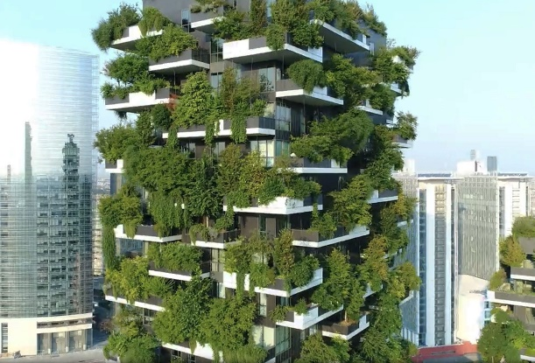
The final two guiding Petals of the Living Building Challenge, Health and Happiness, and Beauty, are perhaps the most loosely defined of all the Challenge’s guiding principles, but for good reason. The Challenge organizers invite designer creativity and imagination so long as their decisions provide “delight.” Access to light and fresh air across interior spaces is also mandatory. As regards Health and Happiness, the Challenge necessitates excellent air quality. It also mandates the incorporation of “Biophilic” design, or design choices that deliberately incorporate patterns and structures inspired by the natural world.
The Bosco Verticale in Milan, Italy, is an example of biophilic design. Image source: Stefano Boeri Architetti.:
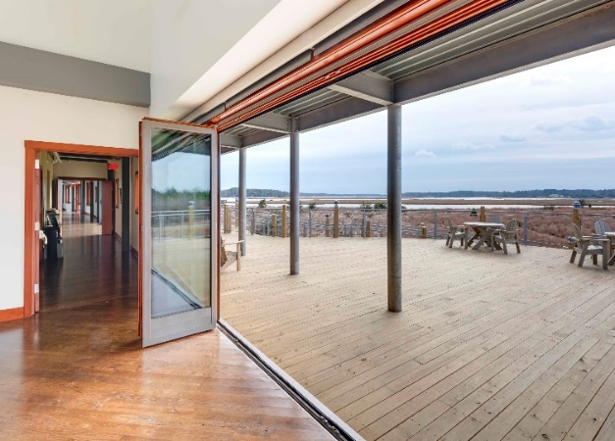
Tech’s Living Building will be a study in biophilic design. In particular, its two-story central atrium will stand out as the “heart of the building. It is designed to draw “people in and through the building” as well as deliver “daylight to the interior of the building while also serving as flexible circulation and program space” (Kingsley and Sprug). To represent for building visitors the “living” systems in the building, the 2017-2018 Student Undergraduate Research Fellows (SURF) developed ideas for a building dashboard. Such a display will show how on-target the building is for each day’s water use through the display of a public water meter (“Living Building Dashboard Pilot Project”).
The Brock Environmental Center of Virginia’s Chesapeake Bay, another Living Building, blurs the distinction between inside and outside (Kelley).
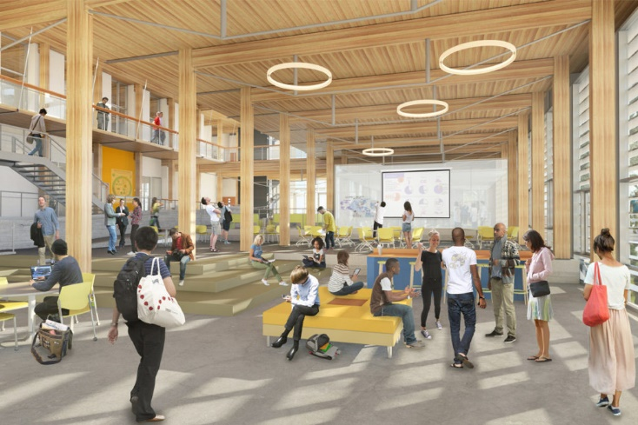
What might the subjective concepts of “Beauty” and “Health and Happiness” look like in Georgia Tech’s living building? Joshua Gassman, leader of the Kendeda Building’s design team, explains that the team is considering a project modeled on the Phipps Conservatory in Pittsburgh that will turn Kendeda’s glass windows into speakers. These speakers would then amplify environmental sounds recorded outside the building back into the building, a way to blur the line between “inside” and “outside” while also treating building users to local, environmental sounds. Based on the design proposals as well as examples of art across Georgia Tech, the campus’s own Living Building will almost surely provide an educational and enjoyable experience for all those who have a chance to visit.
This image provides an example of one of the proposed interior spaces of the Kendeda Building (Edelstein, “Living Building at Georgia Tech”).

Discussion Questions
- What do you think is the most challenging aspect of the “Living Building Challenge”? What do you think is its most interesting or exciting aspect? Why?
- Have you ever visited a building (on Georgia Tech’s campus or otherwise) invested in one of the living building petals (perhaps Equity, Health and Happiness, or Beauty)? How did the building designers take those concepts seriously and/or communicate those concepts to users of the building?
- After reading this case study, what do you think “living” means in the context of the Living Building Challenge? Are there other design projects or decisions besides building design that could be “living”? Name some examples.
- What do you see as the largest barriers to the Living Building Challenge being widely adopted across engineering projects nationwide?
- Propose another living building “petal,” or guiding concept. What would you want future living building designers to consider? What would your petal contribute to the idea of a “living” structure that the current petals do not?

Resources for Further Reading
“Access to Green Infrastructure: A Look at Equity in Green Roofs” (UC Berkeley’s Master of Development Practice program).
“The Benefits of Green Buildings” (World Green Building Council).
Brown, Karen. “What’s the Limit for Green Buildings?” (NOVA Next, 2016).
Edelstein, Ken. “Georgia Tech Living Building at design development” (Kendeda Fund, 2017).
--. “Living Building at Georgia Tech on Leading Edge of Biophilia Imperative” (Trim Tab, 2017).
Endolyn, Osayi. “A Building Alive with Possibilities” (Georgia Tech Alumni Magazine, 2016).
Eskew, Dumez, & Ripple. “Structural Systems Cost & Carbon Emissions Impact.”
Filliat, Annette. “Bridging Equity and Sustainability: Living Building Equity Champions” (Georgia Tech News, 2018).
“Green Architecture: What Makes a Structure a ‘Living Building’?” (Scientific American).
“Green Buildings Could Save Our Cities” (National Geographic).”
“Health and Green Infrastructure” (American Planning Association, 2015).
Hiskes, Jonathan. “The case for super-ambitious Living Buildings. A talk with Jason McLennan” (Grist, 2010).
The Hourigan Team. “Understanding the Living Building Challenge and Its ‘Petals,’ 2014).
Kelley, Jeff. “Sustainable Construction and Engineering Details Behind the Brock Environmental Center” (PR Web, 2016).
Lau, Wanda. “The Kendeda Building for Innovative Sustainable Design’s Quest to Become the First Living Building in the Southeast” (Architect, 2017).
Living Building Chronicle (The Kendeda Fund).
Medlock, Katie. “9 of the most impressive Living Building Challenge certified projects” (Inhabitat, 2016).
“A River Runs through It.” (Georgia Tech News, 2014).
Wallace, Lance. “Living Building Launches on Campus” (Georgia Tech News, 2017).

SLS Student Learning Outcomes

- Identify relationships among ecological, social, and economic systems.
- Demonstrate skills needed to work effectively in different types of communities.
- Evaluate how decisions impact the sustainability of communities.
- Describe how to use their discipline to make communities more sustainable.*
* Note: SLO 4 is intended to be used by upper division, project-based courses such as Capstone.

