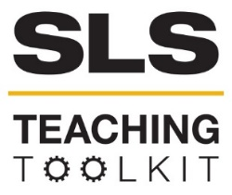 | Concept Maps
Discipline: All | Type: Discussion; Take-home assignment/project; In-class exercise | Time Commitment: 15-60 mins | Category: Assessment
Big Ideas: Long-term visioning
OVERVIEW:
This tool provides an overview of concept maps, and how to use them. Concept maps (CMaps) are diagrams that represent organized knowledge. They are a useful tool for assessing student knowledge over the course of a project, module, or course. You can also utilize concept maps as a pre- and post-assessment activity to test student knowledge regarding a specific topic or skill.
This tool was contributed by Carol Thurman and Owen Cantrell.
INSTRUCTIONS:
- Read the Concept Maps Overview to understand what concept maps are and how they can be used in your course.
- Watch the Concept Mapping Tutorial and Review the Concept Mapping Introduction PowerPoint . Here is an additional Introduction to Concept Maps that you might also find useful.
- Utilize the Concept Map handouts below (How to Build a Concept Map, Activity 1, Activity 2, Activity 3,) to have students complete their own concept maps
- If you’re interested in Concept Mapping using a computer program, consider CMapTools©. Review the Concept Map Complete Instructions (How to Download CMapTools©, How to Use CMapTools©), then assign the Concept Mapping Assignment.
- Use the guides and rubrics to assess student concept maps using either the analytic or traditional method.
SLS STUDENT LEARNING OUTCOMES & ASSESSMENT:
The Serve-Learn-Sustain toolkit teaching tools are designed to assist you in gauging student progress toward achieving not only SLS student learning outcomes (SLOs), but the unique learning outcomes for your own courses. Reflection, concept maps, rubrics, and other assessment methods are shown to improve student learning. For resources on how to assess your students’ work, please review our Assessment Tools.
Want Help?
Serve-Learn-Sustain is the contact for this tool. You can reach us at serve-learn-sustain@gatech.edu

Concept Maps
Overview
This Concept Maps tool introduces and provides an overview of concept maps, which can be used to assess student knowledge in a specific module or assignment.
Concept maps are a useful tool for assessing student knowledge over the course of a project, module, or course. You can utilize concept maps as a pre- and post-assessment activity to test student knowledge regarding a specific topic or skill.

In the documents below, you’ll find some step-by-step instructions for introducing, explaining, implementing, and assessing concept maps as a component of your course. This PowerPoint produced by Dr. Mary Katherine Watson of The Citadel may be useful for introducing concept maps for you (and your students).

After introducing concept maps, some in-class activities are provided you may want to do when teaching students how to do concept maps for the first time.

While students can create concept maps either by hand or by using traditional word processing tools, an online resource is also available. CMapTools© is a program where students can create concept maps digitally and submit them to you. Step-by-step instructions for CMapTools© are also included.

When students complete their concept maps, there are two ways we suggest you may want to score the concept maps: traditional/structural, and analytic. We’ve provided instructions on how to score concept maps using the traditional method. Additionally, there are tools available to score concept maps automatically. Finally, if you wish to score the concept maps using the analytic method, a rubric is available.

If you want to learn more about concept maps, additional resources are also supplied. These Concept Map materials were developed by Dr. Mary Katherine Watson of The Citadel and adapted by Serve-Learn-Sustain.

How to Build a Concept Map
- Identify a focus topic you wish to map.
- Guided by this question, create a list of concepts that are pertinent to the topic using CMapTools®
- Sort through the concepts and move to the side any that you do not fully understand or is not related to any other term.
- Using CMapTools®, arrange the remaining concepts in a way that makes sense to you. Terms you see as related should be kept fairly close together. One approach is to place general concepts near the top of the map and specific concepts at the bottom of the map. Other layouts may also be appropriate.
- Draw linkages using CMapTools® between concepts you see to be related.
- Write on each line the nature of the relation between the terms.
- Review your map and determine if there are any more concepts you can add. You may add to the map new concepts or concepts set aside in step 3. If you do add additional concepts, you should be sure to link them to other concepts and provide descriptive linkages.
- Again, review your map. Look for cross-links, which link together concepts in different areas of your map. Cross-links will help you to elaborate how concepts are interrelated.
- Finalize your map. Make sure that appropriate concepts are linked that all linkages are described.
Additional Resources for Further Reading
Barrella, E. M.; M. K. Watson, eds. W. L. Filho and S. Nesbit. “Comparing the Outcomes of Horizontal and Vertical Integration of Sustainability Content into Engineering Curricula Using Concept Maps New Developments” in Engineering Education for Sustainable Development (Switzerland: Springer International Publishing, 2016).
Besterfield-Sacre, M., J. Gerchak, M. Lyons, L. J. Shuman and H. Wolfe, “Scoring Concept Maps: An Integrated Rubric for Assessing Engineering Education” Journal of Engineering Education 93, no. 2 (2004): 105-15.
Borrego, M.; Newswander, C. B.; McNair, L. D.; McGinnis, S.; Paretti, M. C., “Using Concept Maps to Assess Interdisciplinary Integration of Green Engineering Knowledge” Advances in Engineering Education, no.1 (2009): 1-26.
Cañas, A. J., G. Hill, R. Carff, N. Suri, J. Lott, G. Gomez, T. C. Eskridge and R. C. Arroyo, C., “Map Tools: A knowledge modeling and sharing environment” Second International Conference on Concept Mapping (Pamplona, Spain 2004).
Jablokow, K. W., J. F. DeFranco, S. S. Richmond, M. J. Piovoso and S. G. Bilén, “Cognitive Style and Concept Mapping Performance” Journal of Engineering Education no. 3 (2015): 303-325.
Novak, J. D. and A.J. Cañas, “The Theory Underlying Concept Maps and How to Construct and Use Them.” Florida Institute for Human and Machine Cognition, last edited 2008.
Novak, J.D. “Learning, Creating, and Using Knowledge: Concept Maps as Facilitative Tools in Schools and Corporations” Journal of e-Learning and Knowledge Society vol. 6 no.3 (2010): 21-30.
Ruiz-Primo, A. “On the Use of Concept Maps as an Assessment Tool in Science: What we have learned so far” Revista Electrónica de Investigación Educativa vol. 2 no. 1 (2000): 29-53.
White, R.; Gunstone, R., Probing Understanding. Philadelphia, PA: Falmer Press, 1992.
Van Zele, E., J. Lenaerts and W. Wieme “Improving the Usefulness of Concept Maps as a Research Tool for Science Education” International Journal of Science Education vol. 26 no. 9 (2004): 1043-1064.
Watson, M. K., Pelkey, J., Noyes, C. R., & Rodgers, M. O. “Assessing Conceptual Knowledge Using Three Concept Map Scoring Methods.” Journal of Engineering Education vol. 105 no.1 (2015): 118-146.
Watson, M. K., Pelkey, J., Noyes, C., & Rodgers, M. “Assessing Impacts of a Learning-Cycle-Based Module on Students’ Conceptual Sustainability Knowledge Using Concept Maps and Surveys” Journal of Cleaner Production vol. 133 (2016): 544-556. doi: 10.1016/j.jclepro.
Watson, M. K., & Barrella, E., “Using Concept Maps to Explore the Impacts of a Learning-Cycle-Based Sustainability Module Implemented in Two Institutional Contexts” Journal of Professional Issues in Engineering Education and Practice vol. 143 no. 2:(2017). doi:10.1061/(asce)ei.1943-5541.000030.

Activity 1: Connecting SLS Outcomes & Concept Map Topics
Directions: Reflect on your SLS-associated course. Brainstorm concept map central topics related to your course that could be used to assess SLS outcomes. Use the table below to record your ideas, and the ideas reported by your peers.
SLS Outcome Category | SLS Outcome | Concept Map Central Topics
Develop skills and knowledge | Students will be able to identify relationships among ecological, social, and economic systems.
 | Students will be able to evaluate how decisions impact the sustainability of communities.
Connect to Professional Practice | Students will be able to describe how they can use their discipline to make communities more sustainable.

Activity 2: Engaging in a Concept Mapping Exercise
Directions: Creating a concept map can be hard! Before implementing a concept mapping assessment in your classroom, practice making a concept map on one of your central topics from Activity 1. Use the space below to brainstorm, but draw your final concept

Activity 3: Scoring Concept Maps using the Traditional (Structural) Method
Directions: One of the biggest challenges to using concept maps is extracting useable data from student submissions. Take a look at the concept map below and see if you can apply the traditional scoring method.
- Count the number of concepts (indicator of knowledge breadth). How many are there? ________________________
- Number first-level concepts, which define the hierarchies. How many hierarchies are there? ________________________
- Number each of the remaining concepts based on which hierarchy that they fall under.
- Count the number of cross-links, or connections between concepts from different hierarchies (indicator of knowledge connectedness). How many cross-links are there? ________________________
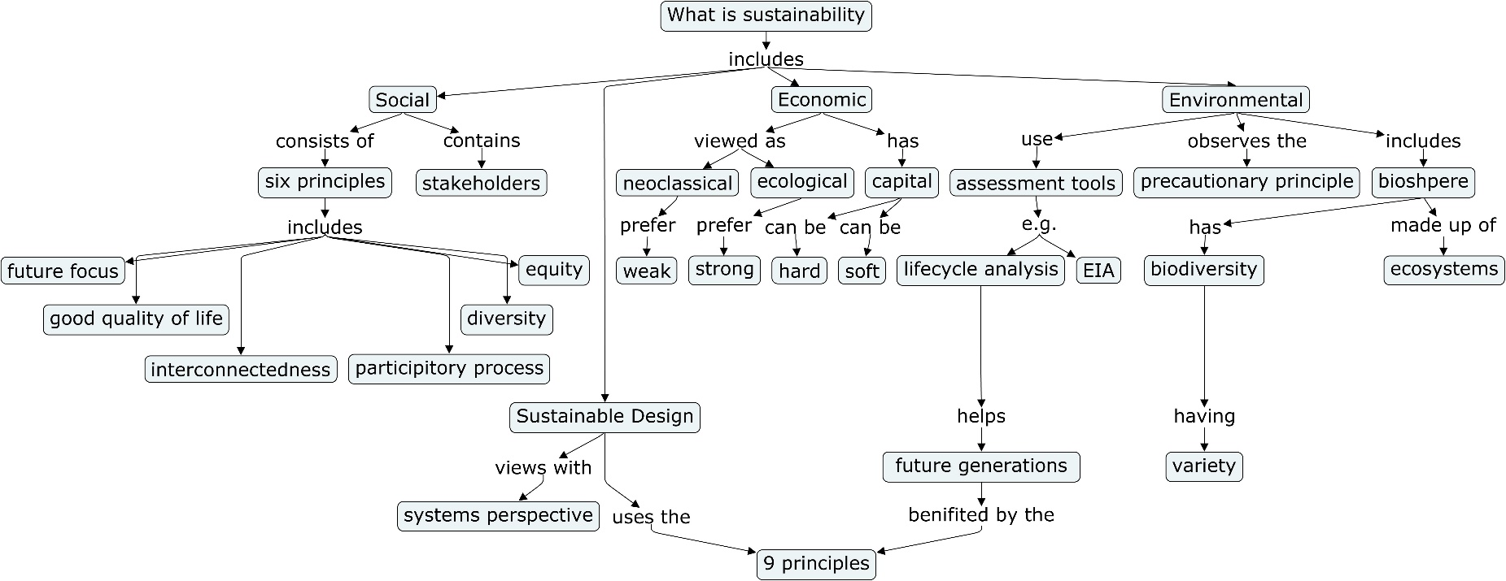
- Count the level (or number of concepts) in each hierarchy, not including the central topic. What is the highest level for this concept map (indicator or knowledge depth)? ________________________

SLS Student Learning Outcomes

- Identify relationships among ecological, social, and economic systems.
- Demonstrate skills needed to work effectively in different types of communities.
- Evaluate how decisions impact the sustainability of communities.
- Describe how to use their discipline to make communities more sustainable.*
* Note: SLO 4 is intended to be used by upper division, project-based courses such as Capstone.

