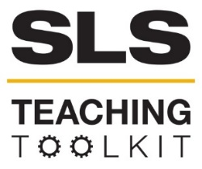 | Living Infrastructure:  The Atlanta BeltLine
Discipline: All | Type: Reading; Assignment; In-class Exercise & Discussion | Time Commitment: 60 mins | Category: Equitable Development; Equity, Justice & Sustainability; Sustainability in Atlanta
Big Ideas: Civic Design; Sustainable Urban Development
OVERVIEW:
This tool uses stakeholder mapping to explore the various entities that influence and benefit from infrastructure projects. Through a short presentation and reading, students will learn about one specific infrastructure project: the Atlanta BeltLine. The BeltLine, originally conceived as a network of light rail lines connecting the city of Atlanta, is a massive project in both vision and implementation. Since its inception, the vision for the BeltLine has expanded to include objectives for parks, multi-use trails, affordable housing, historic preservation, and economic development. Different groups have influenced these priorities over time.
After learning about this history, students will complete a stakeholder mapping activity This presentation and activity will challenge students to think about how large developments/infrastructure projects like the BeltLine grow over time, how the initial vision can change, why the vision changes, and who influences those decisions. Students will consider the implications of who owns infrastructure, who benefits from it, and who makes decisions about it.
This tool was contributed by Dave Ederer.
INSTRUCTIONS:
This tool has 4 parts. See below for detailed instructions.
SLS STUDENT LEARNING OUTCOMES & ASSESSMENT:
The Serve-Learn-Sustain toolkit teaching tools are designed to help students achieve not only SLS student learning outcomes (SLOs), but the unique learning outcomes for your own courses. Reflection, concept maps, rubrics, and other assessment methods are shown to improve student learning. For resources on how to assess your students’ work, please review our Assessment Tools at http://serve-learn-sustain.gatech.edu/tool-category/assessment.
This tool achieves SLOs 1 and 2. See the end of this tool for further details
Want Help?
Contact SLS for tips on how to use this tool. Email us at serve-learn-sustain@gatech.edu

The Atlanta BeltLine: Living Infrastructure
Part I. Visit the BeltLine
While it is not a requirement for completing this assignment, we encourage you to make visiting the BeltLine a requirement of this assignment. Students can visit the BeltLine on their own time ahead of this activity, or you can organize a field trip with the entire class. For the latter, reach out to our Service Learning and Partnerships Specialist, Ruth Yow, if you would like assistance.
Part II. Lecture
During the first 15 minutes of class, present the “Living Infrastructure” slides. While presenting the slides, probe students about their understanding of infrastructure, design, the Atlanta BeltLine and whom it serves. Some probing questions might include:
- What is infrastructure?
- Why do we build infrastructure?
- Who does infrastructure benefit, and who should it benefit?
- Who does infrastructure belong to?
- Based on your experience with the BeltLine and its history, what do you think is the purpose of the BeltLine? Who does it serve?
Part III. Atlanta BeltLine: Origins and Vision
Distribute the Atlanta BeltLine: Origins and Vision handout on page 3. Make sure students also have the Program Elements and Partner List. Give students 5-10 minutes to read these documents, and then talk through the Discussion Questions on page 4.
Part IV. Stakeholder Mapping Worksheet
Break students into small groups of 5-8 students, and distribute the Stakeholder Mapping Worksheet on page 6. Instruct the students to complete the stakeholder map, and discuss their results within the group. Feel free to assign each group of students one of the Discussions Questions at the end, or have groups address all the questions.

The Atlanta BeltLine: Origins and Vision
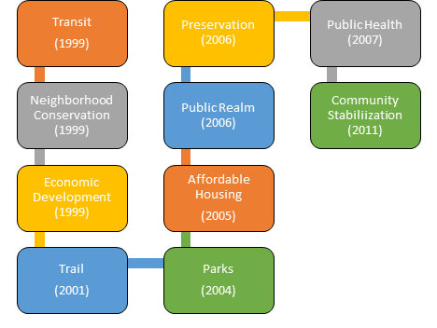
The BeltLine was originally conceived by Georgia Tech Masters student Ryan Gravel as a network of light rail lines connecting the city of Atlanta. After Gravel completed his thesis, others became interested in the BeltLine concept, and how it could become a reality. Community-members formed “The Friends of the Atlanta BeltLine,” a group that lobbied for the BeltLine. This group was also instrumental in shaping the project’s vision. If the BeltLine began as the dream of a transit line, the Friends of the Atlanta BeltLine quickly expanded that dream to include many other goals, including economic development, parks, and community stabilization (see Figure 1 for a timeline on their growing vision). Thus, through community involvement, the BeltLine began to reflect the needs and opinions of many stakeholders
Figure 1. The Atlanta BeltLine’s Expanding Vision

Over time, the BeltLine gained popularity in the city of Atlanta. As a result, politicians wanted to include it in official plans. In 2005, the Friends of the Atlanta BeltLine closed, replaced by Atlanta BeltLine Incorporated (ABI) and Atlanta BeltLine Partnership (ABP). ABI was created under Invest Atlanta, the city’s economic development agency, while ABP is a non-profit focused on securing private, corporate, and philanthropic support for the BeltLine. With the rise of these two organizations, the BeltLine transformed from an advocacy effort to a civic project, with many parties making decisions about priorities and spending.
The BeltLine is not the product of any one person or group, but rather it reflects the visions of many people. As the Beltline has grown, however, the vision driving it, and its implementation, have changed.
The diagram on the next page shows how community driven involvement in major infrastructure projects improves impact, trust, and communication. Look at this diagram. Where on the spectrum do you think the BeltLine started? How has that changed over time? Where do you think it exists on the spectrum now?
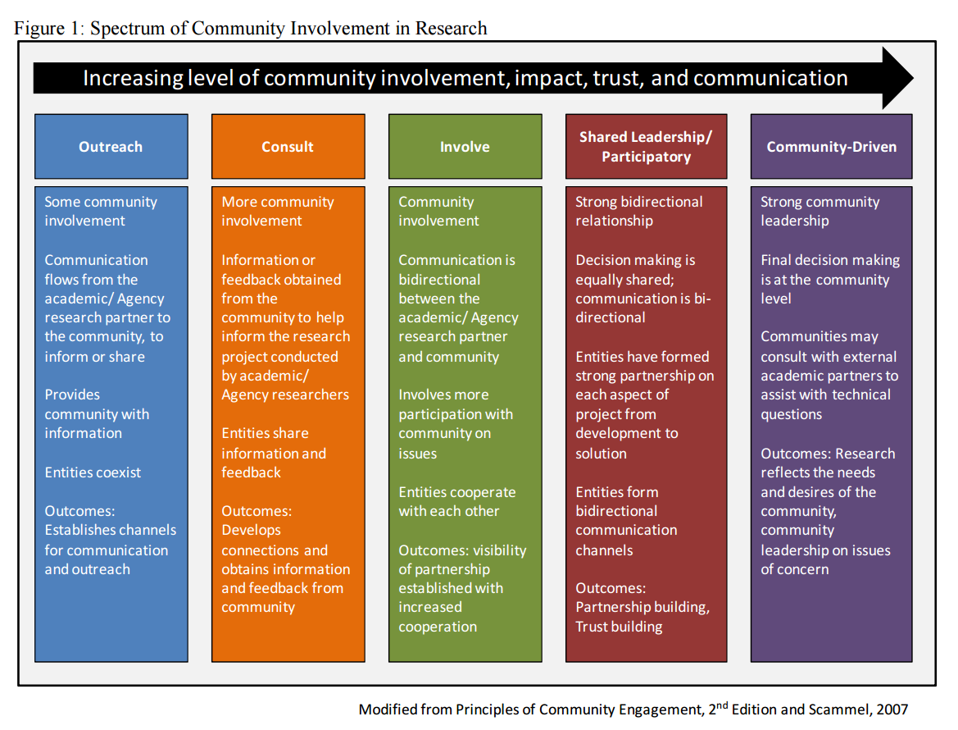
Figure 2: Spectrum of Community Involvement in Research. Modified from Principles of Community Engagement, 2nd Edition and Scammel, 2007.
Next, read the Atlanta BeltLine’s Program Elements and Partner List, before turning to the questions below.

Questions
- The Atlanta BeltLine program elements describe a number of goals for the project. Which of these goals do you thin complement each other?
- Which goals might compete with each other?
- Have any goals taken precedence over others? Why or why not?
- Do you think it is necessary to sacrifice short-term goals to achieve a larger vision? Why or why not?
- How might the goals and vision of a project change when it becomes an official city project vs. a community driven project, as in the case of the BeltLine?

Stakeholder Mapping Worksheet
Stakeholder Analysis: Stakeholder Mapping
Read through Atlanta BeltLine Inc.’s list of partners (pages 20-21 of the Program Elements and Partner List). Each of these partners is a stakeholder in the Atlanta BeltLine. Think about each of these stakeholder’s priorities and needs. Are any groups or populations missing from this list? Note who you think is missing from the list of partners.

Use the following grid to determine the connection stakeholders (both those listed as partners and those that you came up with that are not listed) have with the BeltLine. Place stakeholders on the power-interest spectrum after determining the amount of influence each can have on project outcomes and their corresponding interest in the project.

More Power
Less Power
Less Interest
More Interest

Discussion Questions
- Why do you feel that some stakeholder groups have more power or influence than others?
- How does the design of the BeltLine reflect the needs of different stakeholders? Is it easier to access for some groups than others? Do specific design elements reflect one group’s needs?
- Who has the most at stake with the Atlanta BeltLine project? Who will benefit and who will be negatively impacted? Why?
- How should those involved in developing infrastructure projects balance competing goals and stakeholder groups?
Resources for Further Reading
Atlanta BeltLine, Inc. resources
The Atlanta BeltLine Official Website
The Atlanta BeltLine Community Benefits Agreement & Resolution and Principles
Equity and the Infrastructure
Partnership for Southern Equity
Metro Atlanta Equity Atlas
Florida, Richard. “Building Infrastructure for More Inclusive Communities” (CityLab, 2016).
Immergluck, Dan. “The Beltline and Rising Home Prices: Residential Appreciation Near the Beltline Tax Allocation District and Policy Recommendations to Minimize Displacement” (2007).
Mock, Brentin. “In Search of the ‘Just City'” (CityLab, 2018).
Quirk, Vanessa. “Citing Equity Issues, Founder of Atlanta BeltLine Leaves Board” (Metropolis, 2016).
National media coverage of the BeltLine
Arieff, Allison. “What Happened to the Great Urban Design Projects?” (The New York Times, 2016)
Bandlamudi, Adhiti. “BeltLine’s West Side Brings Concerns about Gentrification,” (Wabe, 2017).
Chambers, Dustin. “Atlanta’s BeltLine: An Ambitious Plan to Bring a City Together” (The New York Times, 2016).
Fausset, Richard. “A Glorified Sidewalk, and the Path to Transform Atlanta” (The New York Times, 2016).
Ryan Gravel’s take on the BeltLine
Gravel, Ryan. “Our Beltline” (ryangravel, 2016).
Gravel, Ryan. “FAQ > “can you remind me the history of Beltline transit?”” (ryangravel, 2016).
Gravel, Ryan. “FAQ > “who benefits?”” (ryangravel, 2014).
Urban Design and people-focused infrastructure
“Developing Sustainable Improvements for Our Future.”
Doig, Will. “The bold urban future starts now” (Salon, 2011).
Doig, Will. “How should we design the cities of our dreams?” (Salon, 2011).Leinberger, Christoper & Hadden Loh, Tracy. “Catalytic development: (Re)creating walkable urban places” (Brookings, 2018).
Song, Lily. “Jan Gehl and the Politics of Transforming Cities” (Planetzen, 2016).

SLS Student Learning Outcomes
- Identify relationships among ecological, social, and economic systems.
- Demonstrate skills needed to work effectively in different types of communities.
- Evaluate how decisions impact the sustainability of communities.
- Describe how to use their discipline to make communities more sustainable.*
* Note: SLO 4 is intended to be used by upper division, project-based courses such as Capstone.

