**Sample Preliminary Concept Mapping Assignment**

**Overview**

Before class, you watched a training video on concept maps. You also downloaded and practiced using CmapTools. Today in class, you will complete a concept mapping exercise to benchmark your knowledge about sustainability (*or insert another central topic*). You will have approximately 30-40 minutes to complete this assignment.

**Learning Objectives**

1. Construct concept maps using CmapTools.
2. Summarize your knowledge of sustainability.

**Concept Mapping Activity**

Use the following guidelines to create your sustainability concept map:

Focus Question:

Create a concept map on the focus question: “What is sustainability?”

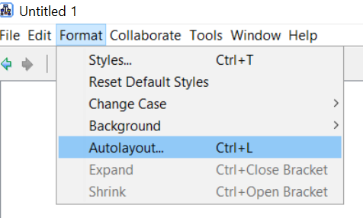What to Include:

1. Prior knowledge from other courses
2. Work experience, internships, service activities, etc.
3. Magazines, newspapers, and other reliable media sources
4. Many other possibilities…

How to Create Your Concept Map:

1. Use CmapTools to create your concept map.
2. The central topic should be: Sustainability.
3. Include as many concepts as you can think of that are relevant to the central topic.
4. Show as many connections as you can between concepts. Remember, each connection should include a meaningful linking phrase.

CmapTools Reminders:

1. Double click on the workspace to create concepts.
2. Single click on a concept and click on the arrow above to connect concepts.
3. You may use the “autoformat” option: Format 🡪 Autolayout
4. You may find it useful to use the “always show arrow heads” option: Select entire cmap 🡪 right click 🡪 Format style 🡪 Line 🡪 Click first option under arrowheads.

How to Submit Your Concept Map

1. Save your concept map as: lastname_firstname_pre
2. Upload your concept map onto Tsquare. Please submit the .cmap file
3. Your concept map will be saved under: desktop 🡪 my documents 🡪 my cmaps